Lemhi County Forest Restoration Group
Field Trip Upper North Fork September 9, 2009
8:30 a.m. – 4: 45 p.m.
DRAFT Summary

Participants:
Gina Knudson, John Goodman, Russ Bacon, Ron Troy, Jeff Hunteman, Dan Garcia, Cindy Haggas, Justin Bezold, Laura Wolf, David Deschaine, Stacey Weems, Cammie Sayer, Vic Phillips, Hadley Roberts, Daniel Bertram, Jim Roscoe, Tim Metzger, Mike Smith, Lyle Powers, Ken Rodgers (affiliations listed in Attachment A)

Welcome and Introductions
Russ Bacon noted that the large presence of Forest Service staff reflected his philosophy that
agency specialist should be involved early in the project design phase so a thorough understanding of the restoration group’s discussions and intentions can translate into a more efficient and responsive analysis.

Upper North Fork GIS Presentation and Conference Room Discussion
The scope of the project thus far includes 41,000 acres stretching from Lost Trail Pass to the
north end of the Hughes Creek Project, on both sides of Highway 93. Russ asked the group to consider if the project should be approached from a strictly hazardous fuels reduction standpoint or from a forest restoration perspective. Gina said during the April 23 meeting, the group selected Upper North Fork over other candidate projects because it lent itself to more forest restoration activities. The group then discussed issues that should be explored and hopefully settled before next field season. Issues that were raised included:

- Roadless areas. Based on the September 2008 field trip at Moose Creek Estates, the group re-affirmed the need to examine some kind of treatment in the Anderson Mountain Roadless Area on the east side of the proposed project area. Although the Obama Administration has reinstated the 2001 Roadless Rule under Clinton, Idaho’s Roadless Rule will stand. Lyle Powers, planning officer for the Salmon-Challis, said the Idaho Roadless Committee is very interested in the proposed Upper North Fork project because of its roadless area implications and would like to be able to attend a field trip/meeting concerning the area in question.

- Visual resources. From the Highway 93 corridor, the Forest is supposed to retain existing visuals (i.e. treelines) and travelers are not supposed to see evidence of forestry work. It is uncertain if there is flexibility to compare the difference of altering the treeline through a restoration project versus the visual effects of a major event such as the 2000 fire in the adjacent Bitterroot Valley or bug kill near Stanley or Helena. The Forest Service does have software and specialists available with landscape architecture expertise who can be useful in designing treatments that mitigate visual resource concerns.

- Old growth. Using Hughes Creek as a model, Russ said he feels the Forest is committed to 1) figuring out what the current conditions are for old growth species, and 2) working

to enhance what is out there, if needed. He said he hopes to have plots in every old growth unit that is part of the project area. To date, he estimates there is around 1,300 acres of designated old growth. Lyle added that the Forest expects the existing old growth polygons to shift fairly significantly as a result of ground truthing and re-configuration.

- Community wildfire protection. Gibbonsville is the biggest concern. Some work has been completed on private land and close to the town, but a false sense of security might be present. Tim Metzger described the historical wildfire patterns in the North Fork District as extremely predictable. Based on that information, Pierce Creek is perfectly aligned with prevailing winds and topography to experience a major wildfire event.

- Project size/Forest Landscape Restoration Act (FLRA). The FLRA was recently signed into law in the Omnibus Public Lands Bill (P.L. 111-11) with an authorization of
$40 million to be competitively awarded to large landscapes (minimum of 50,000 acres) across the nation. The purpose of the Act is to selectively award sustained funding for fuels treatments to large landscapes where a collaboratively developed and science-based ecological restoration plan can be implemented. While the Act has been authorized, it has not been fully funded. The group needs to weigh the advantages/disadvantages of expanding the project’s size to accommodate the minimum standards of the FLRA. Vic Phillips questioned whether the 16,000-acre Hughes Creek project analysis area could be joined together w/ Upper North Fork to reach the 50,000-acre amount. Russ reported that some agency staff at the Region 4 level are wary of some of the FLRA’s “strings attached”. Gina will ask Maia Enzer of Sustainable Northwest to help provide some guidance on this issue.

Stop #1 – Lost Trail Ski Area. Tim Metzger, North Zone Fire Management Officer, described how current vegetation conditions affect wildfire strategy. With the exception of the 2003 Frog Pond fire scar and a few other patches in the drainage, there are no openings in the forest canopy that present obvious places to try to hold a fire. Typically, fire would have moved through the area in 10-25 year cycles. Because of the lodgepole pine component, some of those fires would have been stand replacing fires. Because of fire suppression history and the subsequent buildup of forest vegetation, the stand replacing event is now on track to be on a landscape scale (i.e., entire proposed project area, plus some). Tim feels like he is in a position that when a fire starts in this area, he must suppress it with all available resources.

John Goodman pointed out that the Frog Pond fire moved from the western ridgeline to Highway
93 in about 5 hours.

The beetle and spruce budworm infestations are another contributing factor to the timeliness of this project. While the infestations are not as evident yet, the Stanley basin has experienced around 80% mortality of lodgepole pine creating a fire resilience of virtually zero.

The 1988 Forest Plan that is still in effect does not allow fires to be allowed to burn for resource benefit outside of the Frank Church wilderness. A Forest Plan amendment would be required to change this policy. The use of prescribed fire is allowed.

Jim Roscoe observed that there is potential for higher diversity habitat between Moose Creek and Hughes Creek. He concurred that the area is an important migratory corridor for large mammals such as elk and that the risk of losing a massive segment of habitat in a one-time wildfire event should inspire us to action. He urged an examination of treatment methods that do not have a large footprint, with the possible exception of prescribed fire use.

Daniel Bertram, county weed superintendent, said each year his crew sprays weeds along the highway, starting at Lost Trail and working south. This year they made it to Moose Creek Estates. He views new infestations as his main priority, including rush skeleton, dalmation toadflax, hound’s tongue and diffuse knapweed. He is very encouraged with biocontrol results for spotted knapweed. Disturbance, whether fire, logging, or just increased traffic, usually spurs weed growth so a proactive weed management plan is a must for any project. Daniel learned lessons from the cost share program initiated for landowners in the Hughes Creek project area and is looking forward to working with landowners in Upper North Fork in an even more productive manner.

Stop #2 – Royal Elk Ranch.
We stopped on the west side of the highway and observed a small aspen stand. While not
significant in terms of acreage, aspen is found in many parts of the project area and could benefit from conifer removal. Some of these areas may pose solutions in terms of the conifer having some merchantable value that can contribute to overall project objectives. Private dollars might also contribute to this type of restorative work. Organizations such as Rocky Mountain Elk Foundation have helped w/ aspen regen work in the past and Salmon Valley Stewardship is currently working under a grant from the National Forest Foundation to inventory aspen stands, remove conifers, and monitor post-treatment conditions in the Hughes Creek project area. Whitebark pine is another species that is becoming increasingly rare. So far, whitebark pine has been found to exist on about 400 acres w/in the project boundary.

We crossed the highway onto private property looking east toward the Beaverhead Range and the Pierce Creek drainage. The roadless area adjacent to private lands falls within the Idaho Roadless Rule “backcountry” category, and fuels reduction and even temporary road construction are allowable under the rule. Helicopter logging options are becoming increasingly expensive and less available.

John Goodman reported the Moose Creek homeowners association met in June and Russ made a presentation to them about Upper North Fork. The homeowners initially favor the hazardous fuels objectives of the project, but John said the ecological restoration will be as important to them.

Russ said because the area is so steep and has not been roaded, the potential for big Ponderosa pine restoration is greater than in many areas throughout the forest.

Jim said American Wildlands has a program called Safe Passages that attempts to address issue of wildlife traffic fatalities. Some of the measures employed in that program could be focused on the Upper North Fork area.

Stop # 3 – Votler Creek
We went through an area that had been recently thinned and hand piled. A burn will follow. The
cost of the thinning is running the Forest Service about $500-$800/acre. The group discussed that a less uniform prescription than what we saw in Votler and across the valley in Crone Gulch would be more desirable.

With final Travel Plan recommendations, road issues may be more timely to discuss than during the Hughes Creek project design. While stream restoration opportunities are not as abundant as with Hughes, there are places within the project area where road re-contouring, decommissioning or culverts might have fish benefit.

Next Steps:
- Schedule a field trip of Anderson Mountain Roadless Area. Jake Kreilick from Wild West Institute will be contacted and then available dates forwarded to collaborative members. (Gina)
- Get more information to collaborative members about Forest Landscape Restoration Act. (Maia Enzer, Gina)
- GIS layer of travel plan recommendations in area (Lyle).
- GIS layer (?) of tree species and age class (Russ).
- Consider who else should be invited to participate in collaborative (All).

Lemhi County Forest Restoration Group
Field Trip Upper North Fork October 9, 2009
11:00 a.m. – 5:00 p.m.
DRAFT Summary

Participants:
Bob Cope, Karin Drnjevik, Bill Grasser, John Robison, Bob Russell, Gina Knudson, John Goodman, Russ Bacon, Ron Troy, Jeff Hunteman, Cindy Haggas, Beth Waterbury, Laura Wolf, David Deschaine, Stacey Weems, Cammie Sayer, Hadley Roberts, Bill Grasser, Mike Smith, Lyle Powers, Ken Rodgers (affiliations listed in Attachment A)

Welcome and Introductions at North Fork Fire Department
Russ Bacon announced that Regional Forester (4) Harv Forsgren named the Lemhi County
Forest Restoration Group as the Natural Resource Stewards for 2008. Gina will be circulating some talking points and requesting quotes for PR purposes.

Idaho Roadless Rule and Its Relation to Anderson Mountain
- Although Moose Creek Estates and neighboring landowners are adjacent to Forest
Service lands, they are not technically defined as a “community at risk” under Healthy
Forest Restoration Act (2003)

- The properties are within Lemhi County’s Wildland Urban Interface area as described in the Lemhi County Wildfire Mitigation Plan (2006)

- The Anderson Mountain Roadless Area is categorized as “backcountry” under the Idaho Roadless Rule. Therefore, the Regional Forester must determine that the community or water supply system is facing a significant risk from a wildland fire disturbance event, and the project will maintain or improve one or more roadless characteristics over the long term. A significant risk exists where the history of fire occurrence and fire hazard and risk indicated a serious likelihood that a wildland fire disturbance event would present a high risk of threat to an at-risk community or municipal water supply system.
Officials must also determine that the project cannot be reasonably accomplished without a temporary road.

- The collaborative needs to put forward a recommendation as to our definition of “community protection zone” and whether Moose Creek Estates, et al should be considered a “community at risk.

Discussion Summary
The Lemhi County Forest Restoration Group and the Forest Service are designing the Upper
North Fork project as a landscape level restoration project rather than one with strictly hazardous fuels reduction/community protection aspects. Therefore, the group felt it was too early to pre- suppose temporary roads and/or mechanical thinning treatments would be necessary in the Anderson Mountain Roadless Area.

- Cope expressed the Roadless Area Conservation National Advisory Committee (RACNAC) of which he was a member believed the results to be more important than the methods in achieving sound project objectives. The RACNAC intended for communities to have flexibility in interpreting roadless based on local knowledge and on-the-ground conditions.
- We don’t know where the next fire will start, but we do know where homes are. Any proposed treatments should be complementary and blur the lines across public and private boundaries.
- Issue is not whether commercial or non-commercial activities take place in a roadless area; issues are whether trees are to be cut and/or temporary roads built.

Stop # 1 – Royal Elk Ranch
- Viewpoint looking northeast into Anderson Mountain and Pierce Creek.
- Proposed Upper North Fork project has nearly every forest type found in the Intermountain West. Much of the ponderosa pine stands are second growth because early logging targeted the species.
- Beth Waterbury used a Dahlonega Creek project as a good example of a fuels reduction project. Jeff Hunteman explained the end result left about 50 basal area remaining and is described in timber terms as a commercial thin from below. Beth said for wildlife, the percent of canopy cover remaining is another important factor.
- Moose Creek Estates currently consists of 18 homeowners with potential to have 30. The neighboring ground has not been split up yet and two landowners own large pieces.

Stop #2 – Forest Service land adjacent to Moose Creek Estates on the east slope
- Stand is primarily lodgepole pine, usually subject to a lethal fire regime. This stand could
be described as later succession, about ready to fall down and most likely highly susceptible to mountain pine beetle.
- Lodgepole doesn’t offer easy solutions
- Mother nature is going to thin from above
- One possibility is focusing on crown space

Stop #3 – Further up on the hill
- Estimated 55% slope
- We observed a fire scarred lodgepole indicative of a previous low intensity fire
- Forest stand is mixed with a small patch of aspen, lodgepole, ponderosa, douglas fir all evident
- Spruce budworm is at work
- Russ commented that fire let ponderosa pine win species competition historically
- What will climate change do to the trend of species transitions?
- A variety of age classes and green tree recruitment are desirable
- To move toward a more fire resilient ecosystem, small patches would be required for non lethal fire regime (such as ponderosa pine), a larger patch for mixed severity, and for lethal fire regimes (lodgepole), a large patch size or large mortality would be necessary

Stop # 4 – The Ponderosa Pine savannah

- A small stand of large, old ponderosa pine, typical dry pine site
- The stand would likely withstand a ground fire, but understory and surrounding timber is dense enough that crown fire would be more likely to be lethal
- The stand is moving more toward a Douglas fir succession
- What, if anything, do we do to protect the ponderosa stand?

Stop #5 – Bushwhacking south to an intermittent streambed
- PACFISH only calls for no commercial harvest within 100 feet of an intermittent stream,
150 feet of a perennial non-fish bearing stream and 300 feet from a fish bearing stream. Also, looking at your picture of that intermittent stream it was hard for me to tell if it was an intermittent stream or an ephemeral draw. To be considered a stream channel (intermittent or perennial) there needs to be defined bank incisement where you can definitely tell you are stepping down into a channel (may only be a few inches) and there also needs to be stream substrate in the bottom of the channel. In other words if you have a grassy or mud bottom with no rock substrate and the slopes of the bank are more rolling/gradual without defined bank incisement you are probably looking at an ephemeral draw. PACFISH does not have criteria for ephemeral draws. There are Best Management Practices to protect ephemeral draws but there are no set backs to commercial harvest. [Dan Garcia comment]
- If temporary road was to be built, road would likely cross this drainage and require culverts.
- Roadless rule would require decommissioning, but decommissioning can take a variety of forms.
- To the south, large pocket of insect mortality. Large ponderosa pine component seems to be escaping beetle damage, but fuel loads could lead to fire mortality.

Wrap Up Discussion
- Anderson Mountain is only a very small part of assessment area, but because of complex
issues, looking at this early in the design phase makes sense
- We don’t have to come up with all the answers in one day
- Variety of methods to consider, including tractor logging/temp road, skyline/cabling, helicopter log operation, other possibilities yet to emerge…
- Keep an open mind, think about desired future conditions

Next Steps:
- Schedule a field trip on West side of project area near Gibbonsville (Gina/Russ/ALL).
- GIS layer of travel plan recommendations in area (Lyle).
- Schedule a conference call re: Federal Landscape Restoration Act (Gina/Maia).
- Consider who else should be invited to participate in collaborative (All).

Lemhi County Forest Restoration Group Meeting Salmon Business and Innovation Center February 10, 2010
9:00 a.m. – 4:00 p.m.
Final
Meeting Summary

[Indicates ACTION items]

Participants:
Ron Troy, Bob Schrenk, Rene Toman, Wayne Talmadge, Bob Russell, Bill Grasser, Hadley Roberts, John Goodman, Steve Adams, Jim Roscoe, Dylan Taylor, Gina Knudson, Michelle Tucker, Sean Bascom, Bob Cope, Karin Drnjevic, Russ Bacon, David Deschaine, Ken Rodgers, Diane Schuldt, Karen Dunlap, Mike Smith, Stacey Weems, Glenwood Brittain, Jim Tucker, Chris Erca, Scott Feldhausen, Cindy Haggas, Laura Wolf (Affiliations attached)

Reminder: March 3 & 4, 2010 – Climate Change, Bioenergy and Sustaining Forests in
Idaho and Montana Conference
http://www.uidaho.edu/cnr/forestsbioenergyconference
Bob Russell is driving to Boise and is interested in carpooling. John Robison of Idaho Conservation League is slated to speak on a panel discussion on behalf of the Lemhi County forest restoration group.
Gina said Titcomb Foundation funding for the collaborative may be able to help with registration if someone requests.

Information Repository at Salmon Valley Stewardship
The LCFRG records are being organized and indexed in a file cabinet at SVS. These records
belong to the whole group and anyone is welcome to inspect and duplicate the records. Gina hopes to be able to make the records available digitally in the future but that is realistically 18 -
24 months away.

Hughes Ck Multiparty Monitoring
SVS intern Sean Bascom is focusing on the socioeconomic monitoring chapter of the Hughes Ck
Multiparty Monitoring Plan. He has been calling contractors to determine how many days of work they and employees have put in on all of the various Hughes Ck items, from the private work on the Cerise stream section to the County’s private lands fuels reduction work, aspen regeneration and the Ditch Ck bridge replacement. The monitoring information should help the group and the agencies communicate how much economic and social impact a project like Hughes Creek can have on a community.

When the Forest Service uses stewardship contracting, multiparty monitoring is a requirement.

Hughes Ck Stewardship Contracting
Since the subcommittee met with the Forest Service contracting officials and others, Diane
Schuldt of the Salmon-Challis has been able to review the suggested optional contract item of a pilot weed study relative to weed response to prescribed fire. She said she spent time in the field

\\Server\shares\Restoration Collaborative\Collaborative Meetings\Upper North Fork Meetings\02_10_10 LC Forest Summary Revised.doc

with Jake Kreilick last summer and at the time they determined some possible areas for such a study. The other optional contract item listed is thinning unit #45 and Mike Smith suggested leaving the thinning unit unnumbered.
The contract specifications are expected to be on contract officer Judy Martin’s desk no later than March 1 with a 60-90 day turnaround anticipated before bids are solicited.

Central Idaho Resource Advisory Committee

The following proposals are being prepared in relation to the forestry collaborative:
• Salmon Valley Stewardship. Aspen inventory and monitoring on Breaks project and
Upper North Fork. (approx $5-10K); Hughes Ck multiparty monitoring ($7.5-10K)
• Lemhi County Economic Development Association. Removing conifers from at-risk aspen stands in Breaks project and elsewhere. ($?)
• Lemhi County Wildland Urban Interface. Vegetation survey on private land in Hughes
Creek area in partnership with Youth Employment Program ($9K)
• Salmon-Challis NF. Hughes Ck weeds. ($?)

Williams Ck Restoration Project
Mike Smith, fuels specialist, said he and Jeff Hunteman toured the South Fork of Williams Creek
project area and determined the timber component was not very enticing. They decided to streamline to a restoration project using primarily prescribed fire and some hazardous fuels reduction near the Hoffman private property for a total project size of approximately 3400 acres.

They are drafting a proposed action and expect to use a Forest Service enterprise team to do the NEPA analysis. Wayne Talmadge asked if contracting locally for the work had been considered. Russ Bacon explained that NorthWind, a company that has a presence in Salmon, did bid on the contract but was not successful.
The Forest expects to be able to use CE6, a categorical exclusion for wildlife enhancement. Gina reminded the group that in their strategic plan the group outlined endorsement vs. full
collaborative status for projects that were less likely to be controversial, such as the Breaks project that had no timber component and mostly prescribed burning treatments.

Karin Drjnevic asked if the burns would be timed to accommodate rancher Roy Hoffman. Gina said the 2008 field trip notes should reflect some strategies presented by the Nature Conservancy’s Mark Davidson regarding grass banks, etc.
[Gina will forward meeting summary to Mike Smith and Karen Dunlap; C.Haggas would appreciate copy also]

Cope said the Forest might want the project to have an element of collaboration since there are potential grazing, wildland urban interface, and Idaho Roadless Area issues, not to mention local desire to utilize the wood if possible.

Michelle Tucker asked what the Forest had determined about aspen. Russ said inventories had been completed in the area.

Bob Schrenk said the Elk Foundation looks at 3 sources of funding for wildlife enhancement projects like this one:
1. Appropriated $ for Rx fire
2. $ generated from timber value
3. Grants

He said the size and duration of the project was not typically big enough for RMEF interest who like landscape-level, long-term projects. He recommended the Forest Service not limit themselves unnecessarily with the NEPA document. He encouraged the agency to “set yourself up to be opportunistic”.

Russ agreed, but explained that he has to be mindful of targets. In some cases a streamlined
NEPA process is warranted.
[The SCNF will continue to keep the LCFRG informed, sharing a draft of the proposed action]

Upper North Fork

Background: The Forest Plan classifies 4 management areas within the project area: Lost Trail Ski Area (1A), Dispersed recreation area with no timber harvest planned and minerals, vegetation management and grazing allowed (2A), aquatic habitat management with long-term timber outputs (regeneration and thinning) (3A-5A), and fish habitat, big game habitat needs
(3A-4A) with an emphasis on winter range, vegetation management is allowed for enhancement of habitats.

Laura Wolf commented that Idaho Fish and Game would probably not consider the Upper North
Fork project area to be as important for winter range as it is for summer range.

Bill Grasser asked what management area would be what they used to call the “timber base”. Russ said that would be the 3A-5A area.

Russ said the plan dates from 1986 and the terms “restoration” and “hazardous fuels” may not even appear. Working with a 25-year-old plan creates a struggle for the public and the agency. There is some flexibility because when issues arise, the plan can be amended on a project basis. One foreseeable example is visual quality objectives.

Cope said it makes sense to him to use the Community Wildfire Protection Plan (CWPP) as an overlay on the project area to help the group prioritize objectives.

Previously analyzed projects in the area:
- Gibbonsville EA.
o Signed 2003
o Decision appealed and rescinded by FS
o Revised and appealed again in 2004
o Settlement reached with Alliance for Wild Rockies, Ecology Center 2005

o Final project included ladder fuels treatment and Crone Gulch sale

David Deschaine said one lesson learned for the Forest regarding the settlement is the NEPA analysis linked too many activities, for example, timber units were tied to road reclamation activities. So when units were dropped, they were unable to do some of the linked activities.

Project Boundary Issues
- The President has recommended full funding ($40 million) for Forest Landscape
Restoration Act. Projects need to be 50,000+ to be eligible. Upper N.F is 41,000 approx now.
- Phase II Hughes Ck may be able to be included in analysis area.
- Dahlonega may also be included since some NEPA is already done.
- Potential barriers are an extra watershed adds complexity for analysis; Salmon-Moose settlement specifies an old growth protocol that has not been done in Dahlonega and would be time consuming and costly.

Forest Service Specialist Update

Water Quality/Fish (David Deschaine)
- 11 sediment stations in project area: Dahlonega, Ditch, Hughes, Hull, Moose, Pierce,
Sheep and Twin Creeks, and 3 stations on the North Fork
- This field season they will set up for modeling sediment, bank stability, and potential changes in water yield due to disturbance from project activities

Soils (Stacey Weems)
- The Student Conservation Association accompanied her to 3 sites last field season at
Anderson, Twin Creek and the Johnson Creek areas
- Her work is essentially on hold until site specific info is developed.

Timber (Glenwood Brittain)
- Forest engineer accompanied him to Moose Ck Estates to help inform a logging systems
plan on the hillside above MCE. He examined harvest potential, thinning and fuel break options.

Wildlife (Cindy Haggas)
- Conducted limited surveys on Northern goshawk (sensitive species on SCNF)
- Looked at aspen regeneration potential with timber shop and John Goodman near MCE
- Assembled existing studies on lynx habitat near the Divide and elk security habitat gathered during the Lost Trail Pass/Gibbonsville Integrated Resource Analysis process
- Need to address impacts of project activities on TES wildlife and plant species
- Allan Mountain Research Natural Area was established to recognize subalpine larch and subalpine plant communities; RNAs have unique management prescription.

Weeds (Diane Schuldt)

- In the Krone Gulch area a patch of knapweed 1,300 acres in size has been inventoried
- Otherwise not much has been inventoried in project area and because of expense of doing inventories, most will not be planned until site specific info is available
- Forest did get approval to establish a new biocontrol agent in Hughes Ck area so they are setting up monitoring plots to test results
- Weeds of concern are spotted knapweed, hound’s tongue, cheatgrass, and a new super- competitor blue weed

Fuels (Mike Smith)
- Forest engineer has looked at area above MCE regarding temporary roads
- All but about 3 old growth units have been inventoried

Lemhi County Forest Restoration Group Values
• Fire prevention around rec site
• Aspen
• Whitebark Pine (sub-alpine larch)
• Climate change
• Noxious Weeds
• Old Growth
• Roadless
• Wildlife Habitat
o Deer and Elk Summer Range
o Wolverine, Fisher and Lynx
o Owls (Other raptors)
• Wildlife Migration Corridor
• Wildlife collisions
• Support to the Local Economy
• Community Fire Protection
• Private Land Development (Increased WUI complexity)
• Forest Health
o Dry Douglas Fir/Ponderosa Pine
o Mixed Conifer/Lodgepole Pine

Values to protect
• Community of Gibbonsville
• Hwy 93 corridor
• Royal Elk Ranch
• Moose Creek Estates
• Chief Joseph
• Lost Trail Ski Area
• Twin Creek Campground

• Allan Lake Trailhead
• Continental Divide NST
• Divide Trail
• Twin Cr national historic trail
• Big Hole Battlefield
• Granite Mountain Lookout
• Cultural Resources
• Private land north of Gibbonsville

Resource Conflicts
• Visual quality vs temp road systems
• Roadless vs temporary road systems
• Road Systems and Weeds
• Disturbance and Weeds

Potential Mechanical Treatment Areas
• Area North and East of Moose Creek

THERE WAS UNANIMOUS CONSENSUS THAT THE IDAHO ROADLESS AREAS ADJACENT TO MOOSE CREEK ESTATES SHOULD BE CONSIDERED FOR MECHANICAL TREATMENT.

- The group asked to see a full suite of options that might include hand work only, machinery that accesses by temporary road, or aerial logging.

Next Steps
- John Goodman and Cope expressed a need to share information with the residents of
Gibbonsville, etc.
- [Gina will try to set up a meeting at the Gibbonsville Improvement Association the week of March 8 – 12]
- Another full group meeting should be held to focus on Moose Creek Estates/Idaho
Roadless Area, wildlife concerns, fuels objectives, and visual resources.
- [Gina will poll group about a meeting the week of March 16- 19]

Lemhi County Forest Restoration Group Meeting Salmon Business and Innovation Center April 26, 2010
9:00 a.m. – 4:00 p.m.
Draft
Meeting Summary

[Indicates ACTION items]

Participants:
Maggie Milligan, Bill McLaughlin, Daniel Bertram, Russ Bacon, David Deschaine, Jake Kreilick, Mike Christianson, Gina Knudson, Michelle Tucker, Wayne Talmadge, Mike Smith, Glenwood Brittain, John Robinson, Lynn Bennett, Bill Grasser, John Goodman, Laura Wolf, Cindy Haggas, Ken Rodgers, Jim Roscoe, Ron Troy, Jerry Hamilton, Steve Adams, Jerry Hamilton, Bob Cope, Bill Grasser(Affiliations attached)

Members Update
Society of American Foresters Biomass and Climate Change Conference – John Robinson and
Bob Russell attended. Discussions on strategies for sustaining forests and the services people expect from them. The focus of this conference was on current collaborative efforts in the West. John presented the Hughes Creek project which was well received.

Rural Voices for Conservation Coalition – Gina Knudson attended in DC. RVCC focuses on policy issues that affect rural communities, public lands management, and the continuation of a natural resource-based economy in the West. USDA looking to connect Forest Service and Rural Development more directly. High Divide area which would include Upper North Fork is
potentially a focus area for Secretary of Agriculture because of the successes community-based groups have had in moving projects forward.

LANDFIRE – Lynn Bennett and Ron Troy visited with Lynn Decker, head of Nature Conservancy Fire Learning Center. Discrepancy between local data and Landfire data is considerable for Fire Regime Condition Class (FRCC) in North Fork. [Lynn Bennett will follow up with Jim Smith, the Nature Conservancy's LANDFIRE project manager]. LANDFIRE is a collaborative 5 year project with the USFS and DOI aimed at developing geospatial data for fire regime restoration, fire management and conservation planning, and hazardous fuels reduction. Refresh layers are now being reviewed for accuracy which Russ Bacon agrees is a high priority for the zone.

West Wide Wildfire Risk Assessment – The Council of Western State Foresters and the Western Forestry Leadership Coalition are promoting for 2011 - A wildfire risk assessment to quantify the magnitude of the current wildland fire problem in the west and provide a baseline for quantifying mitigation activities and monitoring change over time. This program is slated to use LANDFIRE data. [Jake Kreilick is tied into this project and will find out more background on the use of LANDFIRE and potential pitfalls with accuracy].

Hughes Creek Update

Stewardship Contract
No new stewardship contracting info per Russ Bacon. Judy Martin, USFS Contracting Officer,
has not been available. Timeline slippage is possible. Russ has a backup plan with a Rocky Mtn

Elk Foundation (RMEF) stewardship agreement to cover in absence of contract from Judy but he wants to hold until we can visit with Judy. Gina emphasized the importance of resolving this quickly and offered 3rd party communications if needed.

Multiparty Monitoring
SVS intern Sean Bascom is done with socioeconomic monitoring chapter of the Hughes Ck
Multiparty Monitoring Plan. NFF funded WildWest for $10k which will enable Jake to spend more time monitoring here this summer. Last year 4-5 people were trained to complete plots in old growth (OG). It is Jake’s riority to complete more plots and photo points in commercial harvest units. Jake hopes to start mid-June by meeting with monitoring committee and start taking photos prior to treatment. RAC funded SVS request for $10k for multiparty monitoring so Jake will have support on the Salmon side.

Implementation
Prescribed burning took place in April. Approx. 350 acres were burned in unit 2a near Salzer
Bar.

Williams Creek Restoration Project
NEPA has been contracted by Ecosystem Management (NM) with field work completed this
summer. Draft proposed action includes 3300 acres of restoration using primarily prescribed fire and some hazardous fuels reduction near private property. The Forest expects to be able to use CE6, a categorical exclusion for wildlife enhancement.

Jesse Creek Project
RAC funded Lemhi County to contract archeological and vegetation surveys. The data collection
is pre-NEPA.

Breaks Project
Several objections were received. Payette NF is having problem with best management plans for
domestic goats in big horn sheep occupied habitat. John Robinson explained that domestic goat grazing is not optimal in occupied habitat per Idaho Conservation League. Daniel Bertram wants to continue to work with ICL to find solution for using domestic goats for weeds. Payette work may lead to model based on the science they are applying to determine risk. Payette decision is anticipated for May 3, 2010.

Gina reminded the group that we had endorsed this project as a collaborative (vs. full collaborative status), and at the time of endorsement, ICL indicated their endorsement hinged on resolution of the bighorn sheep issue. Russ feels using the Healthy Forest Restoration Act (HFRA) objection process prior to decision helped greatly by allowing for resolution with ICL.

Next step: Russ reviews the merits of objections and can move forward with a decision. Implementation would begin immediately with potential litigation. Burn window passed for this year due to early spring conditions, prescribed burning now slated for next spring. This season they could move ahead with aspen inventory and conifer removal funded by RAC, as well as pre treatment for OG and burning next spring.

UPPER NORTH FORK PROJECT

NOAA Fisheries and USFWS have been invited to collaborative and have indicated that current work loads may reduce their participation to reviewing meeting summaries.

Nature Conservancy – Lynn Decker - Director of Fire Learning Network was invited by Ron Troy to come to Salmon to offer guidance on TNC’s resources and role in the collaborative process. TNC offers technical assistance (modeling, training) and limited funding for developing and sharing the collaborative goals (field trips, data verification). Gina felt the biggest take away message was to determine what our questions are before we turn to decision making - What is our shared vision?

SCNF Background Information for Upper North Fork Project Area
Resource specialists provided information regarding project area and potential treatment options: Insects and Disease – 2009 Field Season information from Region 4 based on a fixed wing
inventory for Douglas Fir Beetle , Mtn Pine Beetle, Spruce Bud Worm. Inventory measures
mortality rates, not infestation. New occurrence of doug fir beetle is declining as larger PSME have died out. Mtn pine beetle is expanding quickly since 2008 and following behind the fir beetle. Climate change most likely having an impact as insects can now overwinter and survive. Increased biomass due to fire exclusion also allows bugs to expand. Beatle epidemics aren’t historically uncommon in area but due to expansion of PICO, where PSME typically would occur, they are having greater impact. Mtn pine beetle prefers PICO but will turn to PIPO once PICO depleted. Non historic patterns are causing drastic changes. Need to decide what we want the forest to look like, historic conditions not necessarily possible with altered patterns.

Fire History - Penny Morgan Fire Ecologist U of Idaho completed fire history on SCNF in 2008, including collection of tree scars in and around NFK Project area. Some scars date back to
1600s. 1600-1800 average fire return interval (at least two trees) every 12 years. Dry springs and hot summers correlate with larger occurrence years. This study focused on drier sites and not much project specific data for wetter communities.

Hydrology - David Deschaine – Decreasing fuel loading can help make more water available to trees left on site - 15% Equivalen Clearcut Acre (ECA) implied by PACFish. Project area typically at 5%. What ECA would be considered appropriate by group? Decommissioning roads can also contribute to cumulative watershed health. 53 miles of road identified (classified and unclassified) for potential decommissioning. [ECA map from Dave].

Fisheries - Identified two fish passage culverts for possible treatment. Gradient and drainage area don’t preclude anadromous fish - some good opportunities for enhancing fisheries. [Upper_North_Fork_fish_streams.pdf].

Wildlife – Laura Wolf reported that elk surveys have been completed by IDFG for spring. Upper North Fork Project area considered low density. West side (21) not surveyed. East side (21A) surveyed with low numbers. Even with reduced cow hunts offered numbers are lower. Calf (25.3%) and bull ratios (60%) below objective. Potential calving habitat could be improved. Elk security areas were determined in 1980s and 1990s before introduction of wolves and ATVs. Do these models need to be updated? 15 mountain goats were located in Upper North Fork. [Elk Survey Data from Laura and Elk Security Area from Cindy].

Timber – Glenwood Brittain - Potential harvest units identified for 4,500 acres. Forest plan allows for up to 45% slope. Potential treatments skyline, tractor (2,4000 acres), helo; 12 miles of potential temporary roads for commercial sales. The 2006 Gibbonsville sale (400 acres) was never sold and could also be made available as part of this more comprehensive project. Russ estimates 6,000 acres available for some type of treatment (timber, rx fire, thinning, etc).

Fuels – Mike Smith - Fire regime is the actual fire return interval, FRCC is deviation from natural conditions. Possible fuel breaks include:
Lost Trail – Utilize fireline from 2000 to create a 300’ fuel break west of ski area
Moose Creek – 150’ fuel break around subdivision
Anderson Mountain Road – Coordinate with Wisdom Ranger District

Maintenance – important to preserve fuel breaks. Many ways to achieve fuel breaks, fire, mechanical, thinning.

Weeds – Daniel Bertram - Lemhi Couny Weed Manager, the county is building a weeds layer for known occurrence. Biocontrol for spotted knapweed – have been released throughout the county. Rush skeleton weed, yellow star thistle, hawkweed, dalmatian toadflax, sulfur cinquefoil near project area. Highway ROW is sprayed by county. Private Property Agreement proposed by County – 50% reduced rate for treatment with landowner contract for 4 years. If not maintained, landowner will be charged full rate.

Wildlife -Cindy Haggas - Lynx Analysis Unit – habitat (spruce-fir) is within project area. Current Lynx direction gives flexibility for management in these areas. 28 other species are within project area.

Roadless – John R.- Idaho Roadless Rule generally considered a good model, however most likely will receive national scrutiny due to adversity in other states like Colorado. Values at risk will be used to measure proposed actions in roadless. Referenced Yellow Pine project where commercial timber came out of a roadless area. New or temporary roads will be vulnerable. Jake Kreilck – the further from value at risk, more vulnerable due to roadless. Roadless might be a good sub-committee to address this issue. Access through private land helps reduce need for new roads. 2001 rule allows for fuel reduction. Our project may be the first test of the roadless rule. Idaho Roadless Committee has already contacted Russ to review project. John, John, Jake, Bill and Cope will form subcommittee and invite a representative from Idaho Roadless Committee.

Other Questions Still on the Table
Including parts of the Gibbonsville Sale (2006) – Jake K. would like to visit with Michael
Garrity, Alliance for Wild Rockies. Jake feels the data he has seen does seem to support WUI. Russ said the group’s opposition last go-round was due mainly to: 1) old growth, 2) roadless and un-roaded, 3) distance of treatment area from community.

Jim Roscoe - would like to see more involvement from landowners adjacent to and within the project area. This could help to make the project more seamless and give landowners ownership in project objectives and treatments. Recommends public meeting this summer in Gibbonsville area. [John Goodman will work with Gina on this]

Wayne Talmadge – what economic value does this project bring to the local community? Aesthetic, safety, WUI, property values, ingress/egress to private property.

Ron Troy – special status species need more focus.

John Robinson – what are opportunities for aspen and whitebark pine treatments? Some data available on aspen stands. This summer aspen inventories and risk assessment may be done. Whitebark pine – watershed assessment from early 90s indicates small communities. Seedbeds, replanting and fuel breaks. Whitebark pine authorities (Arno, Tombeck) have done studies in MT on using prescribed fire to site prep around stands. Pine beetle and blister rust are hitting

whitebark. Lessons learned in Hughes Creek about finding stands and recording their presence/treatability.

Gina Knudson – Collaborative Forest Landscape Restoration Program (CFLRP) - requests by the Secretary of up to $40,000,000 annually for fiscal years 2009 through 2019; up to 50 percent of the cost of carrying out and monitoring ecological restoration treatments on National Forest System land for each proposal selected; up to $4 million annually for any one project; up to two projects per year in any one FS region; and, up to 10 projects per year nationally. Russ has been working with Harv Forsgren, Region 4 Forester, to determine if Hughes Creek can be included
or if regional office will get RMEF stewardship to include all of Breaks, Hughes, Upper North fork (70k acres). Group would like clarification on deadlines for application. http://www.fs.fed.us/restoration/CFLR/index.shtml

Ron Troy – What role does our process play in the SCNF forest plan revision? Russ feels it is so far out that right now it doesn’t; however, once initiated, collaborative groups will have a huge input. More successful projects will be used as models and lessons learned.

Russ Bacon – Next step needs to be our shared vision, SCNF needs to set goals for field season. Restorative goals seem to be coming up as prominent strategy. Cope feels the strategy from Hughes Creek remains the same with different tactics. Russ views two project areas: South – very similar to Hughes Creek; North – more tools available and variation for treatments, more restoration.

Next Steps

Russ would like to begin scoping this Fall. This summer, a purpose and need statement would need to be developed, and a proposed action drafted by the end of field season.

Gina will review previous meeting discussions and research shared vision statements from other groups and circulate a draft of that combined statement. The group agreed that initially discussions have focused on:

- Improving watershed function
- Reducing species competing with ponderosa pine, whitebark pine, aspen
- Socioeconomic sustainability
- Noxious weed treatment
- Maintain/enhance wildlife habitat connectivity along the Continental Divide
- Reduce wildfire threat around private property and communities

Meetings to be established:

- May, Roadless Subcommittee Conference Call
- May (3rd or 4th week), Full group conference call re: shared vision statement
- June (3rd or 4th week), Full group meeting, perhaps in conjunction with Idaho roadless committee (Cope will help coordinate exact date)
- July 15-16, Tentative dates for meeting/field trip

Lemhi County Forest Restoration Group
Conference Call
Wednesday, May 26, 2010
3:00 – 3:30 pm

Participants: Gina Knudson, Ken Rodgers, Bill McLaughlin, John Goodman, Jake
Kreilick, Wayne Talmadge, Russ Bacon

Upper North Fork Vision Statement

The first item of discussion was the Upper North Fork vision statement. Members commenting via email include Dan Bertram, Lynn Bennett, and Bob Schrenk. Based on their comments and comments from the group on the call, the draft statement was revised to:

“A century of fire exclusion in the Upper North Fork project area has resulted in ecological conditions that threaten the resilience of plant and wildlife species and natural functions. Native species are declining and the unnatural fuel accumulations increase the risk for extreme fire behavior which would destroy species habitat and important resources. Area residents, private property, and recreational and other assets have become increasingly susceptible to uncharasterically large wildfire events. The Lemhi County Forest Restoration Group envisions a suite of forest stewardship and
management projects that would allow fire to play a more natural role on the landscape where appropriate and create less hazardous fuel conditions within wildland-urban interface areas. The Group supports activities that enhance aquatic and elk and other wildlife habitat, and that address the decline of tree species such as ponderosa pine, aspen, and whitebark pine. Native plants, especially grasses, would benefit from addressing serious noxious weed encroachment. Creating a steady program of stewardship activities over multiple years will provide local contractors incentive to invest in equipment, infrastructure and a local workforce."

The following information was removed and will serve as supporting information for more detailed documents:

“The Upper North Fork area stretches from the Salmon River Mountains to the West to the Continental Divide on the easternmost boundary, and north to south from Lost Trail Pass to the Hughes Creek drainage. The North Fork of the Salmon River and its tributaries are important rearing and spawning grounds for salmon and steelhead, and the diversity of bird and wildlife species that rely on this area for habitat and migration is impressive.”

Gina will post the statement to the Google Group site.

Scheduling

Week of June 1 – 4, TBD – Need to hold a meeting/conference call to discuss endorsement of Williams Restoration. Dates were not discussed because Project Lead Mike Smith’s schedule is not known at this time.

June 7, 7 p.m. – Gibbonsville Improvement Association meeting in Gibbonsville at the GIA Hall (white building). Introduce Upper North Fork project concepts and Lemhi County Forest Restoration Group opportunities for involvement to area residents. Russ may not be able to be there but other Forest Service personnel will help present.

June 29, 9 a.m – 4 p.m. – Upper North Fork Roadless Subcommittee field tour of Anderson Mountain Roadless Area. All collaborative members and others are welcome. Meet at Moose Creek Estates. More info to follow.

June 28 or June 30 (TBD), 9 a.m. – 2 p.m. – Lemhi County Forest Restoration Group full collaborative meeting. Doodle poll will be sent out to determine best day to meet.

August 9 – 10, Idaho Roadless Committee to meet in Salmon. More info to follow. The call ended at 3:33 p.m.

Lemhi County Forest Restoration Group
Field Trip
Upper North Fork Anderson Mtn Roadless Area
June 29, 2010
9:00 a.m. – 4: 45 p.m.
DRAFT Summary

Participants: Maggie Milligan, Bill McLaughlin, Russ Bacon, Jake Kreilick, Mike Christianson, Gina Knudson, Michelle Tucker, Glenwood Brittain, Lynn Bennett, John Goodman, Ken Rodgers, Jerry Hamilton, Bob Cope, Bob Russell, Karen Drnjevic, Matt Hall, Brynn Schroeder, Paul Werner, Doug Wasileski (Affiliations attached)

Gibbonsville Improvement Association (GIA) Building Pre-Field Trip Summary

Roadless Subcommittee Update

Our roadless subcommittee (John Goodman, John Robison, Jake Kreilick, Bill Grasser. and Cope) still plans to have Idaho Roadless Committee here August 7 but have not had confirmation. (Update as of July 20 – Idaho Roadless Committee will not be coming to Salmon on those dates).

Introductions and Review of Anderson Mountain Roadless Area

Russ Bacon - 2001 rule allows for fuel reduction. Our project may be the first test of the roadless rule. Focus on what we want to accomplish and then consider the how. Visuals are also very important in the HWY 93 corridor - Seamless boundaries as well as transition areas between treatments.

Jake Kreilick – Relayed concern from John Robison that temporary (any) roads are a concern for ICL– the further from community at risk, the more vulnerable due to roadless. Access through private land may help reduce need for new roads. All agreed it is important for John R. to attend meetings as the roadless issue is most likely to be our biggest hurdle.

Russ – Objectives for our project area: 1) Decrease fuel loading adjacent to private property. 2) Landscape restoration – aspen/ponderosa communities. 3) Reduce threat to at risk communities.

Traveled to Lost Trail Pass and from Highway 93 overlook observed ski area and
site of possible fuel breaks adjacent to ski area. We noted that across the highway on the east side was not roadless. Discussions included the Frog Pond fire and locations of boundaries.

Traveled to Moose Creek site on west side of Highway and hiked to the creek. The 2- track road is the historic Fahey’s cutoff road and because of its historical value and

close proximity to riparian corridor would not be a suitable entry point for vehicles and equipment.

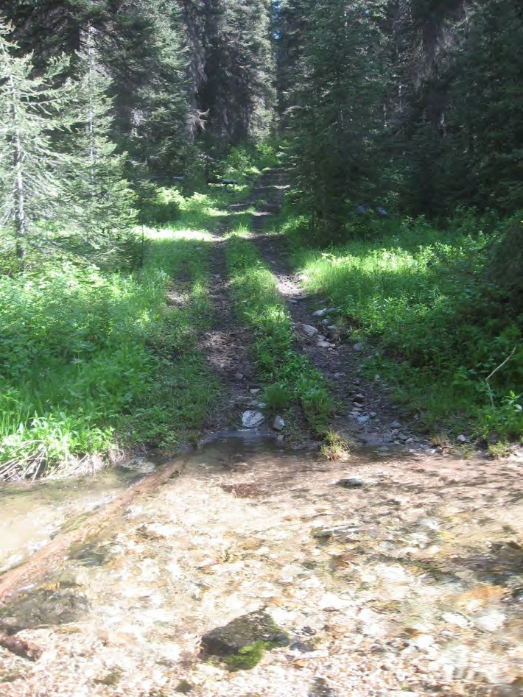
We headed to Moose Creek Estates and at the entry, Karin Drnjevic, Lemhi County WUI Coordinator presented MCE’s John Goodman with the subdivision’s Firewise designation plaque.

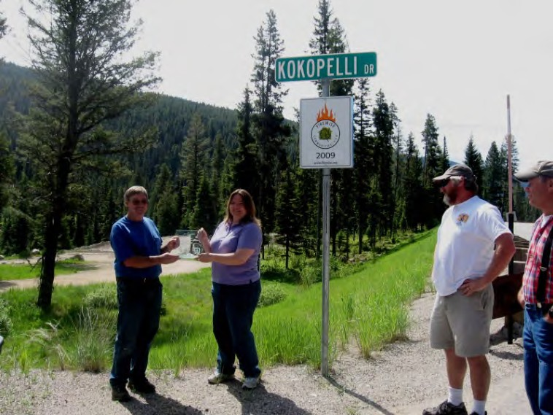

We went into the MCE subdivision and traveled to the southernmost area where private access could lead to an entry point. Ponderosa were rare, but impressive.
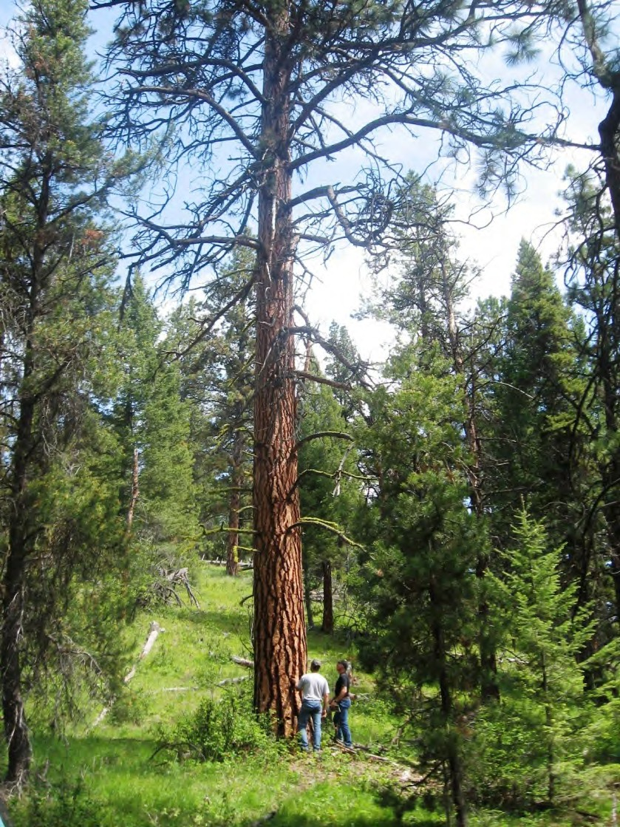

We enjoyed lunch on the deck of MCE owners Bob and Beth Wilson’s house.

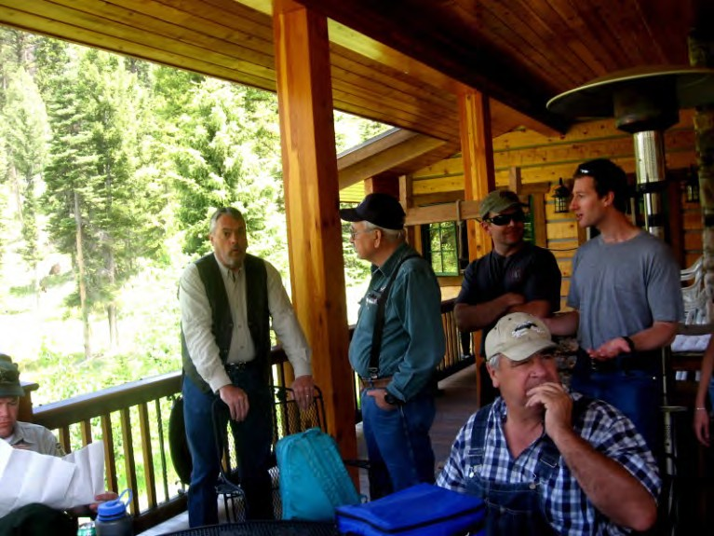

We split into 2 groups. One headed up the mountain directly behind the Wilson’s home (to the northeast). Group 1 immediately saw dense, snarly stands of lodgepole and douglas fir.
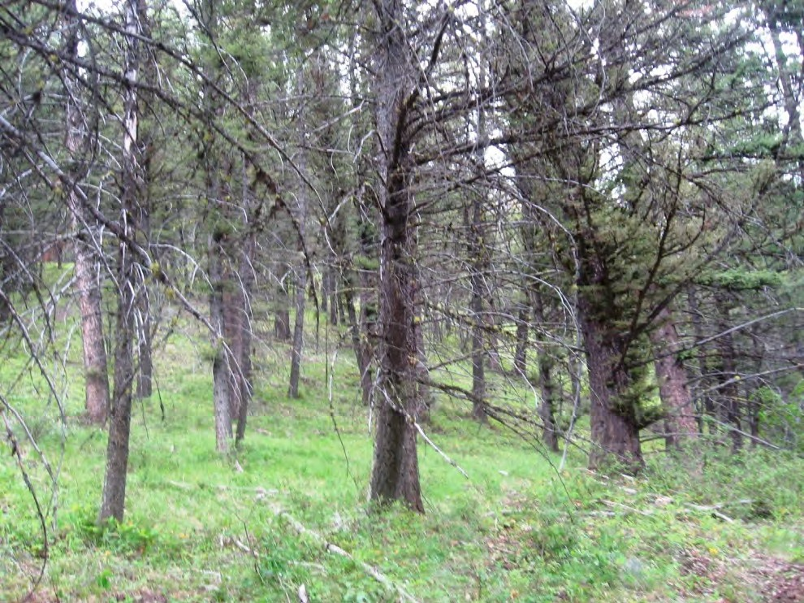

As Group 1 gained elevation, the stands became more open, as shown below.

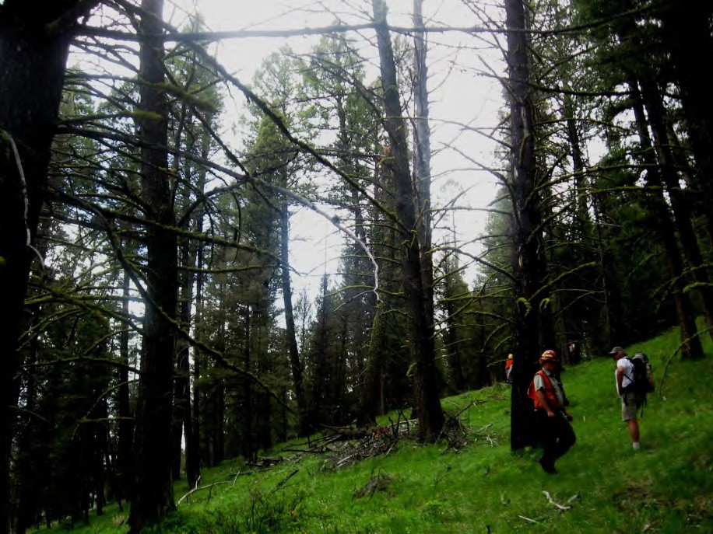

The lodgepole and doug fir had been hit hard by beetle and ponderosa continued to be seen infrequently, often as individual trees.

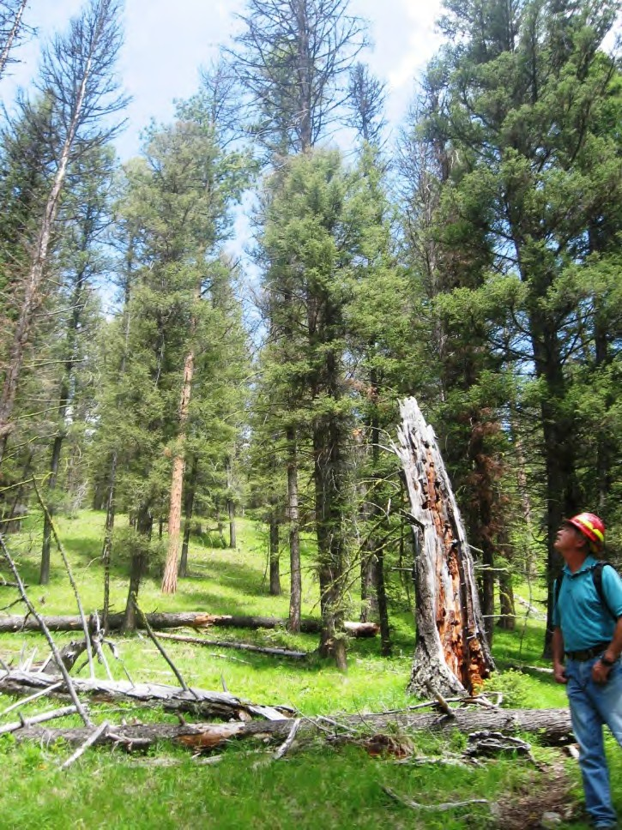

Group 1 discussed the possibility of treating lower area adjacent to the subdivision and using Rx fire for the more open mid-elevation slopes.

Group 2

This area was behind (east) the lower portion of Moose Creek estates. Ponderosa pine was present throughout the area with many age classes represented. Douglas fir prevalent creating ladder fuels. Old age class for both trees (30 dbh +). Fire scars and heavy fuel loading in drainage areas. The group consensus was that this area could be thinned to promote a healthy ponderosa stand and reduce fuel loading above private property. One aspen stand (.10 acres) was encountered with old decadent trees, shading by doug fir and no regeneration present.

June 30 Meeting
Sacajawea Learning Center
9 a.m. – 3 p.m.

Participants: xxx

Observations from June 29, 2010 Anderson Mountain Roadless Field Trip
- Narrow corridor off private land east of Moose Creek Estates presents treatment opportunity

- Want to schedule another field trip from top or Anderson Mountain Road
- Need to consider potential human-caused fire starts from Hwy 93
- Restoration activities for wildlife focused on migration corridors, cover, feed
o Lots of elk sign above Moose Ck Estates
- Restoration activities should favor white bark, aspen, ponderosa wherever
possible (programmatic assessment for these species would be a good tool for the FS)
- How do we/should we take climate change into consideration?
- Roadless issue needs to consider cost & feasibility of temp roads vs. no-road alternatives

What motivates us?
- Economics –
o Our jobs depend upon this work (job retention)
o Restoration jobs (job creation)
- Collaboration with others is rewarding
- Public/private entities working together
- Public relations opportunities
o Highway 93 is highly visible, good chance to interpret restoration work
o Town meetings – Gibbonsville Improvement Assoc. was a good start and generated good discussion and interest
- Large landscape effort, overall forest health
- Recreation opportunities
- Wildlife and fish enhancements
- NEPA can be streamlined, more efficient w/ collaborative input

Who else needs to be here?
- Montana agencies on the other side of Divide (Beaverhead/Deer Lodge)
- Idaho Dept of Transportation
- Lost Trail Ski Area
-
What else do we need to know?
- Better understanding of roadless rules (our group has a wide disparity between those who know a lot about this and those who haven’t participated in those discussions)
- Old growth surveys are completed, so we need to get data interpreted and out
- Lost Trail Ski Area
- Let’s create a good map with Designated Old Growth units and priority restoration areas (aspen, white bark, meadow openings, stream work, etc)

Next steps?
- We looked at the Hughes Creek Recommendation Memo
o Group agreed it was a good template

o Gina will post the Hughes Ck Memo on the Google Group site and will also start a draft that applies to Upper North Fork
o The group will then review and start thinking about the more detailed parts of the Upper North Fork memo
- Jake will get with roadless subcommittee and come up with a date for the next field trip to include another look at Lost Trail and the area on and below the Anderson Mountain Road.

Lemhi County Forest Restoration Group
Field Trip
Upper North Fork Anderson Mtn Roadless Area
August 3, 2010
8:30 a.m. – 4: 30 p.m.
DRAFT Summary

Participants: Bill McLaughlin, Russ Bacon, Jake Kreilick, Gina Knudson, John Goodman, Bob Cope, Paul Werner, Doug Wasileski, Jim Roscoe, Cindy Haggas, Laura Wolf, Lyle Powers, John Robison, Mike England (Affiliations attached)

Moose Creek Estates Pre-Field Trip Briefing

Project Background
The Upper North Fork project area encompasses the Hwy 93 corridor from Hughes Creek north to Lost Trail Pass and goes from ridge to ridge (both sides border the Montana state line) with the exception of Anderson and Dahlonega creeks in the
eastern portion. The purpose of the project is to reduce hazardous fuels around Lost Trail Ski Area, Moose Creek Estates and along Hwy 93 and to complete forest restoration designed to enhance old growth, lynx and other wildlife habitat, whitebark pine and aspen. The purpose of the field trip was to assess the feasibility
of doing fuel reduction and forest restoration inside the Anderson Mountain
Roadless area including the possibility of building temporary roads.

Accessing Anderson Mountain Roadless Area from the Anderson Mtn Road

We followed Forest Service Road #81A to access the hike. From there we walked part way down a proposed temporary road (Road #3 on field trip map) through some mature lodgepole pine and Douglas Fir. We ended up just above where some of us walked during our June 29th field trip (north side of Camp Creek) from the bottom at Moose Creek Estates. June 29 observations were that we could accomplish fuel reduction via Rx burning in that portion of the roadless area.

Observations:
- Scattered whitebark pine (mostly younger seedlings/saplings)
- L ynx habitat improvement opportunity (need to create better forage for snowshoe hares by stimulating young trees and shrubs)
- Below the ridge to the east is a Designated Old Growth (DOG) unit that didn’t
appear to have much old growth characteristic.
- Non-IRA (Inventoried Roadless Area) piece of the project area directly north of the Anderson Mountain IRA that presents fuel reduction opportunities.

- A proposed road (Road #1 on field trip map) that comes off F.S. Road 81A to could access this part of the project area and there is also a possibility of constructing a road off Hwy 93. This proposal would need to be coordinated with the Idaho Dept. of Transportation.

After we walked back up to the ridge, we continued to traverse the ridge along proposed Road #2.

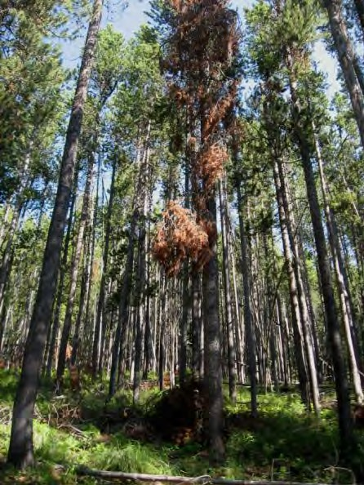
Observations:
- Some commercial opportunities
(sawlogs, post and poles), but lodgepole mortality (Mountain pine beetle).
Douglas Fir trees have been hit hard by
spruce budworm resulting in many defoliated trees. Commercial
opportunities will diminish significantly within the next couple of years.
- Desired future condition ecologically is to create a more diverse forest structure/composition with
mixed age classes. This could be accomplished through commercial and non-commercial thinning and/or RX burning.
- Several drier sites located on knobs or rocky outcroppings would likely have been more open stands (parklands) with natural fire frequency.
These openings could be restored.
- Many of the alder shrubs were in poor condition.
- Treatment options discussed included thinning from below focusing on removing lodgepole pine (striving for a basal area of 80-100), burning some
of the thick lodgepole stands to promote regeneration and non-commercial treatments (slashing, hand-piling and burning).

Discussions:
- What does Idaho’s Roadless Rule allow in terms of temporary roads? There was general agreement that temporary roads in IRA’s are allowed for the purpose of community fuel reduction (Community Protection Zones), but John and Jake both expressed that some environmental groups may question how this would be interpreted in the case of the Anderson Mountain
Roadless Area/Upper North Fork Project. The sentiment expressed was that this project is going to be closely scrutinized on both a state and a national level and may be challenged by various regional and national groups depending on the location and extent of temporary roads. Cope said that the
spirit of the Idaho rule was if the fuel reduction or restoration could be done

without a road fine, but if not, temporary roads could be used as a tool to get to the desired outcome.
- Much of the Anderson Mountain Roadless Area falls within the Lemhi County
CWPP (Community Wildfire Protection Plan), but roadless area proponents may not have the same information our group has about fire history and fire behavior near the Moose Creek/Gibbonsville areas. John R. asked the group to evaluate what fuel reduction and forest restoration could be completed without roads for the sake of comparison.

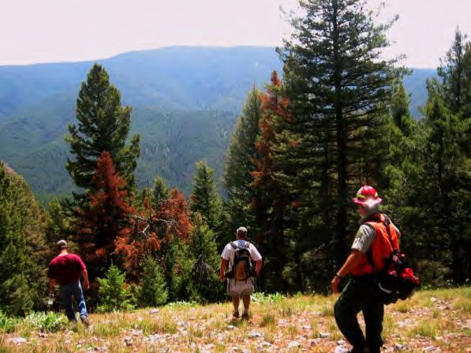
After lunch, we continued down proposed Road #2 until we came to another DOG that came off the ridge and descended towards Pierce Cr. This DOG did contain older Douglas fir as well as various age classes of lodgepole pine – many of which were dead or
dying.

the contour line back to the north.
We came to the point where Road #2 would switchback and follow

Discussion points:
- Feasibility of doing work in the mid-slope area
- Relative cost/benefits of temporary roads vs treatment options w/out roads
- Tradeoffs associated w/ more intensive fuel reduction treatments designed to alter fire behavior vs less intensive treatments emphasizing forest
restoration opportunities.

Moving through the more southerly aspects of the IRA and we started transitioning from Lodgepole/Doug fir/Subalpine fir into Ponderosa pine/Doug fir community. We walked through beautiful old growth ponderosa pine and Douglas fir stands experiencing encroachment. We reached the flag line for proposed temp road 2A (approximately ¼ to ½ mile from the Moose Creek Estates). The southern end also contains a portion of non-IRA land where road construction wouldn’t be as controversial and where there are numerous opportunities to enhance old growth Ponderosa pine and Douglas fir stands.

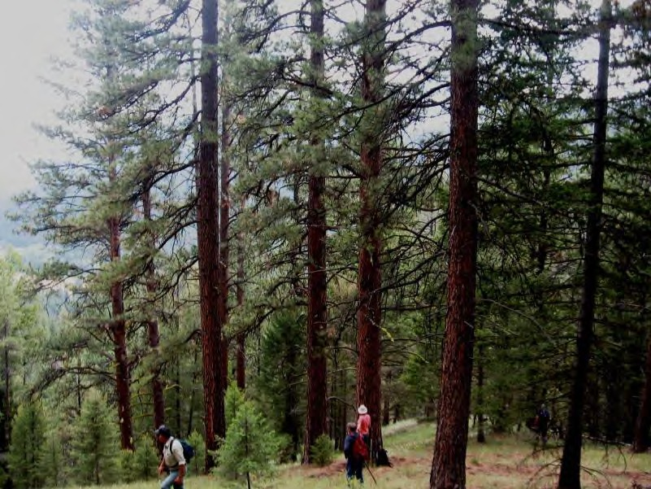

Reaching Moose Creek Estates at the bottom, we debriefed agreed that three options are available:
1) Full implementation of temporary roads 1, 2, 2A & 3 within the Anderson
Mountain Roadless Area.
2) Coming in from the lower end of Moose Creek Estates and following the proposed road (in red on the field trip map) through the non-IRA portion and into the IRA along a contour located about ½ mile above private land. Fuel reduction treatments would be concentrated between this temporary road and the Moose Creek Estates boundary as far north as Camp Creek.
3) Option 2- Plus. Second option would be incorporated along with fuel reduction and restoration treatments on top that could be accomplished without temporary roads.

Next Steps: Roadless subcommittee will schedule a conference call next week w/ intent of considering options and make some draft recommendations that we can present at our next full collaborative meeting in early September.
Early September mtg objective is to spend 1/2 day in the field looking at treatment areas around Lost Trail Ski Area and the rest of the day considering and hopefully forwarding our roadless recommendations to the FS and the Idaho Roadless Comm.

Recap of Anderson Mountain Roadless Field Trip-Upper North Fork Project : August 3rd, 2010

(Participants: Mike England-North Fork Fire Dept., Jake Kreilick-WildWest Institute, John Robison- Idaho Conservation League, John Goodman-Moose Creek Estates, Paul Werner-North Fork resident, Laura Wolf-Idaho Fish &Game, Cindy Haggas-Forest Service biologist, Doug Wasileski-Pyramid Mountain Lumber, Jim Roscoe-American Wildlands, Bill Mclaughin-Salmon Valley Stewardship, Gina Knudsen-Salmon Valley Stewardship, Russ Bacon-Forest Service, Lyle Powers-Forest Service, Robert Cope-Lemhi County Commissioner

On August 3rd, members of the Lemhi County Forest Restoration Group (LCFRG) participated in a field trip to the Anderson Mountain Roadless Area. The field trip was organized by the Roadless Area Subcommittee that was established by the LCFRG to assist in the design of the Upper North Fork project. Located below Lost Trail and Chief Joseph passes on the North Fork district of the Salmon-Challis
National Forest, this roadless area is adjacent to the Moose Creek Estates – a private development on
Hwy 93 – and is a key wildlife corridor between Montana and Idaho.

The Upper North Fork project area encompasses the Hwy 93 corridor from Hughes Creek north to Lost Trail Pass and goes from ridge to ridge (both sides border the Montana state line) with the exception of Anderson and Dahlonega creeks in the eastern portion. The purpose of the project is to reduce hazardous fuels around Lost Trail Ski Area, Moose Creek Estates and along Hwy 93 and to complete forest restoration designed to enhance old growth, lynx habitat, whitebark pine and aspen.

The purpose of the field trip was to assess the feasibility of doing fuel reduction and forest restoration inside the Anderson Mountain Roadless area including the possibility of building temporary roads. After meeting at the Moose Creek Estates, we carpooled up Lost Trail Pass and rendezvoused with Jim R. and Doug W. From there we drove up Chief Joseph Pass to Forest Service Rd. 81A that took us to the northern boundary of the roadless area. We left our vehicles there and side-hilled over to the ridge.

From there we walked part way down a proposed temporary road (Road #3 on our field trip map) through some mature lodgepole pine and Douglas Fir. We ended up just above where some of us walked during our June 29th field trip (north side of Camp Creek) from the bottom at Moose Creek Estates. We concluded from that field trip that we could accomplish our fuel reduction objectives through prescribed burning in that portion of the roadless area. We did find some scattered whitebark pine (mostly younger seedlings/saplings) towards the top of the ridge, but the bigger opportunity we identified was lynx habitat improvements (need to create better forage for snowshoe hares by stimulating young trees and shrubs). Below the ridge to the east is a Designated Old Growth (DOG) unit that didn’t appear to be old growth though we only saw the edge of it.

It should be noted that there is a non-IRA (Inventoried Roadless Area) piece of the project area directly north of the Anderson Mountain roadless area that we identified as a good place to do fuel reduction. There is a proposed road (Road #1 on your field trip map) that comes off of F.S. Road 81A to access this part of the project area and there is also a possibility of constructing a road off of Hwy 93 at the hairpin turn though this will need approval from the Idaho Dept. of Transportation.

After we walked back up to the ridge, we continued to traverse the ridge along proposed Road #2. We observed that there were some commercial opportunities (sawlogs, post and poles), but many lodgepole are dying from Mountain pine beetle. Douglas Fir trees have been hit hard by spruce budworm resulting in many defoliated trees. Commercial opportunities will diminish significantly within the next couple of years. From an ecological perspective, the desired future effect is to create a more diverse forest structure/composition with mixed age classes. This could be accomplished through commercial and non-commercial thinning, prescribed burning and/or a combination of these.

The group did identify several drier sites located on knobs or rocky outcroppings that fire would have maintained in more open stands (parklands) and that could be treated to create such conditions. We also observed that many of the alder shrubs were in poor shape. Treatment options discussed included thinning from below focusing on removing lodgepole pine (striving for a basal area of 80-100), burning some of the thick lodgepole stands to promote regeneration and non-commercial treatments (slashing, hand-piling and burning).

Throughout the field trip, there were a lot of comments and questions pertaining to what the state of Idaho’s Roadless Rule allows in terms of temporary roads. There was general agreement that temporary roads in IRA’s are allowed for the purpose of community fuel reduction(Community Protection Zones), but John and Jake both expressed that some environmental groups may question how this would be interpreted in the case of the Anderson Mountain Roadless Area/Upper North Fork Project. The sentiment expressed was that this project is going to be closely scrutinized on both a state and a
national level and may be challenged by various regional and national groups depending on the location and extent of temporary roads. Cope said that the spirit of the Idaho rule was if the fuel reduction or restoration could be done without a road fine, but it does allow for exceptions such as dealing with municipal watersheds.

While a good chunk of the Anderson Mountain Roadless Area falls within the Lemhi County’s CWPP (Community Wildfire Protection Plan), how roadless area proponents will gauge both the significance and the risk to the Moose Creek Estates from wildfire is unknown. We can anticipate that they will have questions and that they may appeal or litigate. John R. asked the group to try to evaluate what fuel reduction and forest restoration could be completed without roads for comparative sake.

After we had lunch, we continued down proposed Road #2 until we came to another DOG that also came off the ridge and descended towards Pierce Cr. This DOG did contain older Douglas fir as well as various age classes of Lodgepole pine – many of which were dead or dying. After looking at this, we walked a bit further until we came to the point where Road #2 would switchback and follow the contour line back to the north. We head another group discussion here about the feasibility of doing work in the mid-slope with varying opinions expressed relative to costs/merits of temporary roads, treatment options w/out roads and the tradeoffs associated with more intensive fuel reduction treatments designed to alter fire behavior versus less intensive treatments emphasizing various forest restoration opportunities.

Following this discussion, the group dropped off the ridge and made our way down through the more southerly aspects of the roadless area and we gradually transitioned from Lodgepole/Doug fir/Subalpine fir into a Ponderosa pine/Doug fir community. We walked through some beautiful old growth ponderosa pine and Douglas fir stands in need of thinning. We eventually reached the flag line for proposed temporary road 2A (approximately ¼ to ½ mile from the Moose Creek Estates). Like on the northern
end, the southern end also contains a portion of non-IRA land where road construction wouldn’t be as
controversial and where there are numerous opportunities to enhance old growth Ponderosa pine and
Douglas fir stands.

After we got to the bottom, we debriefed and went around the circle so that each participant could convey their observations and offer some recommendations. While it would take too long to summarize everyone’s impressions/views, I can say that we have many areas of agreement, a few sticky issues (namely temporary roads) where we don’t have consensus and a continuing willingness to work
together on a collaborative basis to develop recommendations for the Upper North Fork Project. Russ concluded the go-round by articulating three options:

1) Full implementation of temporary roads 1, 2, 2A & 3 within the Anderson Mountain Roadless
Area.
2) Coming in from the lower end of Moose Creek Estates and following the proposed road (in red on the field trip map) through the non-IRA portion and into the IRA along a contour located about ½ mile above private land. Fuel reduction treatments would be concentrated between this temporary road and the Moose Creek Estates boundary as far north as Camp Creek.
3) This option would incorporate the second option along with fuel reduction and restoration
treatments on top that could be accomplished without the construction of temporary roads.

These three options will provide the roadless subcommittee with a good outline for our conference call next week. We hope to finalize some draft recommendations concerning the Anderson Mountain Roadless Area that we can present at our next full collaborative meeting in early September. Our intent is to spend half the day in the field looking at treatment areas around Lost Trail Ski Area and the rest of the day deliberating and hopefully approving these roadless recommendations.

Lemhi County Forest Restoration Group Meeting
Lost Trail Ski Lodge
September 24, 2010
9:00 a.m. – 2:30 p.m.

Meeting Summary

Participants:
Maggie Milligan, Bill McLaughlin, Russ Bacon, Jake Kreilick, Michelle Tucker, Mike Smith, Glenwood Brittain, Lynn Bennett, Bill Grasser, John Goodman, Laura Wolf, Cindy Haggas, Jim Roscoe, Jerry Hamilton, Bob Cope, Scott Grasser, Judy Grasser, Jan Spencer, Karin Drnjevic, Paul Werner, Dyrk Krueger, Alan E. Howell, Dale Kerkvliet, Ruth Wooding

UPPER NORTH FORK PROJECT

The group met to review the Recommendations for Consideration memo. When asked how much this recommendation memo helped the planning process Russ reported that it was very important especially in light of the upcoming Idaho Roadless Act (IRA) meeting here in Salmon. He reiterated that this project will be the first test of the rule.

The IRA group will be meeting here in Salmon on September 28 and 29. The IRA group is very interested in our collaborative according to Russ and Cope. Russ would like to have a copy of the DRAFT memo (at its current level of completion) to give to the group. Tuesday’s meeting is at noon at the Sacajawea Center. Wednesday will be a field trip of the Upper North Fork Project area. Russ encouraged the group to have good representation at these meetings. Group members will coordinate with Gina and Michelle to make certain we are covered.

After the first half of the draft had been reviewed, the group agreed that the approach to the Hughes Creek Memo didn’t necessarily fit the larger Upper North Fork Project. In order to refocus the scope of the collaborative’s recommendations Russ briefly reviewed what the SCNF will be looking at in their proposed action:

1) Commercially treat 5000 acres in areas that have been previously treated and have existing roads. (Helicopter – 600 acres, Skyline – 1400 acres, Tractor 2400 acres).
2) Moose Creek Community Protection Zone (CPZ) – a half mile buffer around the CPZ, five miles of fuel break would be implemented. Only 1.2 miles of this is in the IRA. Temporary roads will be considered for completing this treatment.
3) Prescribed burning will be implemented throughout the project area
4) Decommissioned Roads – 53 miles have been identified for potential decommissioning.
5) Culvert replacement Deep Creek and Hammerean Creek for fish passage.
6) Shaded Fuel Breaks – identified for Anderson Mountain, Moose/Pierce Creek and Lost Trail

Other Questions Still on the Table

The roadless subcommittee is still very interested in seeing other portions of the project area that we have not been to yet. A meeting was set for Saturday, October 2, at 9am. The group will meet at Lost Trail to visit these sites. The SCNF will make certain that they have staff present to help with the tour.

Upon review of the purpose and need statement it was asked if the group should be addressing climate change more. Left open for consideration.

Next Steps
- Michelle will send a completed draft to the group for review by Monday the 27th.
- The roadless subcommittee and any other interested parties will visit the other roadless portion of the project and report back to the group with their findings.

FINAL

Recommendations for Consideration in Preparing the UPPER NORTH FORK FOREST RESTORATION PROJECT Salmon-Challis National Forest

October 24, 2010

This memo is intended to provide recommendations from the Lemhi County Forest Restoration Group (Collaborative) to the Salmon-Challis National Forest (SCNF) as they begin analysis and prepare a proposed action for the Upper North Fork Forest Restoration Project. Our collaborative group realizes that this is an iterative process, and that as the SCNF undergoes the National Environmental Protection Act (NEPA) process, and develops options for activities and treatments, the group will have additional opportunities to further contribute to the project.

The Lemhi County Forest Restoration Group has reached consensus on the following for the Upper North
Fork Forest Restoration project:

Purpose and Need

Purpose: The primary purpose for the Upper North Fork Forest Restoration project is to reduce hazardous fuels, restore plant communities, and improve habitat diversity for fish and wildlife.

Need: Existing forest stand structure and forest vegetation have created the potential for large-scale, high- intensity wildfires that threaten human life, property, and natural resources. Quaking aspen stands provide substantial habitat value for wildlife and contribute to landscape habitat diversity. However, many historic aspen stands in Central Idaho have been lost, and many others are either regenerating poorly or are otherwise in decline. Likewise, whitebark pine is being considered as the first tree species in the Northwest to be listed as endangered because of a lethal combination of blister rust and mountain pine beetle. Historic logging practices and fire suppression have contributed to a decline in ponderosa pine, known to be more fire resilient. In essence, the rich biodiversity in the project area is at risk.

Project Objectives

The group understands that the proposed project will be shaped largely by availability of appropriated funds and revenue generated by commercial activity. With such considerations in mind, the group has identified the following project objectives:

▪ Create a resilient forest and vegetative structure (fuel profile) immediately around private property, travel routes and other community values that will not sustain crown fire or flame lengths greater than those that can be suppressed by hand crews. Establish strategic fuel breaks and safe areas for communities and values at risk and improve firefighter safety.

▪ Modify fuel loads and forest conditions to restore ecological integrity and function, especially in regard to natural fire regimes.

▪ In the dry forest ecosystems, the desired future condition will be a more open forest structure/stand composition, dominated by large diameter ponderosa pine and to a lesser degree large diameter Douglas-fir. Understory vegetation will consist of mostly native herbaceous plants, including naturally regenerated shrubs and scattered ponderosa pine seedlings and saplings. This could be accomplished through commercial and non-commercial thinning and/or prescribed burning. Insect and disease impacts and trends should be considered when designing treatments.

▪ In the cold forest ecosystems, the desired future condition will be a more diverse forest structure/stand composition dominated by lodgepole pine. This ecosystem should be comprised of stands of different age classes, producing a diverse range of tree species, sizes and stocking densities. Whitebark pine should be one of the primary overstory trees in the higher elevations. This could be accomplished through commercial and non-commercial thinning and/or prescribed burning. Insect and disease impacts and trends should be considered when designing treatments.

▪ Existing roads will be used for access to treatment areas wherever feasible.

▪ In Inventoried Roadless Areas (IRAs), the collaborative recommends developing two alternatives for analysis:

1. Analyze the use of temporary roads within the community protection zone (CPZ) in order to achieve management objectives. This would include creating a strategic fuel break inside the Anderson Mountain IRA within approximately one half mile of private property by constructing a temporary road system.

2. Analyze all fuel reduction and forest restoration opportunities that could be accomplished without building temporary roads in IRAs.

▪ De-classify or de-commission roads where duplicate routes exist, the need for the route is no longer valid, no historic public access exists and/or resource damage or impairment is present.

▪ Initiate a landscape approach to scenery management that provides a framework for the orderly inventory, analysis, and management of visual and scenic values.

▪ Design appropriate restoration and preservation treatments for quaking aspen and whitebark pine stands, as well as high elevation meadows.

▪ Minimize vulnerability to uncharacteristic fire intensities in riparian and old growth areas and help restore natural ecological function to those areas. Treatment within old growth stands and aspen clones may be acceptable where such treatments will clearly maintain or enhance the natural function and characteristics of these communities.

▪ Assess and treat old growth stands if such treatments are warranted to move the stand toward a state that resembles old growth characteristics as described by Hamilton, (Hamilton, Ronald G. 1993. Characteristics of old-growth forests in the Intermountain Region, USDA, USFS).

▪ Contain existing invasive species occurrence and incorporate the four key elements of invasive species management in project planning and implementation (prevention, early detection and response, control existing infestations and reestablishment of desired plant communities).

▪ Ensure that vegetation treatments retain sufficient habitat connectivity to support wildlife security, local movement and regional migration patterns.

▪ Enhance recreational settings, and improve travel routes and interpretive opportunities for recreation.

▪ Indentify and implement interpretive and educational opportunities within the project highlighting forest restoration and health.

Standards and Methods

Standards: The Lemhi County Forest Restoration Group believes that the following basic principles should apply to every collaborative project including the Upper North Fork Project:

1. Monitoring and documentation of project results
a. Tell the story so successes can be replicated, mistakes avoided

b. Specifically highlight wildlife, tree and plant habitat enhancements
c. Establish independent, multiparty monitoring within the project area

2. Economic development
a. Identify opportunities for material utilization
b. Encourage local economic development through utilization and restoration jobs c. Use stewardship contracting and agreements, and best value contracting tools
Methods: The Lemhi County Forest Restoration Group endorses an emphasis on long term prescriptive treatments that will maintain desired conditions and allow for sustainable forest health. The following methods are important tools to achieve and maintain the desired results for the Upper North Fork Project:

▪ Mechanical thinning along major ingress/egress routes, such as Highway 93 North, in consideration of WUI
and the CPZ according to Lemhi County Community Wildfire Protection Plan.

▪ Commercial and non-commercial harvest in order to meet forest restoration and fuel reduction objectives.

▪ Prescribed burn treatments and implementation throughout the project area (approximately 41,000 acres)
understanding that maintenance of these treatments (multiple entries) may be necessary.

Areas of consensus for the Upper North Fork Project

▪ An “all lands” approach will be taken with regard to project objectives. Collaborative members agree to help coordinate activities and assist with fundraising for non-National Forest, as well as National Forest lands. The Lemhi County Forest Restoration Group agrees that this project should be submitted as part of a Collaborative Forest Landscape Restoration Program project.

▪ No commercial harvest will occur in designated old growth areas.

▪ Permanent road construction could be acceptable along the proposed shaded fuel break above Lost Trail Ski Area to achieve project objectives. This corridor was constructed originally during the 2000 fires. If maintained, it would provide for a strategic fuel break for wildland fire as well as a safety route for fire fighters. It would also enhance scenic and recreational values while providing access for restoration treatments. The environmental analysis should also include an alternative without permanent road construction for comparison.

▪ Temporary road construction is acceptable if it provides the only means to achieve desired project results.

▪ Any commercial harvest in Riparian Habitat Conservation Areas (RHCAs) would be tied to aspen regeneration objectives or other vital habitat improvements.

▪ Commercial harvest may be acceptable in portions of IRAs in order to meet specific fuel reduction objectives that cannot be accomplished otherwise.

▪ Treatments along transportation corridors and other community assets (e.g. private property and special use areas such as Lost Trail Ski Area) will be designed to meet community protection needs as the highest priority and forest restoration objectives when feasible.

▪ The SCNF will analyze potential environmental effects using the National Environmental Policy Act (NEPA) process and applicable sections of the Healthy Forest Restoration Act (HFRA). The SCNF will coordinate planning and treatment activities with adjacent land management agencies and private land owners whenever possible.

We appreciate the opportunity to collaborate with the SCNF on this important project and look forward to continue working together as this project advances.

Lemhi County Forest Restoration Group Meeting Salmon Business and Innovation Center Wednesday, April 6, 2011
3:00-5:00 pm

Draft Meeting Summary

[Indicates ACTION items]

Participants:

Gina Knudson, Julie Hopkins, Bill Grasser, Mike Smith, Jerry Hamilton, Michelle Tucker, Bob Cope, John Goodman, Frank Guzman, Russ Bacon, Lynn Bennett, Ken Rodgers, Karin Djrnevic, [John Robison, Jake Kreilick called-in]

Member Updates – American Wildlands has shut its doors according to Jim Roscoe. Jim wants to stay active in our group, however. Gina mentioned she hopes we can find a way to keep Jim involved because he brought a valuable wildlife perspective to the Upper North Fork design.

RMEF Contract Status – Mike Smith – RMEF has bids and SCNF will review for the non- commercial units. RMEF will provide recommendation to USFS panel for selection. Panel will include Mike S., Maggie Milligan, Lemhi County and Economic Development. Gina expressed concern that Hughes Creek stewardship contracting committee recommendation to include collaborative on review panel were not being followed. SCNF officials invited collaborative to join review panel. Karin D. of Lemhi County WUI will fill that role.

Mike Smith (SCNF) will inform Karin of review panel meeting times/dates.

Commerical work will be bid later in the month. RMEF stewardship agreement is in place for
10- year period. Cope commented this would show guaranteed supply for fuels for schools project in the event bond passes this spring, even with the amount only coming from Hughes Ck.

Gina asked for a joint press release when bid is awarded. Agreed.

Hughes Placer Mining Proposal -- Julie Hopkins reported on the current proposal for placer mining on Hughes Creek. Test pits would be excavated upstream from Cerise stream restoration project, directly across from Humbug Road. One tagged steelhead recorded above ford. Four narrow trenches (2 feet wide) between Klop and Gallagher gulch (to bed rock or 10 feet). One trench open at a time; 30 gal/min siphoned from creek while washing. USFWS and NMFS have met w/SCNF on site. Individual from Montana recently purchased claim. John R. asked about the draft EA. Julie anticipates will be complete in two weeks. Comments due by May 2. ICL is
tracking this project closely. John indicates that he is less comfortable with comment period prior to all specialist reports being completed. Draft BA is anticipated to have concurrence.

HC Spring Burns-- Spring burning will begin in Burn Unit 4, Old Growth 1-8. Tree well burning in the next couple weeks. Dan Bill of Salmon-Challis will be fire lead.

Upper North Fork Project: Ken Rodgers, IDT team lead, provided draft maps showing treatment methods and options. Wildlife winter range requirements in treatment areas and especially those next to private land/WUI require extra consideration and more complex mixture of prescriptions. In some cases, primary objective of fuel reduction contradicts thermal and cover goals. Rx fire will be considered in most of the area. Russ can’t give dates on NOI. Gina asked about priority
of project. Russ stated getting Hughes Ck contracts implemented has higher priority.

Idaho Forest Restoration Partnership - John G. and Michelle gave a brief report on the workshop they attended in Jan 2011 in Boise. IFRP is intended to provide support and information to collaboratives throughout the state. John R. gave background on IFRG: Society of American Foresters, The Nature Conservancy, and Idaho Conservation League seminar
prompted groups to consolidate information and support collaboratives in Idaho. John G. was surprised by the # of groups active in Idaho, and level of organization.

Memorandum of Understanding

One of the take-home concepts from the IFRP conference was the need for a formal MOU with the Salmon-Challis. Gina explained that an MOU would clearly define roles and assist in understanding how we plan to do business. This could clarify open meeting rules and Federal Advisory Committee Act rules. Cope recommended identifying geographic region of work at Lemhi County. Jerry likes that the MOU offers opportunity to establish our group’s standards and goals as well as mutual goals. All agreed that we have accomplished a lot under good faith and the MOU would only help sustain this relationship. Discussion that better communication is needed with the SCNF regarding contact person protocol, timeframes for communication and action, etc. MOU would assist in transitions of personnel.

Michelle and John G. will work w/ Gina to revamp the Clearwater Collaborative MOU (attached) for group consideration. Russ recommends that the MOU should includes the formal communication process for our projects. Mike would like to see info on subcommittee outlined. Russ recommends having a dynamic contact document with specific roles, projects, responsibilities by name as an attachment because the formal MOU is cumbersome to change.

Draft will be sent out for collaborative review by April 20.

Maintaining momentum of collaborative: John G. would like to see the group stay active on projects rather than waiting for FS action. Russ warned the group that expectations for USFS should not be increased, due to funding and ongoing project commitments; pace is going to slow down. Gina said collaborative can be involved in Upper North Fork scoping meetings, getting members of the public involved and sharing experience about project design process. Frank said the Salmon-Challis Weed EIS is starting again. Collaborative may be able to work with SCNF. Gina stated that weeds have been a major subject of concern for collaborative so should be a good fit. She said one of SVS’ board members Dave Ellis has been attending meetings of the newly formed Central Idaho Grazing Network, and the collaborative’s growing experience with multiparty monitoring might be useful to the network. She also mentioned that John Goodman has been taking the initiative on getting beetle deterrents into the hands of private land owners, and other collaborative members may want to assist with that effort.

The meeting adjourned at 4:50 pm.

Lemhi County Forest Restoration Group Meeting
Salmon-Challis National Forest Headquarters Conference Room
Tuesday, February 7, 2012
3:00-5:00 pm

Meeting Summary

Participants:

Gina Knudson, Jerry Hamilton, Michelle Tucker, Hadley Roberts, John Goodman, Beth Waterbury, Jim Roscoe, Daniel Bertram, John Jakovac, Tammy Stringham, Gary Foli, Jim Tucker, Bruce Smith, Eric Pfeiffer, Jay Winfield, Jan Spencer, Kim Nelson, Larry Vogel, Cammie Sayer, Maggie Milligan, David Deschaine, Dan Garcia, Cindy Haggas, Frank Guzman, Rob Hoelscher, Ken Rodgers, Mike Smith, [John Robison, Bob Cope, Jake Kreilick teleconference]

Member Introductions

Member Updates

Idaho Forest Restoration Partnership (IFRP) Workshop and Biomass Conference – Maggie, John G. and Michelle attended in Boise. The morning session was informative concerning cold/moist forest restoration. Afternoon was more centered on the wesern Idaho forests and IFRP. John G, Tammy S. & Eric P. attended the next day’s biomass conference. John felt it was a good review of what is happening around the world. Eric felt it was important to focus on collaboration.

An Oregon company Wisewood will be in Salmon this week to consider a biomass feasiblility study for a PreK-8 school Thursday at 1 p.m. at the Salmon Valley Business Innovation Center board room. This company was referred to our community by Angela Farr, Region 1 & 4 State and Private Forestry contact.

Rural Voices for Conservation Coalition Annual Policy Meeting. Gina and Michelle will be attending the RVCC Annual Policy Meeting March 6 - 8 in Vancouver, Washington.

Hughes Creek Project

Rocky Mtn. Elk Foundation (RMEF) Stewardship Agreement Status – Update on stewardship agreement and RMEF stepping out of the process nationwide. Tammy and others met with Senator Risch’s office which resulted with a language fix for BLM agreements that limits liability. USFS liability language still unresolved. RMEF has agreed to finish up 225k left in the existing agreement in Hughes Ck for this season. RMEF has entire bid package ready for spring. All work will be service/hazardous fuel treatment.

Socio Economic Report – 2010 is done and 2011 draft is underway. Data will be available and sent out. Ecological monitoring report for 2011 will be completed and distributed soon.

Upper North Fork Project

SCNF presented information about where they are at in the Environment Impact Statement process.
■ Entire project area has been divided into 15 large burn units.
■ Three Forest Plan Amendments are being considered:
1. Big Game Winter Range - Designated big game winter range is near forest plan threshold. Additional fuels treatments may lower the percent cover available. Two options a) Lower the threshold, b) re- assess boundary lines and adjust for current data that would serve to create a net increase in range.
2. Wildland fire for beneficial use – This would allow natural ignitions within a signed burn plan area to play natural role.

3. Modification of Riparian Habitat Conservation Area (RHCA) buffers – In units where roads are closer than the defined buffers, this would allow the unit boundary to follow the road. Would modify
13.5 total acres to allow commercial harvest acres up to the road boundary but within the RHCA
buffer. Sediment and harvest are site specific in each of the 8 units where this could occur.

Wildlife Update from Idaho Department of Fish and Game (IDFG) Beth Waterbury

Recent lynx siting on SCNF –- on Jan 26 IDFG responded to a call that a lynx had been caught in a foothold bobcat trap. Staff determined the animal was not injured by trap. The animal appeared to be a lynx (foot size, tip of tail features, ear tufts) approximately 20 lb. IDFG decided to immediately release animal to prevent injury. IDFG collected hair and scat and sent to Rocky Mtn Research Station for analysis to confirm species and gender. DNA may also be able to determine relatedness to other rocky mountain populations. The animal was found in Salmon-Cobalt Ranger District outside of Upper North Fork and Hughes Ck project areas.

IDFG is also working with SCNF on forest carnivore stations/trail cameras in UNF area to update population data. A fisher has been found in Hughes Ck and wolverine in a couple other sites.

Upper North Fork Questions from LCFRG

Commissioner Jakovac asked for clarification on what roads are being considered for closing: Most would be entrance treatment for approximately 200’. Majority are roads that were left open from previous harvest that were never closed once project was complete. David D. explained the different impacts roads could have on watershed and weeds. Much discussion ensued regarding the type of road closures and their impacts on weeds, wildlife and sediment.

Action item: SCNF will provide map of proposed closed roads with road numbers.

Beth stated she was concerned about the issue of big game winter range “thermal cover” as addressed in the proposed project. The concept of thermal cover was a long-standing management tenet untested by research. Studies conducted in 1991-1995 at the Starkey Experimental Forest in northeast Oregon found that thermal cover failed to provide energetic benefits to elk during winter. More appropriate habitat attributes to manage for are forage quality/quantity (due to their positive effect on nutrition and animal performance) and structural attributes of habitat that mediate energy expenditures (i.e., security cover from human disturbance, snow intercept). She felt security cover data should be reassessed in the analysis in relation to the value of forage quality/quantity and its importance to deer and elk herd productivity. IDFG could provide information: Cindy clarified that the forest plan site specific amendment would help address current situation.

Action item: IDFG will provide security cover data and recommendations.

Jake asked for clarification regarding the Big Game forest plan amendment: Ken explained two options 1) 25% w/
70% cover – allow for a drop below 25% cover. 2) Re-draw winter range line. Could include additional acres that would allow to stay above 25%. Cindy feels re-draw would allow for more flexibility and better ecological sense by including winter range that is not currently considered.

Bob R. asked about alternative 2 without temporary roads: Helicopter logging increased by 700 acres in these units. Gina asked about horse logging. Eric stated that slope makes it less feasible. Helicopter units analyzed now while not economically feasible will keep them from being excluded completely. The majority of this area is in Anderson Mtn area.

Cope asked for clarification on removal of Lick Creek from commercial treatments: Units were carried over from previous project that was never initiated. Change in treatment was a direct response to scoping comment and Forest Service groundtruthing of existing conditions. Not commercially viable.

Cope asked how much is a Healthy Forest Restoration Act (HFRA) project: Entire project is HFRA which only requires one alternative plus no action alternative. Scoping and collaborative’s recommendation memo indicated the need for an additional alternative.

Gina asked if confirmed lynx presence changed the analysis: Cindy said that SCNF is operating under Northern Rockies Lynx Management Plan of 2007. First project proposed in mapped lynx habitat since 2007. Adjacency to Bitterroot also requires coordination according to management plan.

Gina brought up proposed Bitterroot salvage project at Lost Trail. Does their project impact UNF and are they coordinating with SCNF? Maggie reported that one unit did overlap but does not conflict. Beth mentioned concerns for with lynx, wolverine, and boreal owls in the Bitterroot project. Most mitigation here would be satisified by timing of activities. Gina recommended Beth contact Bitterroot also.

John R. asked about whitebark pine and aspen restoration: Eric stated that prescribed fire is generally assumed to have positive effect. Individual stands would be favored for retention. Programmatic design features are incorporated into both alternatives to accommodate aspen wherever encountered ie) removal of conifer within stand and 100’ around stand. Both alternatives include these. Whitebark would favor retention and removal of competing species.

Jake asked if the treatments above and in Anderson Mountain roadless are warranted given they are in mixed conifer regime and potential lynx habitat: Eric reminded that one of the objectives for the project was to keep the highways safe particularly during larger fires. Cindy stated that the existing lodgepole stand conditions in these areas are mature and are not considered quality lynx habitat.

John R. asked that the analysis show how the project would promote lynx according to Squires guidelines.

Jake asked about meadow restoration and reported that it wasn’t being met favorably in MT: Cindy reported that the meadows targeted for treatment are on south facing slopes and historically would not have conifers. Suppression has resulted in reduction of these natural openings. Meadow treatments are intended to hold big game higher, longer and create forage areas. Eric stated that the meadow margins could be treated in order to create a mosaic of vegetation including herbaceous and shrub layers.

Gina asked how the No Action Alternative is designed: Mike S. stated he is using historical data and modeling to assess the potential for large fires. Particularly, Pierce Ck terrain is similar to the Saddle Fire from last year and he is using Frog Pond data from 2003.

Jan stated that she felt the rehabilitation component of the forest plan is a flexible tool to use regarding visual impacts.

Larry reported that he is supplying design criteria to protect recreation infrastructure, and the work Jan is doing on visual impacts is important along the Continental Divide Trail segment.

Cammie has inventoried 50 sites that will need protection during treatment, but no major obstacles, mostly mining resources and not prehistoric.

A subcommittee was formed to plan for next full collaborative meeting, to establish strategy to achieve consensus when more than one alternative is being analyzed. John G., Jake, Gina and John R. will work on this and report back.

Remote partners suggested that while the distance communication was good, they preferred to be here in person for next meeting which is slated for early April.

Other Business Memorandum of Understanding

The MOU is currently undergoing its second scrutiny by the Regional office. (Fire season sidelined the signing in
2011) Acting North Fork ranger Gary Foli is tasked with helping get this done and he expects to have done next week.

Funding Assistance from Titcomb Foundation

Titcomb foundation has granted SVS $3,500 which can be used to assist members who travel to meetings and tours.

Homework for Next Meeting (TBD Date and Time)

Maggie said the SCNF timeline is for the Draft EIS released this May. To prepare for the next collaborative meeting, All members should review scoping letters that have been distributed to the group.

Lemhi County Forest Restoration Group Upper North Fork Operations Subcommittee Conference Call Summary

Tuesday, Feb 27, 2012
4 p.m – 5 p.m

Participants: Gina Knudson (SVS), Bob Cope (Lemhi Co.), Bob Russell (SVS), John
Robison (Idaho Conservation League), Michelle Tucker (SVS)

Purpose of Call:
The subcommittee discussed how we were going to approach/prepare for the April 5
Upper North Fork Project meeting.

Key discussion items:

• Upper North Fork Project(UNFP) elements that may require new consensus or decision making strategy
• LCFRG Group Structure

LCFRG group structure and Wild West dissent:

• April 5 has been confirmed for our next full collaborative meeting - 9am-3pm.
• John R. drafted a green light, yellow light, red light approach to categorize areas of agreement and concern
Green light (proposals everyone supports) Thinning in dry site ponderosa pine Culvert replacements
Yellow light (potentially significant issues; we need to make sure we address concerns)
Timber harvest in IRA
Intensity of vegetation treatments (openings) Elk security
Core areas and corridors for critters
Road decommissioning (gates vs. full obliteration) Public access issues
Noxious weeds
Effectiveness of fuel reduction efforts on homes
Red light proposals (deal-breakers; have we really avoided these or is there a way to move these issues into the yellow-light arena)
Road construction in the IRA
Others?
• Cope prefers a thumbs up, thumbs down, thumbs sideway approach. The national roadless committee experience emphasized that all members won’t agree on every issue all the time – red light sounds like a veto

• John R. suggested the group should return to the purpose and need statement of the project.
• Cope suggested that the group needs to remember that the project is landscape level and community protection oriented.
• In addition to roadless issues, other items of interest will be wildlife and roads.
Would be nice if we could get an idea of how proposed treatments will actually change fire behavior.
• Gina wants to be able to give the SCNF a heads up on the type of information we are hoping to see at the April 5 meeting (example: what units on Anderson Mtn fall within ¼ mile of Moose Ck or other pvt property)
• Bob asked whether we were still endorsing our initial recommendation memo or whether we were re-opening all issues. Bob would like to start from the memo and move forward.
• John recommended drafting a letter before the April 5 meeting that highlights our memo consensus, points out any sensitive issues and makes recommendations on how to address these in the analysis.
• This draft letter would then be refined during the April 5th meeting, formally adopted/endorsed by each member of the group as we did with our first
Recommendation Memo and sent to the Forest Service for their consideration.
• John also recommended that the list of these sensitive issues could be forwarded to the Forest Service in advance of the April 5 meeting so Forest Service could be prepared to discuss them at the meeting.
• The group again discussed the need to adopt the example from Blue Mountain Forest Partners Operations Manual regarding decision-making. Bob recommending adopting a policy as soon as possible.

“If a time comes when the subgroup or full group is unable to reach consensus the following actions with be taken:
o Areas of agreement and disagreement will be clearly recorded in writing
o Majority and minority reports will be written to address the areas of disagreement. Each of these documents will include:
▪ The name of the lead author and names of all who agree with the report
▪ A description of their proposal and the rationale used to develop it
▪ What group members in the majority and minority anticipate doing if their proposal is chosen by the USFS (i.e. defend it in public), or not chosen (i.e. file an objection, appeal, litigate, etc).”

• The group discussed the value of having LCFRG members present their concerns on project elements that have emerged as issues either before, during or after our Feb 7 meeting.
o Roadless and especially temp road/commercial harvest concerns – Jake
o Suite of concerns specific to forest type (dry, wet) – John R
o Security cover treatment – Beth W and Jim R
o County’s conversation about road closures and decommissionings – Cope

• Recommendation memo from Oct 2010 can serve as starting point and bullet statements with analysis recommendations can be placed under appropriate items. This document will then accompany the cover letter referenced above.
• Gina said Maia Enzer of Sustainable Northwest has tentatively agreed to come to
Salmon for the meeting and assist with facilitation.

Recommendations:

• SVS will draft language amending group structure to include Blue Mtn language and circulate to entire group for confirmation. This will give group greater flexibility in April 5 meeting.
• SVS will circulate draft agenda that will include a) re-visit of purpose/need statement, b) group member presentations on specific topic areas, c) review of recommendation memo with more detail added to items of special interest, d) SCNF update, e) other agenda items??.
• The subcommittee will draft a letter to give to the SCNF and all members before the April 5 meeting to allow all parties to prepare, that revisits our recommendation memo and areas where clarification is needed/desired.
• The major issues in the draft letter will be forwarded to the Forest Service in advance of the April 5 meeting so the Forest Service can come prepared to discuss them
• The LCFRG will have a finalized letter to give to the SCNF as a result of the
April 5 meeting.

Lemhi County Forest Restoration Group Meeting Salmon Valley Business and Innovation Center Thurs, April 5, 2012
9:00 a.m.-3:00 pm

Meeting Summary

Participants:

Gina Knudson, Jerry Hamilton, Michelle Tucker, Hadley Roberts, John Goodman, Beth Waterbury, Jim Roscoe, Tammy Stringham, Gary Foli, Jim Tucker, Eric Pfeiffer, Frank Guzman, Mike Smith, Jake Kreilick, Russ Bacon, Dave Melton, Lynn Bennett, Stefani Melvin, Karen Dunlap, Julie Hopkins, Bob Russell, Mike England, Maia Enzer

Brief History of LCFRG and Amended Group Structure

Formed in 2006 w/ help of Sustainable Northwest and as a result of conversations regarding a proposed
Gibbonsville project between Commissioner Cope and Jake Kreilick. Stated mission was straightforward:

Enhance forest health and economic opportunities in Lemhi County through collaborative engagement of restoration projects and Wildland Urban Interface/community protection using stewardship contracting and other tools.

Salmon Valley Stewardship name gets confused with stewardship contracting, but in reality SVS is not the LCFRG. In August 2006, SVS accepted task of coordinating the group and being willing to raise funds for group activities. SVS has other programs of work and Gina estimates she spends 10 hrs/ wk on forest collaborative activities. Jake has taken a lead role on multiparty monitoring, and SVS has backed him up on that with the hire of Michelle Tucker and the use of interns and volunteers.

Recent change from our original group structure adopted in August 2006 to one that uses the Blue Mountain Forest Partners decision-making model in March 2012 reflects the group being willing to tackle more complex collaborative projects. Maia observed that the Blue Mountain group originally modeled their group structure on the Lemhi County model, so this is a good example of collaboratives learning from each other.

Upper North Fork Purpose & Need

The group reviewed and validated the purpose and need as it appeared in the August 2011 scoping letter from the
Salmon-Challis National Forest (SCNF):

Existing forest stand structure and forest vegetation have created the potential for largescale, high-intensity wildfires that threaten human life, property, and natural resources.Quaking aspen stands provide substantial habitat value for wildlife and contribute to landscape habitat diversity. However, many historic aspen stands in Central Idaho have been lost, and many others are either regenerating poorly or are otherwise in decline. Likewise, whitebark pine is the first tree species in the Northwest to be listed as a candidate for the threatened and endangered species list because of a lethal combination of blister rust and mountain pine beetle. Historic logging practices and fire suppression have contributed to a decline in ponderosa pine, known to be more fire resilient. In essence, the rich biodiversity in the project area is at risk. This area contains the State Highway 93 transportation corridor and scenic byway, private lands, residences and a winter recreation ski facility classified by Lemhi County as wildland urban interface (WUI).
The purpose is to reduce hazardous natural fuels, restore plant communities and improve fish and wildlife habitat diversity while returning resilient conditions to this fire adapted landscape. This proposal is necessary to compliment other existing, on-going and planned fuels treatments surrounding “at-risk” communities within the

North Fork drainage, and to address forest health conditions that are reaching crucial stages towards non- desired change.

Lemhi County developed its CWPP to include localized mapping and definition of WUI areas and designated the North Fork area as high priority for hazard reduction treatment. The identified need for reducing hazardous fuel conditions together with the County’s priority designation for this area are essential criteria allowing the use of authorities and expedited analysis under the HFRA. Private developments, such as Moose Creek Estates, have responded to these needs and have completed planning and hazard reduction treatments necessary to gain enrollment as a “Fire-Wise Community” in the State of Idaho.

Issue Expansion from Feb 7 LCFRG meeting

County Commissioners Clarification on Road Decommissioning

o Commissioner Cope couldn’t be present because he is in Boise for an Idaho Roadless Committee Meeting.
Commissioner John Jakovac had attended Feb 7 meeting and was concerned about decomissioning road activity proposed. They have since met with SCNF and have reiterated their approach to the travel plan management which is: road obliteration may be acceptable when there are two or three roads that connect points A and B. To eliminate all access to a drainage makes the provision of emergency services virtually impossible, and also restricts management options. The County has indicated a preference in road closure instances for gating and/or humping over recontouring. Where recontouring is selected, attention to noxious weeds should be given priority.

Forest Type Discussion

John Robison of Idaho Conservation League was scheduled to present about the current topic of forest restoration activities and how they might differ given different forest types, but John was unable to attend. Michelle said two presentations were given at the Jan 2012 Idaho Forest Partners workshop:

Mixed-Severity Fire Regime Forests of Idaho: Location, Ecology, Species, Influences (Russ Graham, USFS Rocky Mountain Research Station)

Fire Ecology and Risk Factors for Mixed Severity Forests of Idaho and How it is Different from Low Severity, Dry Forests and High Severity, Cold Forests (Penny Morgan, University of Idaho, College of Natural Resources)

Jake added that the Montana Forest Restoration Committee is also working on developing restoration principles that address various forest types. The MFRC says: Ecological restoration in mixed conifer/mixed severity fire regimes may be more complicated than in low to mid-elevation ponderosa pine, Douglas-fir, and western larch forests. At the same time, given the need for restoration, the ecological reality of human-caused, landscape-scale impacts, and the anticipated impacts arising from changes in climate, these complexities should not be avoided.

Hughes Ck. represents the low to mid-elevation ponderosa pine and Douglas fir forest type and Upper North Fork has elements of mixed conifer/mixed severity. Future learning as a collaborative would be a good idea.

Security Cover Treatment

Jim Roscoe and Beth Waterbury have been working on an appendix to our recommendation memo. Beth gave a
PowerPoint presentation and made some of the following points:

• Cover moderates weather, provides security from predators and humans
• Thermal cover does not provide survival or reproductive benefits to elk/deer
• Forest management guidelines developed from Starkey Experimental Forest:

Satisfactory cover Conifers >40 ft with >70% crown closure Marginal cover Conifers >10 ft with >40% crown closure Hiding cover Hides 90% of an adult elk standing <200 feet Forage areas Non-satisfactory or marginal cover areas Cover to forage ratio 40:60
Cover patches 30-60 acres minimum

Road density 2
Miles of road per section (mile )

• If road density reaches 6 miles per section, habitat effectiveness is 100% compromised
• Among national forests, SCNF has comparatively low road densities.
• Where sub-standard cover conditions exist, design techniques could be employed such as:
o Select and reserve densest patches of live trees 1-5 acres in size with 5-10 patches per treatment unit
o Include areas of abundant large woody debris and/or dense shrub understory
o Include adjoining small wet meadows, springs, seeps where available
o Configure patches to link with riparian areas, old growth stands or other features that
attract wildlife

Mike Smith and Eric Pfeifer expressed some concern that where hazardous fuels objectives are being pursued, some of the design techniques might limit effectiveness of treatments.

Beth and Jim are going to update the Security Cover appendix and we will distribute with final changes to memo for sign-on.

Fisher Study

Beth also presented information from a fisher study conducted in North-Central Idaho (Landscape Level Habitat Selection by Fishers in North-Central Idaho [Joel Sauder, Id Dept of Fish and Game; Janet Rachlow, Dept. of Fish and Wildlife Studies, University of Idaho].
• Fisher have large home ranges: males about 40 km2 and females about 15 km2
• They are carnivores that feed on porcupines, snowshoe hares, grouse, tree squirrels, small mammals
• Fisher in our area are considered as part of the Northern Rockies population, the least studied population
• Habitat type is generally associated with:
o complex vertical structure
o mature forest
o high canopy cover
o abundant prey

- Key study findings:
o For microhabitat (rest sites, den sites, foraging locations), positive associations included:
▪ Tree dbh
▪ Density of cavities
▪ Large Coarse Woody Debris (CWD)
▪ Prey densities
▪ Canopy cover
▪ Frequency for tree brooms
o The study did not find negative associations for microhabitat
o For Intra-Home Range Selection, positive associations included:
▪ Specific Forest Type
▪ Coniferous Cover
▪ Deciduous Cover
▪ Shrub Cover
▪ CWD
▪ Tree DBH

o For Intra-Home Range Selection, negative associations included open space
o For landscape selection, positive associations included:
▪ Habitat type
▪ Canopy Closure
▪ Diverse forest ages

o For landscape Selection, negative associations included % open area
o 5% increase in open area reduces probability of occupation by 38%
o With ≥25% open area, probability of occupation by fisher essentially zero.
- Conclusions:
o At the landscape level, fishers select home ranges that:
▪ Minimize the amount of non-forested habitat
▪ Maximize large patches of mature forest that are closely arranged.
o Management actions that influence these landscape characteristics can strongly affect occupancy of fisher at the landscape level
o

Roadless area; temporary road/commercial harvest considerations

Jake explained that the Anderson Mountain Roadless Area presents some challenges for WildWest and for others in the environmental community. Protecting roadless areas has been paramount for WildWest since its inception, but they’ve recently engaged in restoration treatments in roadless area on the Lolo. He said the treatments proposed for the Allan Mountain and West Big Hole Inventoried Roadless Areas (IRAs) are not problematic, especially given the Forest Service’s modification of work proposed in Lick Creek.

Jake said he is proposing 3 approaches to Anderson Mountain with the mindset of what treatment options would best protect roadless characteristics while at the same time benefit WUI concerns. Topography and mixed forest type (split between lower areas and higher elevation forests) were considerations for the following approaches:

• Commercial Treatment w/ Temporary Roads

• Commercial Treatment w/o Temporary Roads
• Non-commercial Treatment w/o Temporary Roads

Jake hopes to see commercial, or mechanical, treatments evaluated based on cost effectiveness (notably the cost of putting in and reclaiming temp road) and how effective the proposed treatments are in terms of modifying forest structure (opening up canopy) without changing character of roadless. He broke the area into 4 different zones:

• From Moose Creek Estates boundary to toe of slope – mechanical thinning up to 18” DBH
• ¼ mile – ½ mile, mix based on feasibility that could include mechanical
• ½ mile – ¾ mile, hand thinning and piling
• ¾ mile – 1 ½ mile, prescribed burning

Visuals are important, so effects of logging should not be visible.
Upper end is more focused on forest restoration than hazardous fuels so he wants that clearly delineated in EIS. John Goodman said property owners are concerned about a fire coming from top down; they feel more
comfortable about ability to halt fire if it starts down low. Property owners are concerned about property values.

Jake said not all of the groups who will be commenting on Upper North Fork have community interests at heart. Some groups focus on wildlife issues. John G. asked if those groups were concerned about losing wildlife habitat in the event of large fire. Jake explained that others hold the opinion that large, stand replacing fires have been part of the ecosystem for thousands of years. He said he personally is not advocating that Anderson Mtn ends up looking like the West Fork after the 2000 fires.

Russ said he understands that collaborative members want to see a discussion in the EIS that makes it clear whether treatments are for fuels reduction or forest restoration objectives.
Fire Behavior Mike Smith said the assumption that a fire is unlikely to start at the top end of Anderson and move downhill
doesn’t account for the erratic fire behavior witnessed throughout history on SCNF. It is a common scenario on the Salmon-Challis for a dry cold front to pass and cause fires to burn downhill. That was the case on the Frog Pond and Withington fires.

Mike used the 2011 Saddle Fire as a model because it presents many similarities as the Pierce Ck drainage, just south of Moose Ck Estates. The Saddle Fire, straddling the border of Id-Mt, was at 7,200’ elevation and is situated similar to Pierce Ck. On Aug 23, 2011, the fire grew from 1,000 acres to 17,000 acres helped by winds moving from the southwest. The Saddle Fire and other incidents confirm that a road like the Anderson Mtn Road would not constitute an adequate fuel break. This past summer on both the Saddle and Salt Fires a ridge road similar to the Anderson Mountain Road was looked at as possible locations to stop the fires. In both cases in that fuel type, the road was not a sufficient fuel break and fire spread past the road. It a wildfire situation occurred below Anderson Mountain Road, significant improvement to the road would most likely happen if the plan was to stop fire at the road. That is a likely objective for a fire in that area that had potential to grow. This would be accomplished with dozers to widen/straighten the road and feller bunchers to remove trees. Mike said as a Division Supervisor, he personally would not commit fire fighter resources under typical Salmon-Challis (late summer) resources to an extended attack fire without improving that road system.Eric Pfeifer agreed that in a wildfire suppression situation, roads like the Anderson Mtn Road would most likely be widened significantly by dozers.

Responding to questions about proposed treatment units 36-42, Mike clarified that the temporary roads on top are not within the roadless boundary.

Outline of Next Steps/Timeline

Maia created the following table for discussion. All dates are for estimatation purposes ONLY:

Forest Service | Lemhi County Forest Restoration Group
North Fork Project | North Fork Project
July 15, 2012  Draft EIS released and the 45-day comment period begins. Public meeting will take place. | Collaborative group reviews draft EIS together?  Use new “declaration of support” process? Discuss how to deal with individual concurrent comments submitted?  Group submits collective recommendation on preferred alternative or submit separate from each other?  Collaborative group reviews Draft EIS together? Conducts Field tours?  Convenes a Science Forum? Really targeted workshop, useful for internal audiences as well as external stakeholders. Look at our EIS comments for topics.
September 1, 2012
Forest Service begins review of comments and preparing final EIS
Final EIS is released to the public | Collaborative group reviews together?
30-day objection period begins
Final decision is released | Party

Idea of science forum was very well received. Group discussed that other stakeholders should be invited, but our internal audience should be primary audience.

Draft Cover Letter to SCNF & Expanded Recommendation Memo Exercise

No changes were made to cover letter and the expanded recommendation memo is attached, with one version showing tracked changes, and the other in the final format that will be delivered to Forest Supervisor Frank Guzman.

Because not all members were present, the group agreed to email sign-on approval once the final version is circulated. SVS will file a copy of all emails for LCFRG record-keeping.

Other Business Level of Commitment
At Maia’s suggestion, group members and agency partners indicated their commitment to the future of the forest
collaborative. All present were unanimous in believing that working together as a collaborative will yield the most productive results for all. Jake said he remains committed to the Hughes Creek monitoring and Upper North Fork

project but other family commitments may make it hard for him to stay involved at the level he has been maintaining. He committed to getting other members of the environmental community involved.

Dates/Subjects for Next Meeting
Doodle poll will be sent for primary date Thurs, May 10 and secondary date, Friday, May 11, 9 – 11 a.m. Agenda items to include general LCFRG operations and strategic direction, Hughes Ck implementation and
mining proposal update, and Jesse Ck.

Meeting adjourned at 3 p.m.

Lemhi County Forest Restoration Group (LCFRG) Salmon Valley Business and Innovation Center Wednesday, August 15, 2012
9:00 – 12:00 p.m.

Participants: Gina Knudson, Beth Waterbury, Jake Kreilick, Tammy Stringham, Doug Leyva, Lynn Bennett, Bill Baer, Jesse Bender, Jim Baker

HUGHES CREEK:

Stewardship Contract - West Saltzer units are being advertised and will be out for 30-day soliciation. Service contracts with Rocky Mtn. Elk Foundation are complete.

JESSE CREEK

Stand Exam – Forest Service received 3 bids and has conducted a qualitative evaluation followed by price rating. Contracting is expected to make award by end of week. Bidders were from Jackson, MT with subs from Wisdom and Missoula, and two from Oregon. Contract will run through 9/30/13. Work entails total of 804 plots laid out on a grid pattern - one plot per 10
acres with min of 3 per stand. Forest types, structure, Brown’s transects, photo points. Beth asked about wildlife components – snags, down woody debris, canopy cover and habitat typing. $65k was available from Central Idaho Resource Advisory Committee (RAC) award to Lemhi County Economic Development (LCEDA). Data will be helpful to entire group and available to LCFRG. A field trip while crew is working would be helpful. Opportunity to go out during inspections so we don’t create delay for crew.

Evaluation of Municipal Watershed Presentation by Bill Baer – (paper attached)

Michelle asked about FS commitment to long-term maintenance of fuels reduction projects like Hughes and Jesse Ck. Lynn clarified that budgeting considerations favor maintenance in fuels program and helps promote continued maintenance of projects already invested in.

Cooperative Agreement with City – There is an agreement/communication between the SCNF and the City of Salmon from 1939 regarding the municipal watershed and a 1975 watershed management plan. These documents should be reviewed by both parties to determine how they should be updated. These updates should be a priority and can be started right away. Gina highlighted the City of Ashland, Oregon and Ashland Forest Resiliency Stewardship Project approach that emphasizes the role of the City in collaboration. This project is part of the Fire Learning Network so we have initiated contact with The Nature Conservancy contact for that area in hopes they might share some of their experiences with us. Beth and Jake commented that Ashland’s watershed situation might not be that different from ours.

Jim Baker asked who was initiating new interest in Jesse Creek as the City has been silent on Jesse Creek conversation since Stan Davis was mayor. Jake reminded that in 2006 when the LCFRG first formed, Jesse Creek was on the list of potential projects. A fly-over and much discussion at beginning but fell off the immediate radar with Hughes Creek and Upper North Fork. Sentiment has been that the complexity of Jesse Creek was too high for a new collaborative but now LCFRG has more experience they are better able to assist.

Jesse B. feels it is time to get the entire City Council involved in a more formal manner. She recommends that the LCFRG meet with the council and possibly community members. Beth asked what the best forum would be to initiate the conversation. It was agreed that a workshop between the City, LCFRG, SCNF and the public would be appropriate.

SVS will compile Jesse Creek information from LCFRG notes to review LCFRG history and research what the appropriate agreement mechanism would be for this project.

UPPER NORTH FORK:

60-70% of old growth surveys are complete. Some specialist reports are not complete.

Memorandum of Understanding LCFRG and SCNF:

Gina reviewed that the MOU was intended to help keep communication open and timeline accountability. Cougar-Phelan and initiation of Jesse Creek (in addition to fire activity) causes some concern that Upper North Fork timeline may slip. Specialist reports are not completed. Then the draft will go to writing. Gina recommended writing a letter requesting confirmation of timeline and commitment to project. Sense of urgency on part of collaborative members needs to be respected. Jake relayed that some collaboratives in MT are experiencing similar frustrations.

The LCFRG worked hard this spring to provide timely input to Forest Service to clarify areas of conflict (primarily roadless issues). As time goes by, it gets more difficult to maintain consensus, so the efficiencies that can be a benefit of upfront collaboration can be lost. Lynn explained that Line Officers are responsible for daily tasks and gant charts for each project. When an issue is stalled it puts entire project on back burner and resource specialists work on other projects until the stalled issue is resolved. This is probably why other projects are coming up before Upper North Fork draft EIS is completed.

SVS will draft a letter asking for review of commitments and request information on what the new timeline looks like.

2013 RAC PROPOSALS OTHER FUNDING OPPORTUNITY:

Gina reviewed the RAC proposals SVS has put in for forest restoration skills and creating an online database for the group’s multiparty monitoring data and photopoints. Tammy reviewed a proposal for research and development to make wood pellets in the field. This could enable some biomass to get out of the forest with less haul costs. The Salmon company is considering using the old beam plant building at Vic Phillips post and pole facility since it is one of the few places
in town with phased power. A local individual bought Vic’s post and pole plant and is planning to continue post and pole manufacturing operations.

OTHER:

Next meeting pending Mike Smith’s availability for tour of Jesse Creek. The meeting adjourned at 12:15 p.m.

Lemhi County Forest Restoration Group (LCFRG) Meeting

Sacajawea Center

Monday, June 10, 2013

Participants:
Alaina Pomeroy, Amy Taylor, Beth Waterbury, Bill Baer, Celeste Bingham, Chuck Kempner, Chuck Mark, Clifford Keene, Dan Garcia, Dave Melton, Dave Swanson, Fritz Cluff, Gary Power, Gina Knudson, Hadley B. Roberts, Jerry Hamilton, Jerry Myers, Jim Tucker, Jody Brostrom, John Goodman, Karin Drnjevic, Lynn Bennett, Maggie Milligan, Marcela Hendrix, Matt Hall, Melissa Sartor, Michelle Tucker, Mike Smith, Russ Bacon, Scott Feldhausen, Sharon Jones, Doug Leyve, Cindy Hagass, Jim Edgrin, Penny Morgan, Sherry Elrod

Wildlife Workshop:
April 4th Wildlife Workshop Linking the Landscape was well received and thank you to Beth and
Michelle who worked hard to pull this together.

Resource Advisory Committee (RAC) Update:
Supervisor Chuck Mark updated the group on the status of RAC; 2012 awards have not been obligated to awardees. The Forest Service left it up to the Governors to choose where sequestration cuts for Secure Rural Schools programs should happen. Governor Otter asked the Forest Service Chief to utilize Title II funds – those affecting RAC – and leave Title I and III funds (county payments for roads and schools) intact. There is still uncertainty about whether any of the
2012 RAC projects will receive funding. $151,000 carry-over/previously allocated that was not spent. The Forest may move continuing youth projects forward first with this carry-over. Projects on SCNF and Sawtooth NF for youth crews come to about $110,000. RAC members in audience suggested the remaining funds (+/- $40,000) could be used for some of the RAC’s regular projects like the county’s firewood program and river outhouses for steelhead fishermen.

The RAC is currently dissolved and the Forest is advertising for new prospective members. Don’t know how much the RAC will have or amount they can spend. Most members had to re-apply for membership and haven’t heard anything back. Hadley Roberts is retiring from the RAC.

An earlier RAC project – the Jesse Creek vegetation survey -- is underway. The contractor is Bob
Lewis of Jackson, MT. Expected to be completed by September 31st.

Rural Business Opportunity Grant:
Salmon Valley Stewardship (SVS) received a grant for 3 science workshops, 3 entrepreneurial (contractor) workshops and a look at the economic benefits of restoration in the Upper Salmon River Basin. Need to decide on the topic for the third science workshop. Could be peers or experts, etc. to grow areas of understanding in the collaborative group.

The contractor workshops were well attended. Next one up is the hazardous fuels training workshop. This could be a 1-2 day workshop in September. Craig Glanzer of Idaho Dept of Lands/Forest Service expressed interest in helping. Fire season may limit availability and SVS will adjust accordingly.

Hughes Creek:
West Salzer Timber Sale: 613 acres. This is a stewardship contract sale with a noncommercial component - Pre-bid meeting a week from today at 11am at the North Fork Ranger District. This sale was originally 1,000 acres and has been reduce to 613 because of the Mustang Fire. This work is being done outside of the agreement with LCEDA but is using the same best value criteria from the stewardship agreements used in Hughes Creek the past two years.

Ditch Creek Private Timber Removal: 650 acres. Private work and land owned by Lemhi Gold, previously Meridian Mining. John Goodman updated the group on the activities he is managing. They are not working with any grant programs but operation is still coming out ahead financially. John said the project is helping 5 families in Salmon, 4 families from Darby, 1 from Hamilton. Timber is going to Pyramid (Seeley Lake, MT) and will take 1.5 years. He reports that 75% of trees taken out are dead and they are removing some large ponderosa pine that were impacted by mountain pine beetle. Rich Quinn of state forestry is doing inspections for tonnage left and stream setbacks. FS said they would share a prescription with John that would complement other work being done in the project area.

John reports it is still difficult to find local people with skill to do work. Could use fallers and skidder operators. Couldn’t find any trucks in Salmon to haul. Need to pull 4 loads out a day to haul to Seeley Lake. As West Salzer, moves forward John is hoping for some economies of scale.

Mushroom Hunting in Mustang Fire Area:
Jim Tucker talked to law enforcement John Perry who said it is very quiet out there. May be an increase in commercial buyers with warmer weather.

Stanley Fire Collaborative:
Gina was invited to attend this group’s first meeting. FS starting a dialogue with local businesses, residents, and the mayor, many of whom are really still worried about the Halstead fire. Two other meetings since then. The Stanley mayor invited two people from Canada to talk about prescribed fire in lodgepole. The group’s priority concern is wildfire. The consensus from our
people who have attended meetings it that the group could benefit from an experienced facilitator, and a defined purpose and scope. SVS has invited the group to this spring’s meetings and
workshops but they have not attended. Lynn Bennett said Matt Jolly of the Fire Science Lab in Missoula published literature indicating red lodgepole pine will not burn. The Canadians have a much different experience and say it will burn.

Upper North Fork:
Background: Gina provided a summary of our most recent activity: In April of 2012 the group decided to send a memo to the Forest Supervisor to ask for an update and why the project had not met anticipated timelines. With the large fire season and staff transition we did not pursue this.

Status: Russ provided an update of the project: On track with a Draft EIS this summer and a Decision this fall. Turnover in key specialists and team leaders as well as forest priorities have delayed project. Have been using an Enterprise Team to augment /help the specialists. They are expensive but they are getting it done. Comment period in the middle of summer is admittedly not ideal, but provides a great opportunity for the collaborative to assist with public involvement by holding an open house, etc. Looking for advice from the regional office on NEPA elements. Russ

emphasized that the SCNF does not want to alter the proposed project that was designed by collaboration and agreements with our group. They are just making certain they are using the right decision tools to complete the project. The SCNF received implementation dollars from the region for the next two years.

Gina asked if LCFRG can do anything to move the project forward.

Russ feels this is a risk management conversation with the regional office not a policy questions. Chuck responded that the forest will be more prepared this fire season and not let a busy fire season interrupt the work commitments as it has in the past.

Gary Power reminded the group that Hughes Creek was the first without litigation in a long time. The trust and agreements made with the LCFRG are important to maintain to keep projects moving forward in light of the amount of time people are volunteers and committing.

Gina asked about LCFRG engagement in comment period. Is it better to hear from individuals or the group as a whole? If it is a group endorsement it needs to clarify fully where the group is in agreement. If individual groups want to comment additionally on aspects that are important to them they should be certain to maintain their agreements to the LCFRG.

Senator Risch’s Office Update:
Amy Taylor, Regional director for Sen. Risch’s Idaho Falls office, said the senator supports Stewardship Contracting reauthorization. The Senator has a forestry degree from U of I and is very supportive of collaboration. He would like to see less spent on fire suppression and more on treatments and projects. He agrees with Rep. Simpson in his disappointment at seeing hazardous fuels budgets reduced.

Stewardship Contract:
The SCNF has signed master stewardship agreement with Lemhi County Economic Development
Association (LCEDA) for all of Lemhi County for 10 years. Fire liability clause included.

Williams Restoration Project: 72 acres. Mike reported that this project will be under the stewardship agreement and the Supplemental Project Agreement (SPA) is nearly complete with LCEDA.

Lemhi County:
Karin is working on getting youth involved in FireWise, limbing up trees near Elk Bend. She reported that the fire teams on the Mustang were happy with the work completed on private property in Hughes Creek.

Multiparty Monitoring Subcommittee:
There will not be a big workload in the field this year for multiparty monitoring as most of the work in Hughes Creek is accounted for and the Upper North Fork proposal is not complete. Michelle and Jake discussed the Monitoring Subcommittee needs and solicited input from the SCNF specialists on pending projects. The Subcommittee also asked the FS if there are any areas that they may need help with monitoring. West Salzer and aspen stands in Mustang Fire will be looked at this year.

Michelle is not inspecting contracts for LCEDA this year and asked that the group help SVS
continue to track the socioeconomic reporting needs. This includes how many companies bid and

work on projects as well as the makeup of their workforce by zip code and earnings. Michelle would like to see the contracts with LCEDA include this required reporting since it is considered a factor in the evaluation criteria.

Donnelly Gulch Sagebrush Planting:
SCNF and Idaho Department of Fish and Game (IDFG) did a joint aerial seeding of sagebrush and identified areas for hand planting. 40 volunteers including SVS volunteers, collaborative
members, and youth involved. Planted 1,500 starts. This was a great way to step out of the box to think about garnering greater community support. IDFG secured funds from Mule Deer initiative program. Greg Painter, IDFG, will monitor.

Field Trip of Mustang Fire Area:

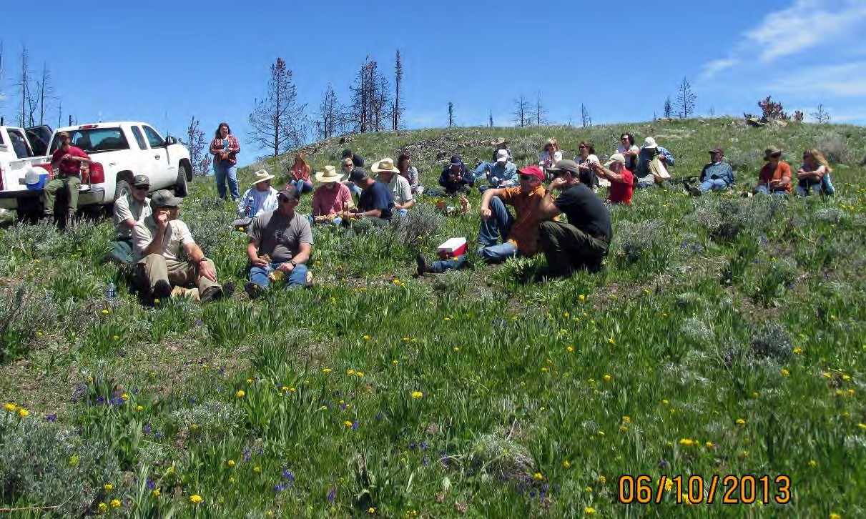
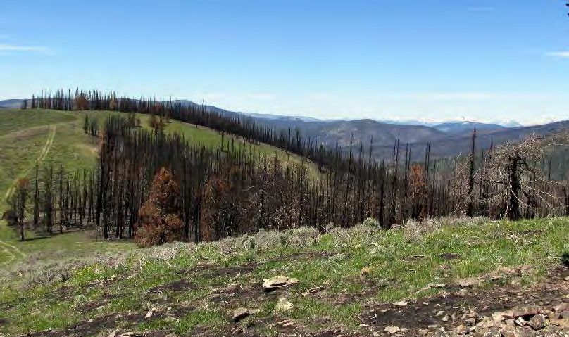
Stop 1: Indian Peak - Lunch and Discussion

From the vantage point of Indian Peak the group looked at the size and scope of the fire area including the large fire runs that occurred and are commonly occur on the forest in recent history. One burning period on the Mustang Fire included an 8 mile, 23,000 acre run.

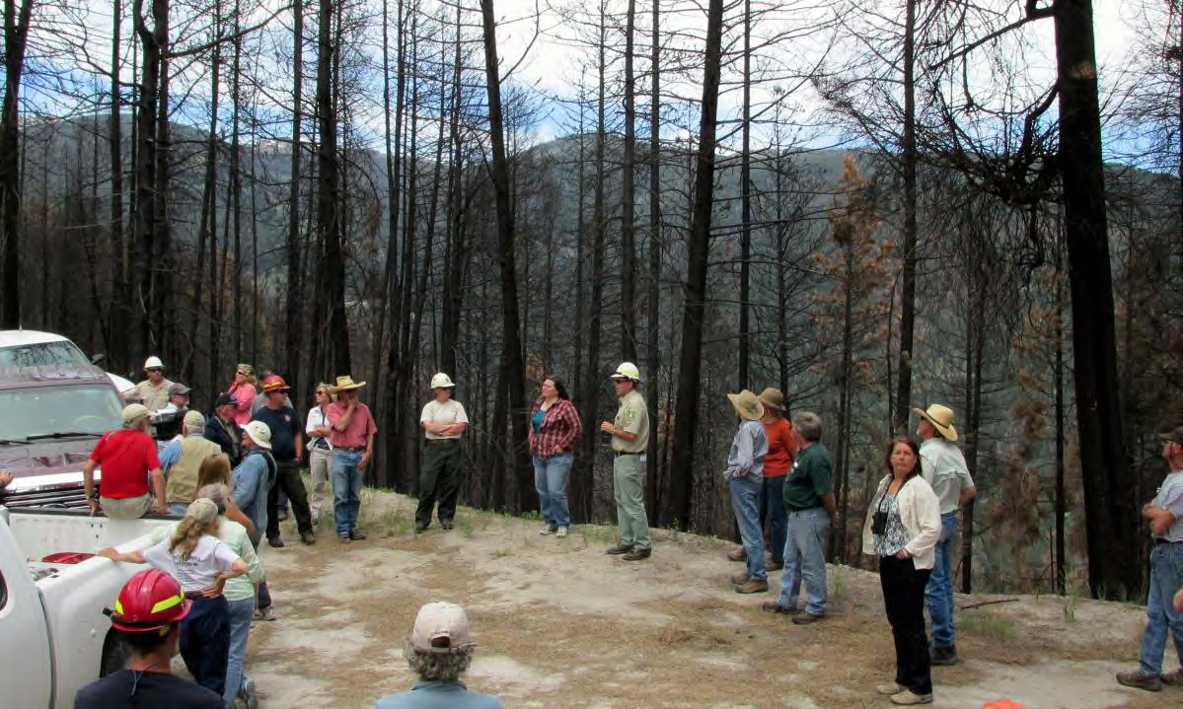
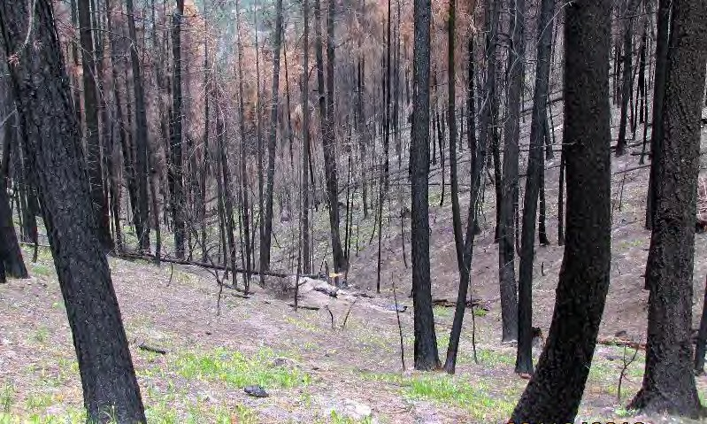
Stop 2: Salzar Bar Overlook on West Fork Road

At the Salzer Bar overlook the group saw the effects slope and adjacent fuels have on fire activity. This area was part of the West Salzar Timber Sale. The question was posed that if the downslope area had been treated, would the severity have been as great?

Stop 3: Junction of Upper Ransack Loop/Ditch Creek Road

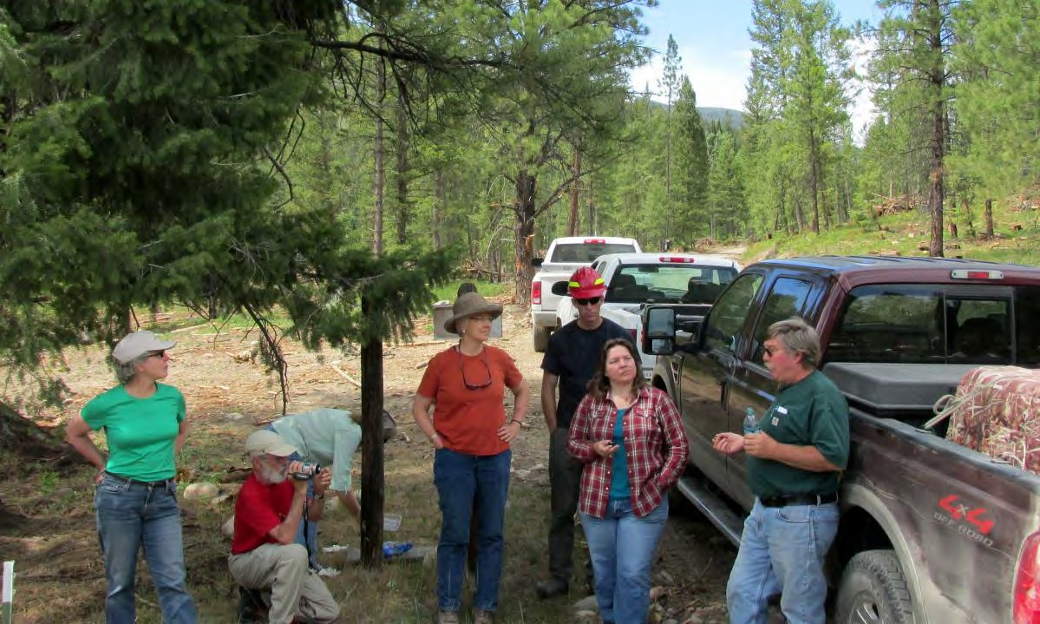

At the intersection of the Ditch Creek Road and the Upper Ransack Loop (unofficially known as the loggers camp) John Goodman explained the private timber operation that is occurring and some of the challenges he faces in accomplishing the project.

Stop 4: Granite Mountain Lookout

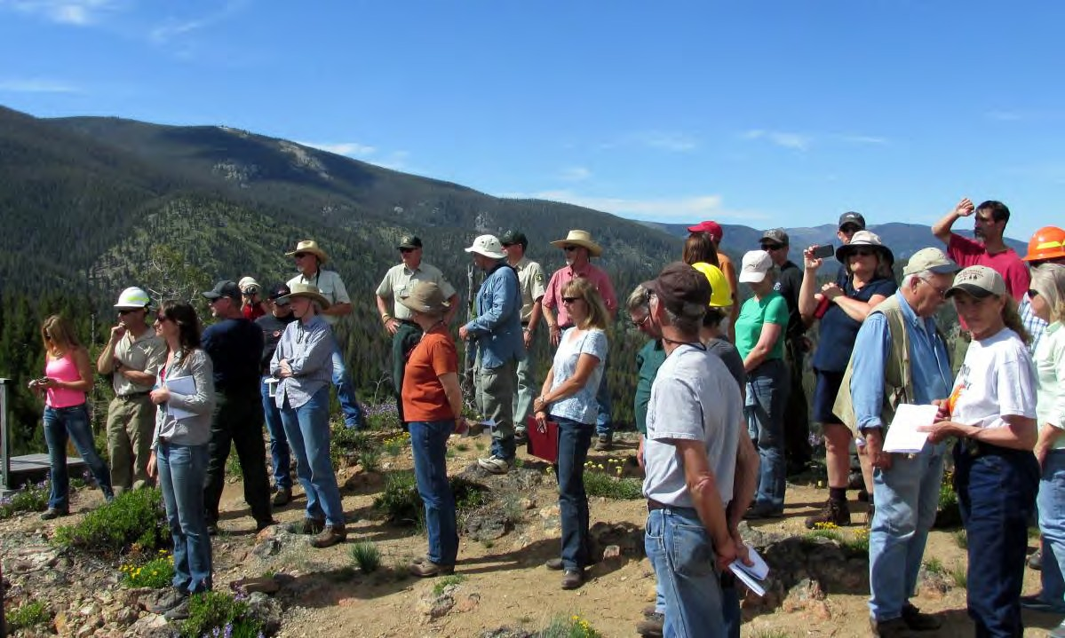

The Field trip concluded with a look at the mixed conifer forests above the dry timber sites and how they may be impacted by a large moving fire such as the Mustang. The group discussed the need to address patch size and treatments in lodgepole stands that would be effective in protecting areas such as Gibbonsville and Lost Trail Ski Hill in a fast moving fire typical of the North Fork District.

Change is the New Constant Workshop

Tuesday, June 11, 2013

Participants: Alaina Pomeroy, Beth Waterbury, Bill Baer, Bill Gaines, Christine Droske, Chuck Kempner, Chuck Mark, Clifford Keene, Dan Garcia, Dave Swanson, Doug Leyva, Gary Power, Gina Knudson, Hadley B. Roberts, Jerry Hamilton, Jim Edgrin, Jim Tucker, Jody Brostrom, John Goodman, Karin Drnjevic, Leslie Mayo, Lynn Bennett, Maggie Milligan, Melissa Sartor, Michelle Tucker, Mike Smith, Penny Morgan, Rachel Layman, Richi Harrod, Ron Troy, Russ Bacon, Scott Feldhausen

Workshop Goals

1. To provide a shared learning experience regarding forest restoration principles for members of the Collaborative and federal partners from the SCNF and BLM.

2. To learn from current research on mixed conifer restoration and management with a focus on disturbances, wildlife and strategies to proceed in the face of a changing climate.

3. To provide a venue for dialogue between scientists and practitioners, relating the research back to core questions expressed by the Collaborative, and developing a plan to move forward.

Background

The Lemhi County Forest Restoration Group (LCRFG) and partners have successfully collaborated on a dry forest project in Hughes Creek on the North Fork District of the Salmon Challis National Forest. This project is in its fourth year of implementation and was part of the Mustang Fire last year. The Collaborative has invested a great deal of time in this project during planning and in
multi-party monitoring both pre and post treatment. Most recently, they have expressed interest in post fire effectiveness assessments in treatment areas; fire severity impacts on the ground; and
what to expect in the upcoming fire seasons in light of changing forest conditions.

Members of the Collaborative have requested opportunities to learn more about forest restoration strategies in mixed conifer forests such as the stands that exist in the Upper North Fork and Jesse Creek project areas. These are primarily lodgepole, subalpine forests with Douglas fir and ponderosa pine at lower elevations. Whitebark pine exists at the higher elevations and is especially prevalent near the Lost Trail Ski Resort and Continental Divide that borders the Upper North Fork
project to the north. Patch size, landscape scale restoration strategies and wildlife connectivity have been areas of concern.

The Upper North Fork and Jesse Creek projects are both still in the planning stage. The
Collaborative issued a Recommendation Memo to the SCNF for the Upper North Fork project in
2010 with an update in 2012. The Draft EIS, originally slated for release in spring 2011, is still pending. The Jesse Creek project is in the first stages of collaboration with one field trip in the fall of
2012. The delay in NEPA on the Upper North Fork project has proven to be troublesome for
members of the Collaborative. The extended planning time is starting to impact the momentum of

other collaborative activities. Expediting NEPA and supporting a more effective approach to resource analysis are priority concerns for collaborative members.

Presenters

Penny Morgan Ph.D. is a professor in the College of Natural Resources at the University of Idaho. She directs the University’s Wildland Fire Program. She earned her Bachelor of Science and Master of Science degrees from Utah State University and holds a doctorate from the University of Idaho. Her current research focuses on some of the broad challenges facing people in the West including: changing climate influence on fire occurrence and severity; bark beetles’ effect on crown fire and burn severity; vegetation recovery following large fires, and post-fire management effect on weeds and other vegetation. Penny is committed to helping people understand and use science in natural resources management in Idaho and the western U.S.

Bill Gaines, Ph.D. is a Wildlife Ecologist and Director of the Washington Conservation Science Institute. He recently retired after 27-years with the US Forest Service. Bill is currently an adjunct faculty member in the Biology Department at Central Washington University, and sits on the Graduate Faculty in the Geography Department at Central Washington University. He has conducted a number of research projects on the effects of forest restoration treatments on wildlife and was a team leader for the development of the Forest Restoration Strategy being implemented in the eastern Cascades.

Richy Harrod, Ph.D. is currently the Deputy Fire Staff Officer for the Okanogan-Wenatchee National Forest. He earned his doctorate in Ecosystem Science at the University Of Washington, College Of Forest Resources. Richy has conducted extensive research on the effects of restoration treatments on plants and forests and was a team leader for the development of the Forest Restoration Strategy being implemented in the eastern Cascades.

Copies of the presentations may be requested from SVS.

LCFRG Follow Up to Field Trip and Workshop

The group had mixed reactions to the Okanogan-Wenatchee Forest Restoration Strategy. Concerns included lack of skills, involved scientists, assessment and reference data, and capacity to
implement the same type of process on the SCNF. Some participants were also concerned about the ability to model landscape scale processes and whether this would open the group up to litigation. Most participants liked the process to the degree that it could: increase transparency, mediate
internal and external disputes over different resource values, and help move past single-species management, help increase planning times and improve NEPA efficiencies. The Forest Service probably doesn’t have the capacity to undertake planning and assessment at scale but they tentatively could partner with LCFRG to try to recruit and secure additional capacity for a landscape
scale assessment. They would do this in parallel to continuing to work on the projects that are already underway. The Fire Modeling Institute (Greg Dillon) out of Missoula could be a good potential partner.

The group had a lengthy discussion about NEPA challenges. Gina is going to share a report that the Blue Mountains Forest Partners completed to assess NEPA barriers and identify recommendations. The group is interested in convening to review this report and talk about local barriers and potential solutions (growing local skills to help complete portions of the NEPA data collection, etc.).

Many ideas, questions and opinions were shared by members of LCFRG and FS staff in this open discussion. Items considered are summarized here:

▪ Examples of fuels reductions projects in a municipal watershed? -Ashland, OR, Bozeman, MT, Sandpoint, ID (Penny Morgan suggested contacting, Peter Robichaud of RMRS).

▪ If you remove a lot of trees with the snow melt faster? Penny: No. With a dense forest a lot of the snow is captured in the crowns so it melts faster, thus there is increased snow retention in clear cuts. Kelly Elder (Rocky Mtn. Research Station who runs the Frazier Experimental Forest, based in Ft. Collins).

▪ Jesse Creek is a 17,000 acre watershed - Landscape modeling important because what happens on the other side of the ridge influences Jesse Creek itself. What authority do you treat it under? Boundaries for HFRA = 1.5 miles from a community at risk. If you can only treat 1.5 miles outside the city how do you get to the scale needed to address the municipal watershed? Mark Finney of Rocky Mtn. Research Station has done work about the location of fuel treatments.

▪ Moving to landscape scale is challenging. The amount of complexity in a document is hard.
Resistance from the public? Are smaller projects less likely to be challenged? How do you address cumulative effects in a small project?

▪ Single-species management is a challenge, these efforts have a lot of force behind them.

▪ Collaborative started in 2006, 10 years under their belt but only one project. One project
doesn’t get rid of 30 years of mistrust.

▪ Entire group missed the Idaho Conservation League, WildWest Institute and the County Commissioners. SVS works hard to keep partners engaged but resources are getting smaller and we are very remote.

▪ One approach to consider for Jesse Creek using Okanogan Model: “West of the ridge or
municipal watershed”. Let’s work on them both at once. Use a tool or a landscape level analysis to think about where to go to reduce the risk to the municipal watershed while also whittling away at Jesse Creek. Maybe we prioritize watersheds 15,000 acres at a time. Fire Modeling Institute – branch of the fire sciences lab out of Missoula. Costs money but they start analyzing it. Have been working in the Blue Mountains. Greg Dillon who is at the Fire Lab and is interested in mixed conifer and landscape scale dynamics. Might have resources to bring to the table.

▪ Does the SCNF really have the capacity to do all of these different projects at once: Jesse Creek, Upper N. Fork, etc? Increase available trained work force and fire qualifications by working with partners like the Nature Conservancy. Usually more implementation means more $. Trigger for more resources is getting more shelf-ready NEPA done.

▪ NEPA efficiencies: Enterprise teams and contracts might free up some specialists’ time to work on priorities (speaks to the volume of work). A NEPA document in 12 months is really moving fast. Difficult because the agency is so reactive, scales up to meet a need and then there is another problem. Getting specialists involved in the collaborative process up front. Challenge in Upper N. Fork is competing priorities on the forest. The longer a project sits mean that new issues might come up. FS is resistant to contracting NEPA. How does Upper N. Fork become a priority without becoming a problem? NEXT STEP: distribute the BMFP paper and then have a NEPA discussion.

▪ Benefits of the landscape perspective and in the large footprint model. Seems like a great approach for wildlife because is not a proponent of single-species management. Going big is a good thing, however, there are limitations to that approach. You could identify wildlife connectivity, etc. That is only one piece of the pie. You can’t model the natural world.

▪ Fires continuing to be large, getting warmer, species like aspen, whitebark, etc. will need some extra attention.

▪ There is growing agreement on mixed-severity forest, whether it’s patchy-gappy, heterogeneity, landscape-scale etc. “You’ve got to start somewhere”. What are our “Big Stickies”?

▪ Collaborative formed based on three main premises: community wildfire protection, economic benefit to the local community and improving ecological conditions.

▪ Training in communications, etc. around Jesse Creek. Huge part of what this is about. What happens if it burns – No Action Alternative. PR for Jesse Creek is going to be critical from a social standpoint. Lack of communication between disciplines.

▪ Current landscape is HOMOGENOUS, historic landscape was HETEROGENOUS, need to increase
VARIABILITY for greater RESILIENCE.

▪ How big is patch size? What scale are we comfortable with?

▪ Build relationship with Rocky Mountain Research Station. Next meeting? Group agreed that they would meet when next workshop is scheduled.

Lemhi County Forest Restoration Group Meeting Salmon Valley Business and Innovation Center Board Room Wednesday, October 23, 2013
1:00 – 2:00 pm

Draft Meeting Summary

Participants:

Gina Knudson, Jerry Hamilton, Hadley Roberts, John Jakovac, Gary Power, Bob Russell, Lynn Bennett [Alaina
Pomeroy via conference call]

Regional Forester Visit

Background: Regional Forester Nora Rasure had intended to come to the Salmon-Challis on October 23 and a meeting with the LCFRG had been on her agenda. Although the visit was cancelled, LCFRG members wanted to take the opportunity to discuss what information should be conveyed to Nora when she does re-schedule.

Discussion:

- How do economic factors/community well-being issues factor into Forest Service decisions?

- Seems to be a lack of understanding among FS staff regarding stewardship contracts/agreements.

- What is Nora’s vision of using stewardship contracting in this area?

- LCFRG needs to know who can make what decisions. Not understanding this upfront has caused confusion and frustration. What are the lines of authority, especially but not exclusively when contracting is involved?

- Having a designated partnership coordinator on the SCNF might be helpful to the LCFRG and our various partners, including the County.

- Hughes Ck is an excellent example of what LCFRG is trying to do and would give Nora a visual on what we have accomplished to date.

- We also need to tell her about our interest and involvement in Upper North Fork and Salmon Municipal
Watershed projects.

- Observation that the cost of doing nothing will outweigh costs of implementing projects.

- Idea of developing a LCFRG strategic plan was introduced. We have not had a planning session since March 2008. Identifying boundaries and agreeing upon priorities would give LCFRG a unified message for Regional Forester. Or in the words of one member, “To eat an elephant, you have to take one bite at a time – let’s make sure we get the prime cuts first!”

- Make sure Supervisor Chuck Mark remains in the loop on LCFRG planning/discussions.

Action item: Gina will check in with rest of LCFRG to make sure they are on board with working on a strategic plan. If yes, set date.

Next workshop topic

Background: Salmon Valley Stewardship and Sustainable Northwest have funds remaining in their USDA Rural Development Rural Business Opportunity Grant to put on one more workshop designed to increase shared agreement among LCFRG members. At our June meeting/workshop, members said they would like to hear from the “environmentalist” perspective regarding why some forest projects are bullseyes for litigation and appeals versus those that garner a broad base of support.

Discussion: Gina, Alaina, and Michelle Tucker have been drafting a possible workshop agenda that includes guest speaker Susan Jane Brown of the Western Environmental Law Center. Brown is an environmental attorney who has successfully appealed many Forest Service projects, but currently is a member of the Blue Mountain Forest Partners collaborative in Eastern Oregon. Last year, Brown gave a workshop about the National Environmental Policy Act to Central Idaho Rangeland Network ranchers and local agency staff. She was also one of the author’s of the Blue Mtn. Forest Partners memo outlining barriers to NEPA efficiencies in eastern Oregon.

If the LCFRG agrees that Brown would be a suitable guest speaker, Alaina will try to get her scheduled.

- Members thought a NEPA workshop could be beneficial to LCFRG.

- Important to note that a different judge reviews cases in this area, so understanding red flags in the 9th
Circuit court would be important.

- The better we understand perspective from potential naysayers, the better we’ll be at responding to concerns upfront.

- Workshop should be scheduled in conjunction with a field trip so members and attendees have
“windshield time,” – time to socialize, accomplish something together, get to know one another better.

- Possibly invite the Region 4 appeals coordinator?

- Panel members or participants from Idaho Conservation League, Wild West Institute, other conservation groups will be very important.

Action item: Alaina will contact Susan Jane Brown about availability/willingness to come to workshop and get back with the group.

Lemhi Forest Restoration Group

Public Lands Building Office

Thursday, April 3, 2014

10 a.m. – 12 p.m.
Meeting Summary
Participants:
Rob Mason – Wilderness Society  Jerry Hamilton – Private Citizen  Gary Power - SVS  Gina Knudson – SVS  Michelle Tucker – SVS  John Goodman – Moose Creek Estates  Bob Russell – Private Citizen  John Jakovac – Lemhi County  Bret Standsberry – IDFG  Karen Drnjevic – Lemhi County  Bob Cope – Lemhi county | Fritz Cluff – SCNF  Tom Schultz – SCNF, North Fork District  Maggie Seaberg – SCNF, North Fork District
Kathy Seaberg – SCNF
Jim Tucker – SCNF
Chuck Mark – SCNF
Ken Gebhardt - SCNF, North Fork District
Melissa Sartor – SCNF
Christine Droske - SCNF, North Fork District
Introductions: Gina introduced and welcomed two first-time attendees:
Rob Mason joined The Wilderness Society in September 2013 as the Central Idaho Representative and works on land protection efforts with communities and local stakeholders in the state. Prior to joining The Wilderness Society, Rob worked as wilderness manager for the Sierra National Forest and as executive director of the Selway-Bitterroot Frank Church Foundation.
Ken Gebhardt and his family moved to Salmon to become the North Fork District Ranger from the Wallowa-Whitman National Forest in northeast Oregon. He served five years as the Wallowa Valley District Ranger and Acting Forest Natural Resources Staff Officer. Prior to his arrival on the Wallowa-Whitman in 2008, Ken served as the Forest Fisheries Biologist on the Superior National Forest in Minnesota.
Collaborative Forest Landscape Restoration Program (CFLRP): Much of this discussion was based on a projected map of Lemhi County and the surrounding area. Some of the conversation regarding this mapping exercise was not captured in the notes.
Gina gave an intro to CFLRP and need to define area of work. The purpose of the CFLRP is to encourage collaborative, science-based ecosystem restoration of priority forest landscapes. She provided examples of other CFLRP groups and their project areas from Kootenai Valley Resource Initiative (KVRI) and Northeast Washington State.
A proposal for a CFLRP project must be at least 50,000 acres and based on a landscape restoration strategy. Projects should ensure that they align with a restoration strategy to improve wildfire behavior and management costs, restore natural ecosystem and watershed functions, and facilitate appropriate utilization of woody biomass and small-diameter wood.
The group plotted existing and proposed projects on a map of Lemhi County. Much discussion ensued about the appropriate size and location of project boundaries. The consensus was that Hydrologic Unit Code (HUC) 6’s were an appropriate unit to delineate smaller project areas and priorities from. The entirety of Lemhi County was endorsed by members with consideration for priority HUCs. Reasons for considering the entire County were aligned with the desire to expand the collaborative’s ability to reach other area partners and promote complementary projects in the Lemhi Valley. It was generally agreed that linking to other existing and in-progress resources such as watershed condition framework can help identify priority areas within the greater landscape project area.
The group consensus was that the larger landscape is more strategic and will help to leverage other partners’ projects and funding to get things done, using Lemhi County as a starting point for a CFLRP application. Once the comment period for the Draft EIS for the Upper North Fork Project is done, SVS will solicit partner input for inclusion into the landscape project such as WUI boundaries, wildlife habitat, fire histories etc. The SCNF will assist in collecting all GIS data and consolidating this on a map.
Upper North Fork:
Comments on the Draft EIS are due by May 5. Public Meetings will be an open house forum:
- April 9 in Salmon, Innovation Center 5:30 p.m. to 7:30 p.m.
- April 10 in Gibbonsville, GIA Building 6:30 p.m. to 8:30 p.m.
It is important that collaborative members attend these meetings if possible and be prepared to discuss the activities and volunteer time they have spent on this project proposal. Individual collaborative members will meet in the upcoming weeks to review the DEIS for consistency with the group recommendation memo. A doodle poll will be sent out to set this date.
[Based on response from the scheduling poll, the review meeting was established for Thursday, April 17 from 10 a.m. – 1 p.m. at the Salmon Valley Business and Innovation Center.]

Lemhi Forest Restoration Group

Salmon Valley Business Innovation Center

Thursday, April 17, 2014

10 a.m. – 11:30 a.m.

Upper North Fork Draft EIS (DEIS) Review
Participants
Hadley Roberts – Private Citizen  Jerry Hamilton – Private Citizen  Gary Power - SVS  Gina Knudson – SVS  Michelle Tucker – SVS  John Goodman – Moose Creek Estates  Bob Russell – Private Citizen  Tammy Stringham – LCEDA  John Robison - ICL | Jim Tucker - SCNF  John Jakovac – Lemhi County  Beth Waterbury – IDFG  Karen Drnjevic – Lemhi County  Bob Cope – Lemhi county  Lynn Bennett - SCNF  Douglas Basford – Private Citizen  Alan Howell – LCEDA  Jim Roscoe – High Divide Consulting

Up Front
April 25, 2014 Task Force Assignments Due
May 1, 2014 Comments to Task Force Findings Due
May 5, 2014 USFS Close of Comment Period for DEIS
Meeting Summary
DEIS public meetings in Salmon and Gibbonsville were well attended. Jim T. thanked those who presented and attended from the Collaborative. Gina reviewed information provided by LFRG at the meetings.
Gina outlined objective of today’s meeting: to use the recommendation and clarification memos as a basis to review the DEIS and determine if the group feels our recommendations have been well represented. Gina solicited comments from group.
John G. reported that many of the comments at the Gibbonsville meeting focused on the closing of a Hammerean Loop road in the 2nd alternative. This locally popular road has perpetual problems with sliding according to the SCNF. Gina reported that David Deschaine (SCNF) explained in the Salmon meeting that this road is a maintenance problem and wildlife security issue. Jim T. expressed that it was obvious the community feels this road is important. Beth doesn’t recall this road closure being a recommendation from IDFG. Jerry also reminded the group that the road may be valuable for fire suppression.
Michelle asked how many had time to review the DEIS. None in the room besides Gina and Jim T. raised their hands. Beth has only had time to skim. John R. has only skimmed also. He did report that he appreciated the consideration for two alternatives.
Gina asked if the group felt 45 days was long enough to review the DEIS. Beth did not realize review time was negotiable and was anticipating a 90 day review period. Gary commented that the quick turnaround could help get contracts on the ground sooner. Cope feels that the group has had five years to provide input. In summary, the group agreed to request a two week extension but be prepared to meet the existing deadline in the interim.
Gina stated that she has reviewed at least 2/3 of the DEIS and did feel there are some surprises, including helicopter logging in both alternatives. Michelle stated that she was also surprised by this in light of recent information that helicopter logging is no longer economically viable. Her concern was that the areas targeted for helicopter logging would never be treated. Jim T. relayed a conversation that he and former North Fork Ranger Russ Bacon had while driving through the area of Pierce Creek. Russ stated that he wanted to designate some units as helicopter logging in case the timber market ever supported this option. John G. feels the timber above Moose Creek has little value now and it is important to have the fuels reduced sooner, rather than waiting for helicopter logging to become viable. Jim T. pointed out that Hughes Creek is a good example of what we can anticipate for the timber market. Michelle asked again if this meant that these areas would not be treated at all. Bob R. clarified that these are most likely areas where temporary roads are not an option due to slope. Cope feels the county would rather see treatment if other alternatives are possible, however, if the only option is helicopter he would prefer to leave in. The group agreed that they would like clarification on the areas designated for helicopter logging under the preferred alternative. Larger maps will be required. Would these units be a candidate for any other type of treatment, and if not, why?
Jim R. has had time to review summaries and some mitigation features. He was disappointed that more consideration wasn’t given to wildlife recommendations he and Beth provided in response to a meeting with the SCNF in 2012. Gina reported a concern for elk security was raised at the April 9 Salmon public meeting. Beth wants time to process the mitigation measures, but she feels that the input provided by the collaborative for carnivores and owls was disregarded. Michelle asked if there is any indication that input from the collaborative regarding wildlife was incorporated or even cited. Beth pointed out that local or natural heritage records were not cited. Jim R. feels a blanket prescription, without consideration for specific habitat and connectivity concerns is being presented in the DEIS. Beth noted brief review of the draft showed a unit with a surface fuel loading reduction to 70% that did not sufficiently address forest carnivores. Michelle expressed that she feels it is very important to utilize local specialist knowledge. Hadley also did not see any previous local work cited. Beth would like to see new spatial modeling and tools used. Her example was that one goshawk record on Upper north Fork was cited. However, spatial modeling, not presented in the DEIS, shows much more available habitat. She feels the analysis could have been simplified or more transparent if modeling exercises were conducted. Jim R. commented that the forest plan standard for winter range was not going to be used, however, they don’t provide a justification or discussion for this project specific amendment. Is this precedent setting? If so, they should disclose this. The consensus was that the SCNF has not shown a strong rational for wildlife decisions and has not incorporated the comments solicited and received from Jim R. and Beth.
Gina asked what our comments at this time mean to the SCNF at this point in the National Environmental Policy Act (NEPA) process. John R. explained that many Idaho forests are using the new Objection Process for HFRA projects. We are currently in the “comment” period. Ideally comments can be submitted as group or individual to SCNF and those comments would be reflected in a Final EIS. The new objection process includes a draft decision, giving a chance to review and comment before any signed decision. John R. would characterize it as a chance for refinement and a chance to bring any remaining concerns to the USFS in a less adversarial way than the regular appeals process. It is intended to solve problems ahead of litigation. Jim T. will track with Carol Krieger to define the objection process (Already received and attached).
John R. reminded the group that if we feel there is an issue of concern, we should also offer a solution. He is concerned that in order to maximize effectiveness of restoration, we all need to lobby for funding in areas that may not pay for themselves. Cope reminded the group that Hughes Creek had a lot of above base funding and we should continue to support this process.
Many of the group expressed difficulty in using the electronic copy of the DEIS. Jim T. arranged for 25 copies of the DEIS to be printed as well as larger maps and made available at SVS and the Public Lands Building.
With limited timeframes, Michelle asked the group to consider splitting up the DEIS into areas of concern and assigned “task forces” to review. The group agreed to the following assignments:
- Roads and Roadless – ICL and Lemhi County (Cope and John J.)
- Economics (Local Workforce Benefit, Recreation, Restoration Budgeting) – Michelle, Tammy, Gary
- Wildlife – Jim R., Beth, Hadley
- Helicopter Logging and Treatment Option Concerns – John G., Jerry
Each task force will provide a basic review and notes to the collaborative group email by April 25. All members are encouraged to review these notes and make comments electronically by May 1. SVS will consolidate these comments into a recommendation letter and provide it to the SCNF by May 5, unless we are granted an extension. If the extension is granted, the group will adjust timeframes to provide for additional review.

Lemhi Forest Restoration Group

Public Lands Building

Tuesday, July 8, 2014

10 a.m. – 12 p.m.
Meeting Summary
Participants:
Jerry Hamilton – Private Citizen  Gina Knudson – SVS  Michelle Tucker – SVS  John Goodman – Moose Creek Estates  Karen Drnjevic – Lemhi County  Lynn Bennett --SCNF  Doug Leyva - SCNF  Tammy Stringham - LCEDA  Ken Rogers – SCNF  Bob Cope – Lemhi County | Maggie Seaberg – SCNF  Chuck Mark – SCNF  Ken Gebhardt - SCNF  Christine Droske - SCNF  John Roscoe – High Divide Consulting  Kristin Nesbit - SVS  Hadley Roberts – Private Citizen  Call-in Participants  Dani Mazotta – Id Conservation League  John Robison - ICL  Rob Mason – Wilderness Society
Upper North Fork DEIS Update
Chuck, Ken G. and Maggie will brief Regional Forester Nora Rasure Friday, 7/11 on the preferred alternative (alternative 1). The draft record of decision is underway to support that decision. Chuck stated that they will be focusing their meeting on the comments received and what has been done to address these concerns.
Maggie provided an estimated timeline:
- July 11 - Brief Regional Forester
- Week of July 14 - Final EIS in Federal Register
- Week of July 21 – Pre decisional objection period begins (if unresolved objections, 30 days objective resolution period, ending ~ Aug 30)
- Implementation can begin 5 days after the object period has ended. The SCNF doesn’t anticipate any contracts before the new fiscal year and will spend the winter working on contracts for spring implementation.
Wildlife
Ken G. informed the group that the SCNF held a productive meeting with ID Department of Fish and Game (IDFG) regarding carnivores, riparian and other wildlife concerns. He feels it was a successful meeting. Jim R. asked for more information regarding these discussions, particularly security cover for big game.
- Maggie explained elk security was emphasized in the IDFG meeting. The Pierce Creek trail change to non-motorized use will benefit the security buffer area.
- Commercial thinning treatments will have a less uniform spacing than that used in Hughes Creek and provide for clumps and openings while still meeting the silvicultural prescriptions. Clumps and openings will be left where they don’t pose a threat to fuel loading and provide retention of healthiest tree(s). These areas will range from less than one to five acres. These leave trees should also help in retention of a seed source as replanting is not part of the project design.
- Jim R. asked for clarification on linear downed feet as he felt it was a minimal standard. Doug explained that this was a forest plan criteria and addressed production goals for prescribed fire. Christine explained that all burning was intended to be mosaic wherever possible. Jim would like to see monitoring from a wildlife perspective to address adaptive management relative to the results of the prescribed burning that includes adjacency, timing and can meet multiple objectives rather than just fuel loading. Doug explained that is part of the intent of having separate units and allows for modification for each unit as they progress to make certain that objectives for all resources are addressed. Jim felt it important to clearly state this in the EIS.
- Ken G. reminded the group that the purpose and need stated for this project is fuels reduction, there may be short term negative impacts from a fuels stand point for overall improvements for habitat. John R. added that wildlife habitat is an underlying goal of the project as an integrated approach to lead the forest environment to a healthier state.
- Maggie explained that some comments addressed concerns that all roads would have a shaded fuel break treatment on both sides of the road. This is not the case. Shaded fuel breaks are strategically placed to protect key assets such as Lost Trail.
- John R. asked that wildlife corridors in key areas be retained wherever possible. John recommends that this is explicitly stated in final and describe how they will be maintained and/or protected. If this project is challenged the weakest link in recent projects have been lynx.
- Jim R. asked if integrated design features in Appendix A could be referenced with each unit.
Treatment Options and Priorities
John G. asked whether helicopter logging had been reduced in the preferred alternative and if that meant these areas would not be treated due to economics. Maggie said this has not been changed. The SCNF wanted to retain this option in steep or inaccessible areas (without roads) should the economy allow. These units are not restricted to helicopter logging per se and could be hand worked or burned.
Ken G. explained that the SCNF has a team addressing out-year plans and priorities for the Upper North Fork project. WUI and recent treatments will be priorities for implementation. The collaborative will have a chance to participate on the criteria and priority list. Ken would like to provide a draft plan with SCNF specialists and then invite collaborative and interested members of the community for input.
John G. would like Moose Creek Estates to be addressed as a priority in light of the work they have already put into the private land. Michelle feels Lost Trail also falls into this category as they have been doing hazardous tree and fuel treatments.
Michelle asked that stewardship contracting be considered in prioritization process and use of local work force. Gina reminded that we followed up with an implementation memo with Hughes Creek. The implementation memo addressed items such as contracting, monitoring, and public relations.
Jerry asked about use of available alternative logging systems. Ken explained that these systems are not limited by the EIS as long as they are able to meet prescription. This includes other options such as horse logging.
Jerry asked about re-entry for the treated areas. Doug and Maggie confirmed that the EIS doesn’t cover any follow-up treatments for commercial harvest, only for prescribed burning. Jerry would like these to be identified as to when they would be recommended for re-treatment.
Gina asked whether the use of clumping and opening was a formal strategy for the SCNF. Ken explained this is an approach to mixed carnivores and ponderosa pine in many areas. Jim R. recommended contacting Dillon BLM where strategy has been used successfully for some time. He recommended this be cited in the assessment.
Other Upper North Fork Discussion
Gina asked what other type of comments were received and whether they were substantive. Maggie explained that many of the comments were similar, particularly for wildlife. An overwhelming number of comments were received about the Hammerean Loop. No other comments that were markedly different from the comments received from Collaborative members.
Gina remarked that when this group started in 2006, a strong relationship did not exist between the IDFG and SCNF. The group agreed that this is expressly improved.
Michelle asked about preparing local contractors over the winter for upcoming work and if stewardship contracts are on the docket. Maggie recommended that post-fire season/fall would be a good time to discuss based on priority list. Ken G. stated that even if we have a big fire season he is committed to keeping work going on the home front.
Cope stated that this project seems to fit well with the Western Regional Cohesive Strategy. It would be a project they would be interested in and he suggested the Forest share information with the regional coordinator. Chuck agreed.
Jesse Creek Vegetation Survey
Doug updated the group on the Jesse Creek Vegetation Survey. A total of 804 plots were originally in the contract, and 170 were dropped as too hazardous to access. All but 44 are complete, the contractor is working this week. Doug feels this is quality work. The contractor is Bob Lewis of Jackson, Montana, and he hired two people out of Hamilton/Missoula area. The contractor has been surprised by how inaccessible the area is. Data from the survey will give information regarding species distribution, number, snags per acre, fuel loading, and tree and canopy base height. Will also help determine where high fire risk areas are and mortality due to insect and disease. Jesse Creek has ranked out primarily in the Douglas fir habitat types.
Other
Gina asked about Farm Bill project – the Jesse Creek insect and disease project proposed to the Governor. The Forest has not had an update. Cope thinks it is still unfunded. Region 1 may have tried to issue decision using the categorical exclusion and may have been challenged. Lynn has heard that implementation dollars would come from above base and associated competitive criteria. Cope feels we will rank well.
Michelle informed the group that RAC funded multiparty monitoring for $7,000. The original application was for $15,000, but many projects went unfunded.
Gina updated the group on a restoration economy tracking project SVS is completing. It was hard to track USFS dollars spent on contracts. If any partners are interested SVS has a template now that will help standardize project funding data collection. The final Hughes Creek Socio Economic Report is available on the SVS website. The Fact Sheet is being developed. Cope said the new Forest Planning Rule emphasizes socioeconomic considerations and it is good that we are ahead of the game.
Maggie updated the group on two small salvage projects -- Cougar Phelan and Deep Creek, each under 250 acres, near roads. Both sales will be advertised as small commercial sale. Maggie will send advertisement electronically to SVS.
Hadley asked for clarification for the process for a forest plan amendment. Maggie and Ken R. explained that if it is site specific, an amendment can be done under a NEPA assessment such as the Upper North Fork EIS. If anything your project is proposing doesn’t meet the forest plan, you state it in the NEPA assessment and disclose effects. If the amendment is permanent or forest-wide, there is a separate process.
NEXT MEETING: Will be scheduled after objection period. TBD.

Lemhi Forest Restoration Group (LFRG) Meeting
Idaho Fish and Game Conference Room

Thursday, October 17, 2014

Participants:

Beth Waterbury (ID Dept of Fish & Game), Jessie Shallow (IDFG)
Kim Murphy (Natl Marine Fisheries)
Dani Mazotta (Id Conservation League)
Bob Russell, LFRG
Ken Gebhardt (Salmon-Challis N.F)
Bill Baer (Bureau of Land Management) Gary Power, LFRG
Gina Knudson (Salmon Valley Stewardship)
Hadley Roberts, LFRG
Jerry Hamilton, LFRG
John Goodman (Moose Ck Estates)
Bob Cope (Lemhi County)
Karin Drnjevic (Lemhi County)
Lynn Bennett, (SCNF)
Michelle Tucker (SVS)
Doug Leyva (SCNF)
Tyre Holfetz (ID Dept of Lands)
Rob Mason (Wilderness Society)
Jim Roscoe (High Divide Consulting)
Jim Tucker (SCNF)

Action Items in RED:
Cope stated he would like to more strongly align our group with the National Cohesive Wildland Fire Strategy. He recommends making this a standing agenda item and to forward an agenda to Katie Lighthalll in Bend Oregon before meetings.
The Forest Service gave an update on upcoming harvest activities: Ankle Deep commercial firewood sale and Sagewood commercial personal use sale each under 250 acres. State highway dept. will be doing work from Lost Trail within easement and/or 30 feet from center line. Topped, limbed and chipped. Jeff Eagle at state highway dept. is point-of-contact. State highway contacted SCNF as a courtesy. Group suggested any firewood potential from this work should be considered for county firewood program for residents in need.

Collaborative Forest Landscape Restoration Program (CFLRP)
Last spring, group came to consensus that we would like to prepare for a CFLR when/if the next funding is available. We agreed that Lemhi County would be our boundary. Forest Service GIS shop will be responsible for making initial map of existing restoration projects. Forest Service representatives confirmed that they should have capacity to accomplish this task.

Salmon Municipal Watershed Project
The Forest Service has invited Missoula Fire Lab personnel to a Salmon Municipal Watershed field trip on Oct 23 to review the Ridge Road, outside and adjacent to the Jesse Creek project. Those interested in attending can meet at Supervisors Office at 9am. The project that was submitted to the Governor’s Office under the Farm Bill insect/disease streamlined environmental analysis program was approved by Gov’s Office. While the Farm Bill did give authority for projects, additional funding was not part of legislation that was passed. The Forest Service can use existing budgets for these projects.

Upper North Fork
Upper North Fork Update and Next Steps: No objections were received for the project proposal. Ken explained that they anticipate a signed record of decision once the fisheries services provide a biological opinion (BO). Some terms and conditions required by the service may need further discussion. Kim informed the group that a draft BO has been submitted for review.
Gina expressed the need for the group to re-engage during implementation as we had done in Hughes Creek. She reminded the group of the implementation memo for Hughes Creek which provided guidance for collaborative work on public relations, provide input on stewardship contracting, and conduct multiparty monitoring. Will circulate Hughes memo as an example.
Ken provided a draft implementation plan for input and feedback. District and forest staff consolidated plans to implement all project features. This plan provides a draft treatment schedule from 2015 – 2017 and summarizes the decision factors behind scheduling. Priorities are WUI, existing projects and fire scars. Strategic about future treatments under this three year plan.
Gina asked about contracting vehicles for 2015. She encouraged the Forest Service to consider using stewardship contracting where appropriate particularly considering material utilization and local economic development. She recommended we utilize a stewardship contracting subcommittee again for this project. LCEDA still has an agreement in place however Region 4 has been resistant to using stewardship agreements. Regional specialists are due to visit to open this discussion. The group requested time to meet with contracting specialists when/if they come to Salmon. The group agreed it is important to keep this contracting mechanism available to assist in local use of workforce. Doug suggested that local contractors should work to get on Indefinite Delivery Indefinite Quantity (IDIQ) register. However, it is unknown when this register opens to new companies again. In the past, few local companies have had capacity to contract via IDIQ. Bonding for small companies is also an issue. Bob R., John G., Doug, and Karin agreed to work on stewardship contracting subcommittee.
Multi-party monitoring: Michelle felt the draft implementation plan was very helpful in planning for multi-party monitoring. Beth asked if the forest would be inventorying aspen stands and whether the aspen working group could assist on inventory. Doug explained that the 2013 infrared maps (NAIP) did not pick up all aspen but was fairly accurate on larger stands. Gina noted that for Hughes Ck monitoring Jake Kreilick of Wild West Institute invested a lot of his time and acquired grants to help with monitoring activities. SVS has received some funding from the Central Idaho Resource Advisory Committee (CIRAC). Dani stated she feels monitoring helps to support future endeavors and tells a strong story. Dani is willing to visit with ICL about support. Cope stated monitoring was important for adaptive management and this is going to become increasingly important. Pre- and post –treatment data will be important for telling the story. Rob asked about resource area monitoring in particular wildlife component. Jerry would like to monitor the silvicultural prescriptive process. He put in plots after Clear Creek Fire and will share with group.
Beth feels wildlife effectiveness monitoring is important but IDFG is limited by staffing capacity. There is not a lot of information for the project area. Jim R. reminded the group that monitoring could be a moving target in terms of climate. Need to be aware that information for climatic conditions is important. Cope echoes the need to factor in external influences and identify what impacts are beyond the scope of the project . Cope and Michelle also feel socioeconomic monitoring is very important. John G., Hadley, Rob M., Jim R., Dani, Jerry H., and Beth would like to participate in monitoring subcommittee.

LRFG Website Demonstration
The website for multiparty monitoring in Hughes Creek is ready to launch. CIRAC funded this project to enable Salmon Valley Stewardship to share monitorng data more easily and make it available to all partners. The site was developed in cooperation with the US Geological Service and meets security requirements for the Forest Service.

Other Business
Tyre updated the group on the Nature Conservancy (TNC) fire adapted communities pilot programs. The upcoming national roll out will mean other areas can participate in program. Cope explained involvement in Community Wildfire Protection Plans (CWPP) are important to participate in these programs. Lemhi County updated CWPP to prioritize three areas that align with Cohesive Strategy. More information can be found at www.fireadapted.org
Idaho Forest Restoration Partners next meeting is set for Feb 18 and 19, 2015 in Boise.

Next Meeting
The group agreed to set up quarterly meetings in the future. Next meeting on week of Jan 20. SVS will send out scheduling poll to pick best day.

Lemhi Forest Restoration Group (LFRG)
Meeting Summary
Wednesday, January 21, 2015
9 am – 12 pm
Idaho Department of Fish and Game, Salmon Region Conference Room

Action items emphasized in underline.
Our Mission: Enhance forest health and economic opportunities in Lemhi County through collaborative engagement of restoration projects and Wildland Urban Interface/community protection using stewardship contracting and other tools.

Participants:
Beth Waterbury – Idaho Dept Fish & Game (IDFG)
Kim Murphy – National Marine Fisheries Service (NMFS)
Bob Russell – Citizen
Ken Gebhardt – Salmon-Challis National Forest (SCNF)
Gary Power – Salmon Valley Stewardship (SVS) board
Gina Knudson – SVS Staff
Jerry Hamilton – Citizen
Karin Drnjevic – Lemhi County
Lynn Bennett – SCNF
Michelle Tucker – SVS Staff
Doug Leyva – SCNF
Tyre Holfeltz – Id Dept of Lands (IDL)
Jim Roscoe – High Divide Consulting
Louise Bruce – High Divide Consulting
Riley Rhoades – SCNF
Suzy Avey – SVS Staff
John Jakovac – Lemhi County Commissioner
Mike Smith – SCNF
Bob Cope – Citizen, Retired Lemhi Co. Commissioner
Christine Droske -- SCNF
Large Landscape Approach - in the style of Collaborative Forest Landscape Restoration Program (CFLRP)
Gina briefed the group on last spring’s LFRG meeting when we discussed CFLRP. The program was intended to encourage collaborative groups to bring projects to larger scale. Multi-year funds granted for these projects cannot be used for planning, but are used for implementation and monitoring. The first two program rounds were in 2010 and 2012. The Forest Service has significant resource commitment to these large, multi-year projects, so the likelihood of a new round of funding being announced in near future is slim.
That being said, landscape scale projects proposed collaboratively seem to be the new way of doing business. By going through process of completing a CFLRP application, we are preparing our group for future funding, which may be CFLRP or other competitive funding.
The CRLFP requires defined landscape scale project boundaries that are collaboratively designed. Last spring the LFRG committed to a project area boundary that would encompass Lemhi County.
Ken is very supportive of the landscape approach, but reminded the group that if selected as a CFLRP, that project impacts the entire forest and can pull resources from other forest priorities. The group agreed that these are important considerations.

Ken is excited about mapping resource issues and conditions on the SCNF, and using the map to identify where there are overlapping priorities to target future projects. This information can help guide the forest 5 year plan. Christine presented a map to demonstrate how the landscape map can be used.
GIS data goes back into the 90s on SCNF. Ken is proposing a forest wide map for previous 20 years that includes information such as the national watershed condition framework (WCF) as well as national terrestrial data available. Ken anticipates that overlapping polygons/areas will represent resource components and provide direction for treatment and establish priorities. Doesn’t preclude small project where an area needs help.
Cope feels this is a great step and will have good support from landowners. Sage grouse is very important in this process. He cautions not to tie into condition class too much. WCF does answer some good questions but wants to take to a broader scale. Cope feels we need general overarching goals. John J. agreed this map could help prioritize and define specific goals. Gary thinks birthdates for previous treatments are very important to re-assess if needs are being met. Items considered for landscape map include WCF, historic range of variability,
Governor’s priority insect/disease layer, community wildfire protection plan, fire history, as well as planned, present and past projects.
Michelle mentioned that similar landscape mapping exercises are being conducted by other partners such as Office of Species Conservation and Upper Salmon Basin Watershed Project. Jim R. pointed out that most Land Use Plans revisions and Resource Management Plans (RMPs) are large mapping exercises. All of these efforts could contribute to or benefit from a comprehensive map.
Jim R. voiced concern for forest staff capacity and bottle necks are limiting what we can do. With landscape scale how do collaboratives come into play? Gina agreed that collaboratives can create work but can also help address other capacity issues if strategically approached. Tyre recommended state support such as Idaho Forest Restoration Partner (IFRP) participation. State may be able to pull in larger groups to help.
Kim mentioned that with increased scale agencies don’t always have the capacity to monitor and meet the needs of endangered species consultation monitoring. Collaboratives have opportunity to support monitoring workload. Much of the monitoring required by consultation could be supplemented by assistant or programmatic support up front with umbrella monitoring that complements all. Consultation monitoring requirements drive project planning. Current approach and limited staff capacity are causing federal land management agencies to fall behind on requirements. Could the collaborative convene federal land management agencies and regulators and help find a streamlined approach that still met priority monitoring objectives?
Tyre thinks we each have a niche that we can specialize with our partners such as key species indicators for treatment. Research is out there, but how do you narrow the scope to make it manageable? Doug pointed out that it is important to determine the metric to look at the issues and find agreement up front for what will be credible and useable data. Beth feels that monitoring for wildlife standards are not always obtainable. A lot of non-game data is lacking but need to consider standards and protocols. Tyre pointed out the importance of defining that process up front to make certain process is sound, repeatable and defendable from the beginning. Kim stated that getting information out to public to garner more support for actions may foster adaptive management strategy. Trust and credibility is important to share on a broader scale.
Jerry emphasized the need to follow the prescriptive process for past treatment. The complications of the National Environmental Policy Act (NEPA) have lessened the chances that this routine maintenance happens. John J. agrees monitoring objectives need to be streamlined. Tyre suggested that modeling may reduce work load and in particular field time. Michelle agreed but wants ground truthing. Jim R. emphasized that local perspectives need to be addressed that modeling doesn’t always speak to. Validating on the ground is very important. Jim feels this comes into strategic planning discussion as we consider more responsibility in limited funding and capacity.
LFRG Strategic Plan
Existing LFRG strategic plan was completed in 2008 and intended to provide strategy for 3-5 yrs. Do we need to re-visit? Gina can find assistance to go through a revision or update of strategic plan. Does it feel worthwhile, does the group want that?
John J. feels the plan is still a good representation of our group. He doesn’t want to lose focus on our core issues stated in the mission. He feels we are able to meet the goals established with existing capacity. Including a larger Lemhi County Landscape is enough of a challenge for the group at this time.
Gary summarized Rob Mason’s recommendations for strategic planning. Rob encouraged the group to expand our influence into other areas such as:
- Greater sage-grouse: How can the most-intact and highest density sage-grouse habitat area be permanently protected in a way that makes sense for ranchers and Lemhi County?
- ​Cattle grazing: How can we ensure that cattle grazing on public lands will continue into the indefinite future as an important aspect of the economy, heritage and culture of Lemhi County in the face of potential uncertainty from sage-grouse, invasive weeds, and other destabilizing challenges?
- ​Wildfire Prevention & Suppression (includes Restoration): How do we ensure appropriate wildfire management in order to preserve the native ecosystem?
- ​Economies: How do we maintain/enhance existing natural resources-based economic opportunities and diversify into new ones?
- ​Ecological values: How do we best protect and enhance the value of anadromous fisheries, wildlife habitat, and wildlife connectivity corridors into the future, especially in the face of climate change?
- ​Backcountry/Wildland values: How do we protect the unspoiled and wild places critical to the long-term health of the area and many of the resources that we value?
“The Wilderness Society would like to propose that the LFRG expand the scope of its mission and vision to address all public land natural resource issues within Lemhi County, including but not limited to the issues listed above, using a collaborative-based approach to resolving land management issues.”
Gary noted the existing strategic plan does not represent some issues where we have found agreement (such as wildlife), but he feels the overall core values have remained constant. Gary felt Rob was asking the group to really broaden our scope. He feels we have done a phenomenal job in our area of focus.

Bob noted that we have evolved enough to say who we need in the room at a minimum, do we have these folks and what are our transition strategies?
John J. said there are already several groups working on sage grouse issues, and we should be careful not to duplicate these efforts.
Jim R. emphasized that we need to remind ourselves of the issues we are considering, what are our partner constraints. For example, he asked where is the forest biologist? If we tried to expand as Rob suggests, would we exceed capacity of our existing structure? Jim R. emphasized that with the inclusion of all of Lemhi County we are already taking on an expansion.
Beth feels what Rob is suggesting would stretch our capacity. She thinks it is a good idea to continue to focus on forest and interface with other lands and habitats. Beth recommended that changes to the strategic plan should be minimal revisions and not take too much energy.
Lynn pointed out that when we started we had limited resources and knew we had to be focused and tied to accomplishment. We used a coarse filter approach and focused on structure and process to find agreement.
Gina reminded of the group decision on the Breaks project as an example when we provided support of a project but we decided not to fully engage because the project did not fit with all our filters.
In conclusion, the group agreed that our strategic plan is representative of the group’s values and committed resources. Gina asked all members to look closely at the strategic plan and send in recommended edits. These edits will be available by the next meeting in April 14 for consideration and approval by the group.

Upper North Fork Project (UNF Project)
Ken G. updated the group on the UNF project. The draft 5 year plan presented at our last meeting has not changed much. The 1st sale will be Stateline. The forest is considering using a stewardship contract for this sale. 2nd sale being considered in UNF is skyline work. Ken reported this might not be a good fit for the use of the stewardship agreement. Recent discussions with Lemhi County Economic Development Association (LCEDA) indicate they don’t feel they are prepared for a large project such as Stateline so the stewardship agreement will not be used for this initial work.
Gina reminded the group that Hughes Creek used both a stewardship agreement and contract. Michelle asked how West Salzar went as it was a stewardship contract and if lessons learned will help move this forward. The forest feels that their contracting office is better equipped to approach Stateline after their experiences on West Salzar. Doug reported that West Salzar had more timber value so Stateline may cost more.
John J. asked if stewardship agreements versus contracts were preferred. Doug and Ken emphasized that all tools would be considered. Ken and Chuck Mark, SCNF Supervisor, are considering an entire suite of options for the UNF Project that will allow the forest to meet collaborative agreements and treatment goals.
The forest has held a couple of meetings with LCEDA and forest contracting. LCEDA and the forest are looking for small sale opportunities. State Line will include the use of 1.2 miles of temporary roads. Retained receipts from the timber sale will be needed to complete other project objectives and restore the road. The forest won’t know until contract is bid and awarded if there will be any receipts to retain on the project.
Mike S. pointed out the in the LCEDA meetings they learned they don’t have to have a service contract in timber sale in same NEPA assessment area. The Stewardship Agreement with LCEDA is for the entire North Zone. This enables other sales in the North Zone to contribute to the retained receipt value. This must be considered when writing the Supplement Project Agreement (SPA).
Michelle reminded the forest that we had used best value criteria for Hughes Creek and asked that the forest review the socio economic report for lessons learned through this process. She also asked if the forest would continue to use the criteria developed with LFRG and the forest. She emphasized the need of the forest to place a requirement in the contracts to help track socio-economic value that summarizes use of local labor and resource. Cope emphasized the need for this documentation. Gina pointed out that Forest contracting officers should require a summary of how the contractor met best value criteria so socioeconomic monitoring can be accomplished as efficiently as possible. Michelle asked if a collaborative member could serve on the selection committee on Upper North Fork like Karin did for Hughes Creek. Mike recommended we convene our Contracting Subcommittee to answer many of these questions.
The issue of match under the stewardship agreement was raised by LCEDA at the recent meetings. All agree that the organization doesn’t have to put match up front, but it needs to be provided over the life of the agreement. Regional forester has discretion to reduce to 5 % from 20% but this has not been done. The group acknowledged how hard the SCNF has worked to meet local economic goals of collaborative, persevering on a very steep learning curve.
Gina updated the group on the potential creation of a statewide stewardship agreement to implement these agreements across the entire state. Id Dept of Lands is taking the lead, but entity would be a new non-profit organization. May help solve the issue of capacity of smaller groups like LCEDA, and industry has shown interest providing cash and in-kind match. This aligns with the Western push for better management and state input for public lands. Montana is already using a similar model
Doug relayed that the Indefinite Delivery Indefinite Quantity (IDIQ) register for timber will expire in next year. Ken realizes it is a challenge to go through the process but he feels it is worth the effort. He encourages the group to work with LCEDA and FS contracting officer Judy Martin to offer training. Small Business Administration may have resources available. This may be released as early as spring 2016.
Multiparty Monitoring
Cope participates in the Western Region Cohesive Fire Strategy committee and reported that adaptive management is being heavily discussed. He asked if we have recently outlined our desired future conditions for Upper North Fork. Michelle reported that most of the monitoring we have done to date was to establish baseline and effectiveness of treatment. Cope agreed that monitoring is impossible without a baseline.
Michelle reported that the last monitoring plan we had was designed by Jake Kreilick (Wild West Institute) for Hughes Creek.
Beth asked about monitoring funding and grant funding. She understands that most funders want to see on the ground work and are not as supportive of monitoring. Michelle reported that the loss of Secure Rural Schools funding (delivered locally through Central Idaho Resource Advisory Committee) was going to be hard on monitoring efforts because they have provided a significant portion of our work to date. Beth asked what we could expect from the forest for help in monitoring and what realistic options are. She recommended we laser in on key issues due to funding and capacity constraints. Cope feels it is important to assess what data has already been collected. Beth said we might need to focus on vegetative treatments as they are what we can manage as a collaborative and tie to our mission. Jim R. stated is was important to pair down to priorities and ensure we maintain credibility. Michelle reminded the group of the Rapid Assessment process being used in Montana. Michelle will send out an invite for a Multiparty Monitoring Subcommittee meeting in the next couple weeks.

Calendar
Idaho Forest Restoration Partnership, Boise, Feb 18-19, 2015. Travel assistance is available.
Next possible meeting dates for LFRG: April 14, 15, 21, 28-30

Lemhi Forest Restoration Group (LFRG)
Meeting Summary
Wednesday April 16, 2015
10 am – 11 am
SVS Office/Conference Call
Participants:
Our Mission: Enhance forest health and economic opportunities in Lemhi County through collaborative engagement of restoration projects and Wildland Urban Interface/community protection using stewardship contracting and other tools.

Beth Waterbury – Idaho Dept Fish & Game
Kim Murphy – National Marine Fisheries Service
Ken Gebhardt – Salmon-Challis National Forest (SCNF)
Gary Power – Salmon Valley Stewardship (SVS) board
Gina Knudson – SVS Staff
Jerry Hamilton – Citizen
Lynn Bennett – SCNF
Michelle Tucker – SVS Staff
Dani Mazotta – Idaho Conservation League
Jim Tucker – SCNF
Hadley Roberts - Citizen
Toni Ruth – Back Country Horsemen and Anglers
Louise Wagenknecht – Citizen

Upper North Fork Project Implementation Memo:
Gina asked for comments on the draft Implementation Memo sent out to LFRG members through email.
Ken stated that he had reviewed the memo and wanted to make clear that there are going to be times when the SCNF needs to rely on the trust built with the Collaborative as they are very busy and may not be able to share information in a timely manner.
Michelle feels that the communication has greatly improved over the past few years and the Collaborative is asking to be considered not only in the public notification process but also in order to assist the SCNF in public outreach for Collaborative projects.
Gina emphasized that the Collaborative isn’t asking to micromanage the SCNF.
Gina called for any objections to the Implementation Memo. None received. SVS will send out an electronic copy for member signature.
Update on Farm Bill
Ken updated the group on the SCNF plans for the use of the categorical exclusion under the Farm Bill:
The South Zone Farm Bill Project will be the Forest’s 2015 priority, Big Hills Project on Challis/Yankee Fork. A project initiation letter is underway.
The Forest Priority for 2016 will be the North Zone Farm Bill Project Ken would like to solicit LFRG assistance in drafting the proposed action and purpose and need. Right now they anticipate that firefighter safety and municipal watershed protection will be a priority. A project initiation letter will be out this fall and a decision is planned for 2016. Implementation will occur after 2016..
Gina offered to send our notes from the 3/6/14 LFRG meeting where we discussed the Farm Bill and assisted the SCNF in identifying the proposed project areas for members who were not in attendance.
Ken clarified that from here out, to avoid confusion; the North Zone Farm Bill Project is different than the Jesse Creek Project. The proposed North Zone Farm Bill Project is being proposed for an area west of the Ridge Road. Gina reminded the group of the antiquated City of Salmon/SCNF agreement for the Municipal Watershed. This will need to be addressed before moving forward on the Municipal Watershed Project.
Multiparty Monitoring (MPM)
Michelle reminded the group that team assignments are due back Friday. She has heard back from most groups. Once this information is received she will consolidate and schedule a meeting for the Sub Committee.
Toni asked if there is an updated implementation schedule.
Ken will get one together for the group.
Michelle offered that Ken provided this in the last MPM meeting and it is in the notes. She will re-send this to Toni and Dani to use until Ken has a new version available.
Joint Chiefs Project
Gina explained that SVS has reached out to Mark Olson with NRCS to discuss ways the LRFG could assist the NRCS in the upcoming Joint Chiefs Project. Mark’s schedule is very busy but will let the group know as soon as a date is set.
Lynn told the group a public meeting has been tentatively scheduled for May 4 in Gibbonsville.
Gina asked that LFRG be include in the notification of the meetings.
H.R. 2 – Secure Rural Schools
This bill passed the senate and it is anticipated that RAC funding will be reauthorized for two years once it goes to the House.
Next Meeting – To be determined

Lemhi Forest Restoration Group
Upper North Fork Project
Multi-Party Monitoring Sub-committee Meeting Notes

Thursday May 7, 10:30 am

Attendees: Michelle Tucker, Toni Ruth, Doug Leyva, Jerry Hamilton, Jenny Gonyer, Beth Waterbury, Louise Wagenknecht. Call-in: Dani Mazotta, Jim Roscoe

2015 Implementation Schedule Update
Doug reviewed the most recent 2015 Implementation Schedule
- Stateline Sale – waiting for snow to melt, 80-90 acres meadow restoration (conifer removal)
- True North Sale - removed from list for this year
- Twin Creek Campground – shaded fuel break – 50 acres
- Aspen Stand – 10 acres – across from Royal Elk Ranch, FS crew will do it
- Lick Creek - reduced to 148 acres
- Joint Chiefs – Units located along Hammerean Loop - approximately 170 acres currently – 400 acres for additional funding for FS
- Lost Trail - Shaded fuel break, 340 acres with timber sale, no whitebark will be removed

Joint Chiefs Gibbonsville Community Meeting
Michelle noted that the LFRG were not notified/invited to the meeting and hopes in the future the collaborative will be included as they can help get information out to landowners or attend and show support for the project.
Doug – Mark Olson talked for 15 minutes about Joint Chiefs Project to a small group of landowners
LFRG has a meeting with Mark Olson Monday, May 11 at 10am (anyone welcome). This is to get an update and learn about the NRCS role in the project as well as determine if LFRG can assist in the process.

Review Issue Recommendations by Assigned Teams

Mixed Severity Cold Forest – Group Members: Michelle, Penny Morgan (technical expert)
- Michelle attended SW Crown adaptive workshop and was impressed with a modeling exercise that included landscape scale treatments and their impacts on large fires, she sent the information to the FS others but has not heard back specifically about the opportunity to move forward.
- Issue: All collaboratives moving to landscape scale, from dry to mixed stand types – what is the best treatment size? Are they effective? Impacts?
- Data: Modeling for Upper North Fork (from Mike Smith) – this has been requested but not received; Missoula Fire Lab Resource – working with FS on a project for Jesse Creek, Idaho Forest Partners seminar in Boise – meeting focused on issue, notes from seminar available and sent out by Michelle; Frank Romero – after Mustang fire looked at Hughes Creek – LFRG has never seen the results from this tour and assessment, Jim Tucker might be able to acquire it
- Existing protocol: not much for specific issues
  - Tree Search (OR) has an article that Michelle sent out that gives Oregon standards for new protocol in 4 forest types.
  - SW Crown - model exercises, fire behavior models – models treatment areas (didn’t show much change)
  - NF – stand types experiment to help with future projects – model exercise with UofI and Firelab – making up as we go along
- Funding Potential: NFF, RAC, U of I (Penny has a grad student but no funding)

Implementation Review - Group Members: Dani and Toni
- Dani reported that they looked through the EIS and identified triggers for monitoring
- Issues: Opportunity to develop implementation monitoring plots (add to overall goal) but would want to understand what the FS plans for monitoring are.
- Data:
  - Lemhi County Weed Management – locations of insect release sites and weed inventories
  - IDFG nesting locations
  - Track when activities are supposed to take place – restrictions (in stream – meadow burning, wildlife)
- Protocols: Rapid Forest Assessment with SW Crown – follow same design features where applicable as guide.
Michelle - Jake helped design rapid forest assessment. 2 years ago held a workshop to teach it. He may be available to help get started.
- Funding Potential: reach out to universities – Nat. Resource Management courses, get college students interested in Rapid Forest Assessment
- Doug - Monitoring funding is very short, opportunity for FS to get monitoring plan
- Dani - this is opportunity for MPM to help with FS gaps, Rapid Forest Assessment
- Michelle - Ken expressed he needs help with monitoring in last meeting
- Beth - recommendation on wildlife activities such as temporary road closures where intensive timber management to avoid further wildlife disturbance or sensitive wildlife populations such as mountain goats
- Jim - minimize area/extent of disturbance – cluster activity as much as reasonable
- Doug – FS contracts cover many of these issues and are inspected at the end before payment, Mary Beth is the timber sale administrator and does the bulk of this work.
- Concerns expressed that this is a FS responsibility and the LFRG doesn’t have resources to cover them

Whitebark - Group Members: Doug, Beth, Michelle

Since this species is listed as a candidate for threatened, funding through IDFG is potentially available
- The group moved forward with a proposal since it was due quickly. Intended to monitor effects of various fuel treatments on whitebark recruitment. This would contract SVS crew to conduct quick plot stand exams in both treated and control areas. The funding available may even help to cover Jesse Creek area.
- Data: FS stand exams, whitebark working groups, West Fork Bitterroot study sites
  - Doug: Lost Trail Treatment (no data, but no whitebark will be cut) – will give more data, no blister rust up there
- Protocols: Quick plot assessment, Greater Yellowstone whitebark group
  - Tying in with habitat suitability for wolverines
  - Monitoring Sentinel sites where projections for climate change show a stronghold for species
  - Beth (showed Maps): Upper North Fork treatment layer with wolverine habitat improvement models (created with spring snow layers, known satellite wolverine and female locations); highlights treatments in upper areas of project area – Anderson Mtn and Lost Trail area
  - Wolverine layer representative of whitebark – at the snow and treeline area
- Funding Potential: Beth - IDFG Section 6 funding - $300,000 a year for endangered species/threatened
  - Beth: $25,000 – looks like funding will happen (full proposal within next 3 weeks, award in late July-early august)– contract with SVS, SVS match – avoids overhead costs
  - Contract made for crew of 4, travel, data analysis
  - Use Doug’s expertise for study design for Upper N Fork – then Jesse Creek

Aspen – Group Members: Michelle, Jerry, Louise
- No monitoring memo for Aspen
- Doug - Treating aspen from Hot Springs Ranch in the Upper North Fork (10 acres); Treat other areas of aspen as opportunity arises
- Michelle - The Central Idaho Aspen Working Group held spring meeting last month. The group has an established protocol for the area. Not much aspen work of late due to funding. Michelle was in field with Jessie Shallow and IDFG for potential projects in Williams Creek
- Doug and Michelle updated the group on the potential for the FS to complete programmatic NEPA for aspen treatment. Doug - planning meeting with north zone – fish specialists and wildlife.
- Protocols: – Central Idaho Aspen Working Group Rapid Assessment Inventory and Monitoring protocols, BLM has database, SVS, IDFG, FS – agreed to use Central Idaho protocol – quick assessment for stand health and risk.
- Potential Funding: NFF, IDFG, RAC, Michelle – IDFG mule deer initiative coordinator – has funding for aspen work and NEPA

Connectivity - Group Members: Rob, Ken, Jim, Beth
- Met April 6th – looked at available GIS layers, to look at status of connectivity
- Issue: project area covers carnivorous habitat and areas of large linkage corridors
  - Linkage areas – travel routes and broad areas of habitat and security
  - Preserve areas for long term longevity – lynx, wolverine, grizzly bear, +
  - Species sensitive to disturbance, don’t like openings
  - Roads bisect area – sports and fuel treatments at Lost Trail – large human footprint
  - E-W Wildlife corridor just south of LT area – large importance – another corridor south of there
- Data: Beth, a self-professed non-GIS expert used the GIS layers available and compared to other delineated linkage areas dark green areas best habitat – forest cover, where no road densities. She was surprised at how multiple attributes pointed to same area (corridors).
  - Maps: Road Densities: Land Cover, Continuity of Wolverine Habitat Corridor, Wilderness Society Wildlife map – all show about the same areas for corridors of value
  - Jim - Northern Corridor – ties to Montana side on east – monitor west side of bitterroot, if have treatments units on either side. Bring foresight into highway projects – wolverine mortality right at northern corridor, incentive for highway to at least install signs.
  - Beth - overpass: 1 million dollars, expensive --- environmental engineer IDT, Tim Cramer
  - Michelle - consider taking SW Crown approach to fire modeling and seeing how potential corridors are impacted
- Funding Potential: NFF

Review upcoming Funding opportunities
Michelle reviewed funding opportunities:
- National Forest Foundation (NFF) - Proposals are due on or before June 24, 2015 at 11:59 MDT and must be submitted through the on-line grants portal. Dani, Gina and Michelle worked on draft one time – NFF had Fall meeting in Missoula, aware of SVS and collaborative. Strict requirements of 1 to 1 match – proposal needs nexus or benefit to FS lands. Focus on FS health and outdoor experiences, on the ground projects, community engagement. Forest Health (citizen help, resiliency, remove or reintroduction), need 5013C, need to be completed in one year, can’t be federal.
- Central Idaho Resource Advisory Committee - Proposals due May 22: http://www.fs.usda.gov/main/scnf/workingtogether/advisorycommittees
  - RAC – no match needed, it is very supportive of collaborative and monitoring
- Michelle - SVS putting in RAC proposal for MPM webpage and socioeconomic monitoring
- RCPP - USDA Farm Bill – Toni brought information to group. Heavy match, large application and business focused.
- Suggestions for MPM monitoring

Assign/Confirm proposal applications as appropriate for each partner
- Beth: would consider NFF for aspen monitoring – go Forest Wide – beyond N. Fork – have Central Idaho Group on that
- Dani - See if NFF interested in rapid assessment that’s additive to FS current plan – tie in other working groups, not just solely implementation monitoring, take design features of FS.
- Toni willing to work with Doug to determine what the FS is monitoring this season
- Important that any LFRG member submitting a proposal to RAC or others let members know so no one applies for the same project

Confirm Multiparty monitoring plan for 2015 season
- Michelle: in a perfect world would have a monitoring plan –Jake worked on plan for Hughes Creek that was never finalized. If group wants a formal plan, could be a proposal for RAC.
- SVS will create a monitoring plan table with implementation schedule to capture completed and potential work.
- Toni would like to see a map to prioritize where to monitor: What needs to be done, where is it, aspen, priority for monitoring, etc.

New Business
- Next collaborative meeting in field, when Dani is around, Doug can help with field travel route. SVS will send out a poll.

NRCS - Upper North Fork – Joint Chiefs Project

May 11, 2015

Attendees:
Lynn Bennett, Salmon-Challis National Forest
Melissa Sartor (SCNF)
Doug Leyva (SCNF)
Michelle Tucker, Salmon Valley Stewardship
Gina Knudson (SVS)
Mark Olson, Natural Resource Conservation Service
Tammy Stringham, Lemhi County Economic Development Association
Karin Drnjevic, Lemhi County Wildland Urban Interface

Joint Chiefs Award for Upper North Fork – NRCS Implementation Plan

Mark explained that NRCS’s original proposal was for $240K with $40K to be spent in Year 1, and $100K each in Years 2 & 3. Instead, it appears the funding will all need to be obligated this year.

Although the Salmon office of NRCS doesn’t typically deal with forestry concerns, they are very familiar with working with private landowners on agriculture issues. The process will be very similar.

- Funds can be spent on private lands fuels reduction. Private land must be within the North Fork watershed.
- Advertisement soliciting applications from landowners will be posted for 30 days starting Thursday, May 14, in the Salmon Recorder-Herald and Idaho Falls Post Register.
- Applications will be ranked. SCNF has worked with Mark to identify National Forest lands in the area that have had recent vegetation management or are slated to through Upper North Fork. Lynn displayed the map they had created. Mark invited collaborative members to offer other ranking criteria.
- Ranking process will take place at the end of June.
- Landowners will work directly with contractors. NRCS has a specified price for each type of work (thinning, slash pile disposal, etc). Landowners will be paid this amount for work completed, regardless of whether the contractor price is more or less than the specified rate. Pay rates do take into account more specialized work, such as tree removal services close to homes or other structures. Fee structure is consistent throughout the Northwest.
- From the time of award, landowners must commence work on their property within one year, but the work can be completed over a time period not to exceed 10 years. Mark expects most of the work will be completed in a shorter time period, i.e. 2-3 years.
- Technical assistance for silvicultural prescriptions, best management practices, etc. will be available to landowners from Northern Idaho NRCS forestry specialists. Possibility that Idaho Dept of Lands foresters may also help.
- Federal funding and project is ground disturbing so National Environmental Policy Act is triggered. Mark expects to be able to process most of the work under a Categorical Exclusion.

How can collaborative help?

- Help spread the word and recruit landowner participation!
- If there is desire to be part of the ranking process or suggest ranking criteria, contact Mark Olson.
- Several people in town took the contract inspection workshop put on by the SCNF and SVS last year. Inspectors can’t be paid from NRCS funds, but landowners may want to pay out of their own pocket to assure quality work.
- Mark’s experience is that some landowners don’t have a written contract with the people performing work. Group could provide templates (Northern Idaho has many examples).
- Forest Service plans to identify example units to demonstrate desired outcomes.
- Collaborative could host a 1-day workshop to provide info for landowners, and follow the info session with a job fair where contractors could have booths offering their services.

Lemhi Forest Restoration Group (LFRG)

North Zone Farm Bill Tour – Ridge Road Summary

Tuesday, August 18, 2015
8:00 a.m. – 2:00 p.m.

Participants: Gina Knudson (SVS), Jerry Hamilton, Doug Leyva (SCNF), Christine Droske (SCNF), Mike Steck (SCNF), Chris Lowery (SCNF)

Stop 1
Intersection of Ridge Road and Leesburg Road. We crossed to the NW side of the Ridge Road in a lodgepole stand.
- Primary project objectives under Farm Bill authority -- reducing fuels and improving stand conditions.
- The primarily lodgepole stands would have been historically subject to stand replacing fire on a very infrequent basis (est. 300 years). Jerry guessed that insect and disease have resulted in approx.. 80% mortality. The volume of dead trees means areas like this will mostly involve service work rather than producing merchantable material. Firewood is a possibility.
- Thinning lodgepole is problematic because the thinned stands are susceptible to windthrow. Clearcut is the typical treatment for lodgepole and forest plan limits these treatments to no more than 40 acres.
- Whitebark pine occur within the project area and opportunities to help improve whitebark are abundant. Fire break cut in 2000 has dense re-growth, including whitebark. Thinning the stand and making whitebark the dominant species is an option.
- Chris reported that cultural surveys are nearly finished, and no issues of significance have been found. There is little water in the area so much of the use would have been people passing through.
- Doug said that old growth surveys still have to be completed. Talked about the possibility of inviting collaborative members or others along to see how surveys are conducted.

Stop 2
To the southeast of Stop 1 on Ridge Road.
- Mike showed us a wildlife camera trap.
- Mike said the Ridge Road represents one of the SCNF’s lynx analysis units. Areas with mature lodgepole with no limbs to the ground do not offer good foraging habitat. Younger lodgepole and species like fir and spruce that do have lower limbs can provide foraging habitat. For denning habitat, appropriate amount of deadfall on forest floor would be important. Group talked about finding balance between not leaving too much fuel on the ground, but leaving suitable habitat where appropriate. We need to take care to not reduce potential lynx denning habitat whenever possible.
- Canada lynx need winter/spring foraging habitat near to spring denning habitat.
- Winter/spring Foraging habitat is young timber stands or thick timber understory/undergrowth layers that stick up through the snow and are food for snowshoe hare, which in turn are food for lynx.
- The proposed project could provide more lynx foraging habitat in the project area.
- Lynx denning habitat includes big logs/cavities and thick brushpiles on the ground that provide secure places for lynx kits to stay in. These are usually found in over-mature timber stands.

Stop 3
To the southwest of Stop 2 on Ridge Road; a non-system logging road.
- There are several logging roads that go west from the Ridge Road, down the hill. These may serve to help access the project area, with the concept of thinning on this western edge of the project to help fire drop to the ground lower down on the ridge.
- Another way to deal with lodgepole is a shelterwood treatment. This could involve thinning 60% of a stand, leaving the best seed trees, and several years later thinning these remaining trees, resulting in a new, young growth stand.
- Where whitebark is present, a thin from above approach might be considered to favor this species.
- Some blister rust was observed in the whitebark.
- Chris said when he was conducting cultural survey on the lower part of the ridge, there were several wet meadows that were being pretty heavily impacted by grazing. Gina suggested these meadows might pose an opportunity to enhance for wildlife benefit.
- Next steps: Develop a purpose and need statement. The collaborative should be involved in this step and may need to call a meeting for this specific purpose.

Lemhi Forest Restoration Collaborative Meeting
October 26, 2015
1-3:30 pm

Participants

Leo Marshall– Mayor, City of Salmon
Chuck Kempner, Citizen
Jerry Hamilton – Citizen
Beth Waterbury – Idaho Dept Fish & Game (IDFG)
Jessie Shallow, IDFG
Madison Harper – SVS Staff
Rachel Layman – SVS
Gina Knudson - SVS
Toni Ruth, Backcountry Hunters & Anglers
Bob Cope – Citizen, Retired Lemhi Co. Commissioner
Kim Murphy – National Marine Fisheries Service (NMFS)
Jody Brostrom, US FWS
Phone Participants
Dani Mazotta, ICL
Louise Wagenknecht, citizen
Jonathan Oppenheimer, ICL
Kim Trotter, Yellowstone to Yukon
Ken Gebhardt – Salmon-Challis National Forest (SCNF)
Cheri Ford – SCNF
Jim Tucker, SCNF
Tom Ford – SCNF
Tom Schultz – SCNF
Lynn Bennett – SCNF
Wade McPhetridge – SCNF
Maggie Seaberg—SCNF
Doug Leyva – SCNF
David Deschaine – SCNF
Dan Bill- SCNF
Alex Sholes - SCNF
Jeff Hunteman – SCNF
Andy Klimek – SCNF

Phelan/Sharkey Project: Background
Cope and Jonathan Oppenheimer have both been involved with the Idaho Roadless Commission. The project area is within a roadless area, but is exactly the kind of project the commission envisioned when it was creating different categories of roadless. This project falls within Backcountry/Restoration and General Forest guidelines. Cope helped commission members understand that even 15 miles from town can be considered Wildland Urban Interface (WUI) if forest and grassland conditions are conducive to wildfire spreading to a community, as would be the case in the Salmon River Mountains west of Salmon. Gina gave a brief history of the LFRG’s interest in the Salmon Municipal Watershed. The group acted quickly on the new Farm Bill streamlined environmental analysis authority in March 2014, proposing what is now being called Phelan/Sharkey. The project fits this authority because it is 3,000 acres or less, is within the WUI, is in condition class II, and has an identified insect and disease issue.
Ken talked about the importance of working west of the Ridge Road because the watershed is very steep. Phelan/Sharkey is designed to maximize the easily accessible terrain and avoid riparian areas or other geographic features that would be difficult to treat.
An August field trip brought to light three issues that had not been discussed in the years of thinking of hazardous fuels treatments: Improvement of whitebark regeneration, Lynx management analysis, observation of riparian areas.
Doug talked about the management for whitebark and the current conditions on the ridgetop. There is a fair amount of whitebark on the ridgetop, small but healthy, rust is prominent in the older trees, lots of regen in the understory. Activities can benefit whitebark. Prescriptions will call for leaving the largest, healthiest trees. No winter harvest is planned because it packs down the snow and allows other game to intrude on Lynx habitat. Goal is to create a mosaic landscape with different sizes and classes. Wetlands are getting trampled by cows so is there something we can do to protect the springs? Ken touched on Lynx: Allows travel corridor, opportunities to measure BAF, which will help with movement.
Dani mentioned the Farm Bill directs the maximization of old growth, promoting the most resilient species for the stand.
David said the project would be designed to avoid damage to wetlands or riparian areas.
Ken had been advised that project area had no fishbearing streams. Beth believes bull trout are present.
Cope recommended tying the National Cohesive Fire Strategy to purpose and need. The idea of having a National Cohesive Strategy is to identify places like Lemhi County where we’re already putting the goals of the strategy in action, and share successes and lessons learned with a broader audience.
Beth said IDFG’s interest is to see a purpose and need statement that is explicit about wildlife values. The area is a roadless area and has a very high value for a movement corridor. Wolverine could be expected to move through the area. Other important ecological connections in the area include: Whitebark and the Clark’s nutcracker ecological connection; forested owls associated with lodgepole and sub-apline fir; wet areas for amphibians; Sub-alpine fir and lodgepole stands are great for woodpeckers and other birds; bat species are prominent in these forests. If we can leave those elements on the landscape with design features to preserve those species. Any waters that drain into Panther Creek have a connection to salmon and steelhead.
Jessie said deer and elk move through the project area from Black Rock and Diamond Creek areas. The treatments could be beneficial as long as cover is maintained.
Beth recommended that any temporary roads be considered really carefully, providing lowest road density possible, ensuring decommissioning and monitoring is done efficiently, and that invasive and noxious weeds do not come in after the ground disturbance.
Doug said some of the temporary roads would be utilizing already on-the-ground user-created routes, and then decommissioning after the treatments are conducted. Would actually improve things from a current road density perspective.
Jerry asked if temporary roads had to be closed. We might want to use them in the future.
Dani said the roadless rule has very specific requirements about timeframes and methods of road decommissioning. Not optional.
Jody mentioned that the timing of road work and other activities will effect wildlife movement.
On-the-ground implementation would be expected to begin in 2017.
Phelan/Sharkey: Purpose and Need
Purpose should be stated as a positive outcome expected and the need establishes evidence the problem exists, preferably backed by scientific evidence.
Existing draft:
- The SCNF is proposing to utilize the Farm Bill Authority to treat up to 3,000 acres of hazardous fuels to help reduce the potential impacts of a large catastrophic wildfire, to improve firefighter and public safety, and to help reduce the threat of a large fire to the Salmon Municipal Watershed. There is a need to reduce the large accumulation of dead and dying hazardous fuels resulting from insects and disease and to improve public and firefighter safety. There is also a need to help reduce the potential negative effects from a large fire to the Salmon Municipal Watershed. This proposal will create a ridgetop fuel break which will help to address the desired purpose and need.
Discussion:
- Ridgetop fuel break has different meaning and should be phrased differently.
- Whitebark pine might be referenced specifically.
- Ashland, OR is involved in similar municipal watershed project. Their purpose & need statement reads:
  - The Purpose of the action is to protect Values At Risk, reduce hazardous fuels, reduce crown fire potential, and obtain conditions that are more resilient to wildland fires.
  - The Need for action is urgent reduction of the potential for large-scale, high-severity wildland fire in the Upper Bear Analysis Area. One hundred years of fire exclusion and fuel accumulations in this forest’s wildland/urban interface now presents high potential for largescale, high-severity wildland fire that could significantly interrupt the supply of clean water and late-successional and old-growth forest ecosystems in this Analysis Area.
- Values at Risk might be a good catch-all phrase for structures, watersheds, timber, trails, wildlife, clean water, etc.
- Phrasing of reducing crown fire potential, etc. is good because it makes it clear that we know we can’t and don’t want to stop ANY and ALL fires in the area.
- Purpose and need properly constrains the project, and helps define reasonable range of alternatives. We have to remember the Farm Bill authority uses a categorical exclusion, so is streamlined under National Environmental Policy Act (NEPA). Do we need to be careful to not make the project too complicated?
- Do not shy away from other benefits that can come from this project. Room to acknowledge other benefits in this project, either in purpose and need statement or proposed action description.
– Don’t forget about the purpose the silvicultural prescription provides.
Community Wildfire protection plan- CWPP important to mention how the WUI is identified and illustrate fire regimes, spelling out clearly for the Categorical Exclusion. can address in Need statement, how many acres of disease do we have?
- Do we have agreement that commercial treatments can be used? Yes. Other treatments being discussed to economically achieve fuels reduction objectives include mastication.
- Next Steps for developing Purpose and Need Statement
- Ken said he committed to having collaboratively development statement done by Jan 1, 2016
- SCNF will take group’s input from today and have draft to LFRG by Nov. 20. Will include purpose and need statement and proposed action description
Upper North Fork Update
Ken- Implementation is happening quicker than expected. We need to get next big project in the pipeline.
Maggie gave an update on Timber sales in The Upper North Fork.
Stateline Stewardship Project:
-“Goods”: 385 acres of commercial timber sale off the Anderson Mountain Road
-“Services”: 100 acres of meadow restoration & Spraying of noxious weeds within the project area post-harvest
-Advertised in September but not awarded due to underestimated funding in FY15 (didn’t account for timber market going down). Will be re-advertised and awarded in 1st quarter FY16.

Far North Timber Sale:

-300+ acre commercial timber sale South of Lost Trail Ski Area
-Timber is marked but still need to cruise to determine volume.
-Overlaps with a shaded fuel break unit that is currently under contract. Can’t have overlapping contracts so Far North will be advertised once the shaded fuel break contract is completed (probably summer 2016).

Granite South Stewardship Project:

-330 acres of commercial timber sale
-Just started marking the timber this week. Field work will be completed by summer 2016.
-Service work will be thinning & piling of small diameter non-commercial material within the units to meet fuels reduction objectives.

Doug – FS crews did the conifer removal/aspen enhancement work across from Royal Elk Ranch on Highway 93.
Wade – Crews have thinned about 80 acres near Twin Creeks Campground (good example of what shaded fuel breaks look like) and 170 acres by Gibbonsville cemetery.
David - Deep creek culvert on Hammerean Loop is done with an open bottom concrete bridge now installed. About 17 miles of road decommissioning has been completed in the project area so far. Learning lessons about integrating road decommissioning and fuels reduction objectives.
Doug – Whitebark monitoring is underway by SVS, thanks to funding from Beth and a Fish and Wildlife Service grant she received. How does whitebark respond when fuels treatments reduce competition for them?
Dani- Idaho Dept of Lands Landscape Restoration Grant. She will attend informational webinar and send the group her notes. Federal lands are not eligible for these grants, only private, non-federal lands. Opportunities to help on private lands that border federal lands, as well as education and other projects. Grant is due Jan 22, 2016.
Save the Date:
Friday, Nov 6 – Doug Leyva Farewell at The Elks @ 6pm
Friday, Nov 20 -- Understanding Forest Plan Revision, National Forest Foundation Webinar, 12:00-1:30 at Idaho Fish and Game conference room. Public meeting and collaborative discussion 1:30 – 3:30. Social hour to follow.
Feb 24 -25 -- ID Forest Restoration Partnership annual conference in Boise.

Lemhi Forest Restoration Collaborative Meeting
Idaho Department of Fish and Game Conference Room
November 20, 2015
3:30 – 4:30 pm

Participants

Jerry Hamilton – Citizen
Jessie Shallow – Idaho Dept Fish & Game (IDFG)
Madison Harper – SVS Staff
Gina Knudson - SVS
Toni Ruth, Backcountry Hunters & Anglers
Dani Mazzotta, Idaho Conservation League
Louise Wagenknecht, citizen
Chuck Mark -- Salmon-Challis National Forest Ken Gebhardt –SCNF
Cheri Ford – SCNF
Tom Schultz – SCNF
Sandy Kollenberg -- SCNF
Wade McPhetridge – SCNF
Maggie Seaberg—SCNF
Jeff Hunteman – SCNF

Phelan/Sharkey Project: Purpose & Need
Ken explained the interdisciplinary team (ID Team) led by Maggie Seaberg took the collaborative’s input from the Oct 26 meeting and prepared a draft Purpose and Need statement (attached).
The group discussed that an emphasis on wildlife benefit was prevalent at the Oct 26 meeting, but that is not reflected up front in the P & N statement. Jeff Hunteman explained that as they discussed the Farm Bill authority and its purpose, fuels reduction and insect and disease were intended to be the drivers. Wildlife benefit can certainly be discussed in the background, current and future conditions, design criteria etc.
Gina said that seems consistent with the field trips and meetings the group has had about the Salmon Municipal Watershed area over the years. Although the group highly supports the integration of treatments that benefit wildlife, the reason for selecting the area were more focused on creating a fuels break for the watershed.
Dani had questions about the use of unauthorized roads for project purposes. She expressed concern that if the FS bladed these unauthorized routes to improve them for fuels reduction treatments, they would start to receive even more unauthorized use.
Jeff explained that once they are used for project purposes, unauthorized roads become temporary roads, and the Farm Bill authority requires decommissioning within a prescribed time.
Jerry questioned whether this was wise, given the silvicultural need for repeat entries into the area.
Maggie explained that the FS has no choice in the matter; the Farm Bill authority is clear on the decommissioning requirement. If repeat entries are desired, the categorical exclusion option under the Farm Bill is probably not the best option. However, nothing prevents the FS from including silviculture recommendations in the planning document.
Chuck said the Farm Bill authority should be used when there is a sense of urgency to accomplish fuels/forest health objectives, and he believes Phelan Sharkey fits that bill. All agreed.
The group discussed possible methods of road de-commissioning. Ken said he was excited to bring the group on a field trip to the Lick Creek (?) area where as part of Upper North Fork a temp road was obliterated and camouflaged for 300 yards in.
Forest Service staff said the term de-commissioning can mean a full suite of activities, such as the treatment Ken described, or even just gating a road. Kim Trotter of Yellowstone to Yukon could not stay for this meeting, but she emailed a study document on the “Efficacy of Road Removal” for consideration (attached).
Louise had expressed some concerns about whitebark after the Oct 26 meeting, and had some subsequent email conversations with Keri Evans, the lead contractor for the Upper North Fork whitebark monitoring, about these concerns. An excerpt from this discussion follows:
Louise – “If conservation of whitebark pine is going to be part of a purpose and need statement, I think we need to be realistic about what, if anything, such a project can do to preserve the species in this area. I heard one of the Forest Service people (maybe it was Doug?) state that although there had been some mortality due to white pine blister rust, that there were many seedlings in the area. This kind of made my hair stand on end. Due to their thin bark, young trees are the most vulnerable to rust, and the vast majority of them will not survive. The environmental factors which can preserve them from the rust include a dry climate, as great a distance as possible from Ribes stands, and preservation of as many old growth trees as possible, so as to have a wide gene pool. But high elevation is also a risk factor, according to research from western Idaho.
If thinning and burning is going to result in greater concentrations of Ribes, this would not be good for whitebark pine.
In the 1970s and 1980s I did some work with the blister rust research site on the Klamath National Forest. After thirty or forty years of cross-breeding resistant strains of several species of white pine, resistance was still pretty hard to come by and not always predictable. Young trees that seemed fine in a dry year would succumb in a wetter one. ”
Keri Evans response – “Louise raises issues to be considered, and points out some reasons why we should have limited expectations of success, given the many factors involved in whitebark's decline.
If thinning and burning is going to result in greater concentrations of Ribes, this would not be good for whitebark pine.
This is the crux if it, and there is research to show that levels of blister rust are higher in stands with higher levels of ribes spp. present.
However, spores can travel great distances, and there is a complex interplay of wind patterns, presence of waterbodies, and climate that can affect distance that spores will travel, so lack of/lower levels of ribes nearby are no guarantee of lower infection levels. Up on Lost Trail, we saw no ribes in our stands, yet had plots with significant levels of rust.
The level of canopy closure that shades out ribes is also detrimental to whitebark pine recruitment, and lesser levels of shade, insufficient to shade out ribes, can lead to longer periods of cooler moister conditions (on the very local level) that promote rust infections in both ribes and whitebark pine - potentially leading to higher levels of infection than a more open stand structure with possibly higher levels of ribes present.
Expert consensus is still that careful thinning and burning is the preferred management technique for preserving/increasing the whitebark pine component of mixed seral stands. This reduces competition, and increases the likelihood of caching by nutcrackers (they do this in open spaces, generally), to promote future regeneration.
Increasing the volume of whitebark pine recruitment is, due to its high susceptibility to rust, considered the most likely way to ensure enough survival to maturity to maintain its presence. The hope is that despite high mortality rates, when rust is present in an area (as it is in ours), surviving trees are likely the more genetically tolerant/resistant ones, and eventually an equilibrium will be reached where selection for resistance has occurred at the local level.
Without very intensive intervention, there is little that can be done to reduce rust infection, and little that can be done to reduce bark beetle mortality, but we can work to reduce the third threat to whitebark pine - increased (due to climate change) competition from subalpine fir and lodgepole pine.”
The group agreed that Beth Waterbury (IDFG) and others not present at this meeting have been involved in previous project discussions and should have an opportunity to weigh in prior to a collaborative vote.
Next step: Gina will send a Doodle poll to schedule a short conference call. Every attempt will be made to schedule this and have a decision before Christmas.
Save the Date:
Feb 24 -25 -- ID Forest Restoration Partnership annual conference in Boise.

Lemhi Forest Restoration Group

3/24/2016 Meeting Summary

Brooklyn Annex 1-4 pm

John Jakovac, Lemhi County Commissioner
Mindy Crowell, SVS
Tammy Stringham, Lemhi County Econ
Development
Lacey Whitehouse, SCNF Karin Drnjevic, Lemhi County Maggie Seaberg, SCNF
Marii Stratter, SVS Gerry Grosenick
Dani Mazzotta, Id Conservation League
Jerry Hamilton, Bob Cope
Steve Adams, Youth Employment Program
Chuck Mark, Supervisor SCNF Jeff Hunteman, SCNF
Jim Tucker, SCNF Ken Gebhardt, SCNF Gina Knudson, SVS Madison Harper, SVS JP Wade, SCNF

Action Items in Red

Lemhi County Wildland Urban Interface Update
Karin Drnjevic reported Lemhi County has received grant funds for Upper North Fork to reduce hazardous fuels on private lands. Mark Olson, from NRCS, was given contact information for private landowners in the Upper North Fork. Karin set up and attended the local meeting at the Gibbonsville Improvement Association last year to inform local residents about community awareness on behalf of the Forest Service, NRCS and other County programs. The County Wildfire Mitigation Team met on March 22 and they are revising the WUI map to encompass the Hydrological Unit Code (HUC) for the watersheds overlaying the existing WUI boundaries. The group will also produce a map of completed and projected projects on both public and private ground.

The group discussed how LFRG could be instrumental in engaging private landowners in Upper North Fork area. There could be an opportunity to leverage the Cooperative Weed Management Area (CWMA) spray days to share hazardous fuels incentives with landowners.

LFRG will coordinate with Jeremy Varley, CWMA superintendent, and Karin to see how group members could help communicate with Upper North Fork landowners.

Karin will let us know when next Fire Mitigation Team meeting is.

Public Lands Planning

The next meeting for Public Lands Planning will be May 17 in Challis from 1-5 pm at the Challsi Community Event Center. SCNF Supervisor Chuck Mark reported they are close to filling positions on the Forest Plan Revision Interdisciplinary Team. Some assessment portions of the
revised plan have already started, including a Region 4-wide climate change assessment. Chuck is
participating in a focus group of Forest Supervisors to share lessons learned and best practices for plan revisions. He mentioned how important it is to ask the right questions, focus on analyzing what is most important to constituents, and identify the need for change.

Those interested in public lands planning processes were asked to indicate their interest in being on the mailing list for this issue.

Upper North Fork

The group reviewed the Upper North Fork Ecological & Socioeconomic Multiparty Monitoring DRAFT Report. This report incorporates more detail about what the FS is monitoring than the Hughes Ck monitoring report did. The report needs to be a tool to adapt practices where necessary. Examples discussed included:

- Lessons learned from Lick Creek road de-commissioning. Lack of communication between fuels and hydrology led to thinning of small trees that were effectively “closing” some road prisms.
- Through the years, LFRG members have expressed interest in helping SCNF achieve road de- commissioning activities. This field season, the SCNF should communicate upcoming activities and allow for participation by LFRG members.
- Meadow restoration will continue to be of interest to the group. As these activities are
planned on-the-ground, the SCNF should consult w/ LFRG on timing and invite participants in appropriate activities, take photo points, etc.

LFRG discussed the socio-economic portion of the UNF MPM DRAFT Report and the major concern was that over 81% of the workforce distribution went out of the area. Items discussed that influence these circumstances include:

- Difficulty in getting registered on the federal Indefinite Delivery Indefinite Quantity (IDIQ)
contractor list
- Wood products industry workforce has been mostly lost in the area
- Bonding/ Insurance considerations can pose a barrier
- Work opportunities are inconsistent; local contractors have to be willing to travel around to do one thing like hazardous fuels thinning
- Size of project, complexity of tasks, and length of time for project completion all need to be
“right-sized” to local workforce to give them a chance

The group discussed how to adapt these circumstances to favor local hires:

- Getting youth interested and giving them a chance to gain experience is the key to re- building a local workforce.
- Youth Employment Program, local youth getting jobs with SCNF, BLM, IDFG are ways we could accomplish this
- Good Neighbor Authority. A pilot project between Id Dept of Lands (IDL) and SCNF is in the works. IDL has more flexible contracting mechanisms that could benefit local workforce and local purchases.
- “Doing Business w/ the Government” workshops have been happening here for years and
this year the agencies are hitting all area communities. Gary Moore, the Procurement Technical Assistance Center (PTAC) specialist offers to help individuals and businesses who want to become registered federal contractors. An area business interested in getting into hazardous fuels work is working with PTAC. This business owner will report back to the group about his experience. If PTAC help is not enough, we may have to consider hiring consultants to provide technical assistance.
- Identify local biomass utilization opportunities. We know people are interested in firewood, post & poles, but there are new businesses making log homes who are purchasing wood from outside the area because they believe it is unavailable here.
- SCNF can utilize existing agreements with LCEDA & YEP.
- Increased coordination will be key in moving forward.

Phelan-Sharkey Project Update

Maggie Seaberg gave an update for the Phelan-Sharkey project. Scoping period has ended and they received comments on the Draft Purpose and Need Statement. No substantial comments, but concerns about making firewood available and not “smoking out” the community.

The timeline is on track for analysis to be completed and a decision made in 2016, but ground work is not expected to occur until spring/summer 2017.

The length of road de-commissioning is 11.8 miles. Some roads that are on the ground but user created routes will be used to accomplish treatments, but Farm Bill authority specifies they must de-commission w/in 1 year.

Regulations don’t allow for clear-cut patches to be larger than 40 acres. Plan is to leave larger diameter trees and whitebark pine. (More complete treatment descriptions appear in attached document).

The group had questions about how wildlife concerns are being incorporated into project design. The SCNF is going to provide more information about this and:

- What tree species will be left in these stands?
- How much woody biomass will be left on the forest floor?
- Fire/fuels personnel will explain how patch placement will serve to provide a strategic fuels break.

Research on Collaboration

Group was informed about the Upper Salmon River Restoration Services Directory and the FS’s
2015 Accomplishments in the Upper North Fork.

The group agreed to assist Oregon State University’s Emily Jane Davis and Northern Arizona
University grad student who would both like to use LFRG as a case study for collaboration.

Next Steps

Next meeting/field trip will be the week of May 2 -6. Specific date and time will be posted ASAP.

Lemhi Forest Restoration Group
Upper North Fork Field Trip
Wednesday, May 4th, 2016
1:00 p.m.-4: p.m.

Participants
Emily Jane Davis, Oregon State University John Goodman, North Fork Fire Dept
Gina Knudson, Salmon Valley Stewardship Jerry Hamilton, Private Citizen
Robert Cope, Natl Cohesive Strategy Gary Power, Private Citizen
Lynn Bennett, Salmon-Challis Natl Forest Ken Gebhardt, SCNF District Ranger
Tom Ford, SCNF Louise Wagenknecht, Private Citizen
Dan Bill, SCNF Gerry Grosenick, Private Citizen
Beth Waterbury, Idaho Fish and Game Madison Harper, SVS
Toni Ruth, Backcountry Hunters & Anglers Dani Mazzotta, Idaho Conservation League
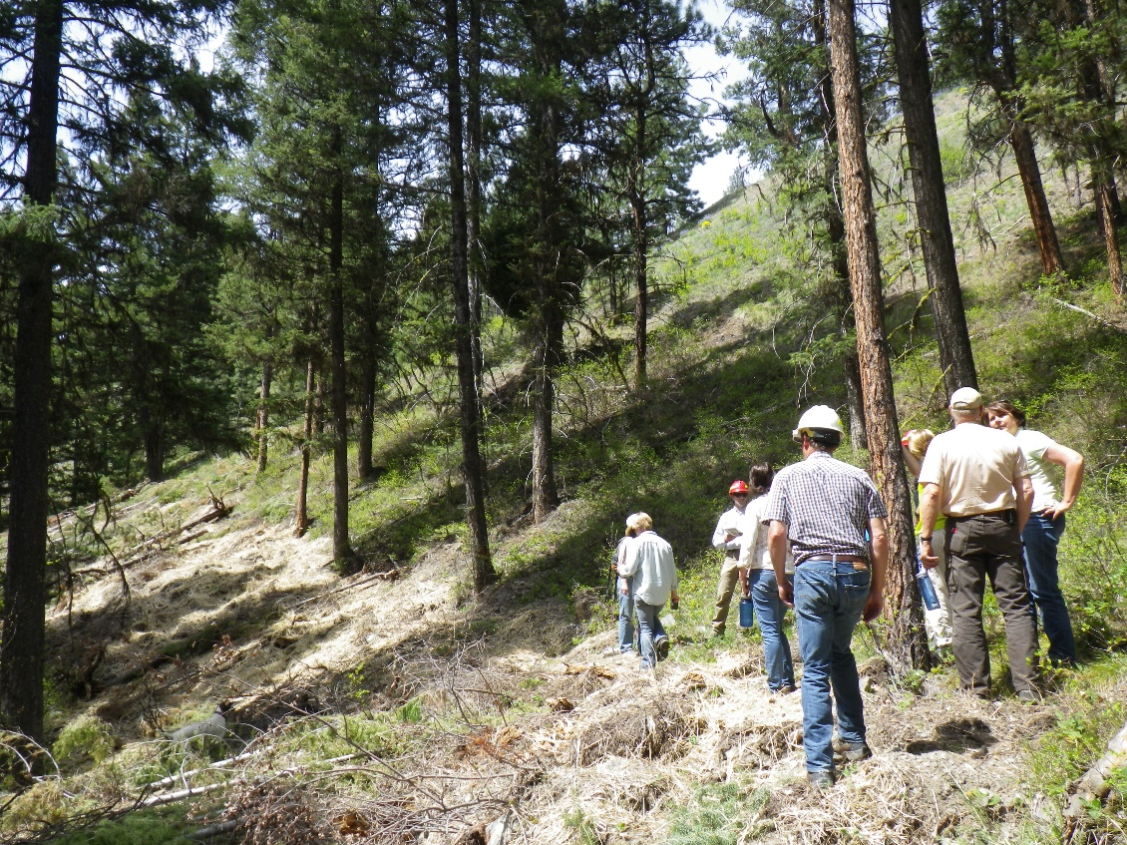
Betsy Mizell, Idaho Conservation League David Deschaine, SCNF
Stop #1: Lick Creek Road Decommissioning
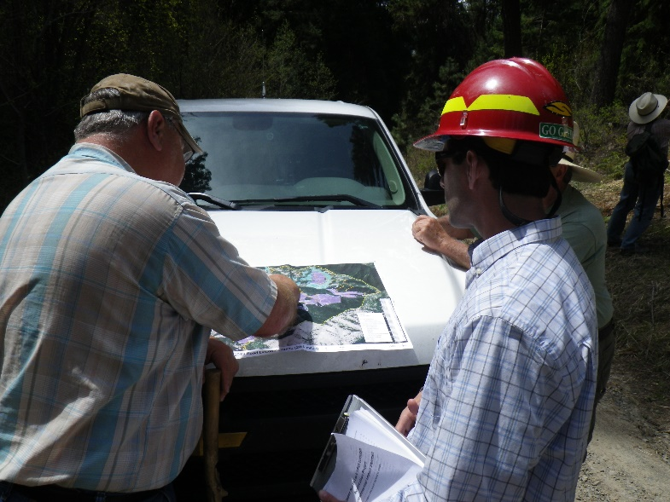
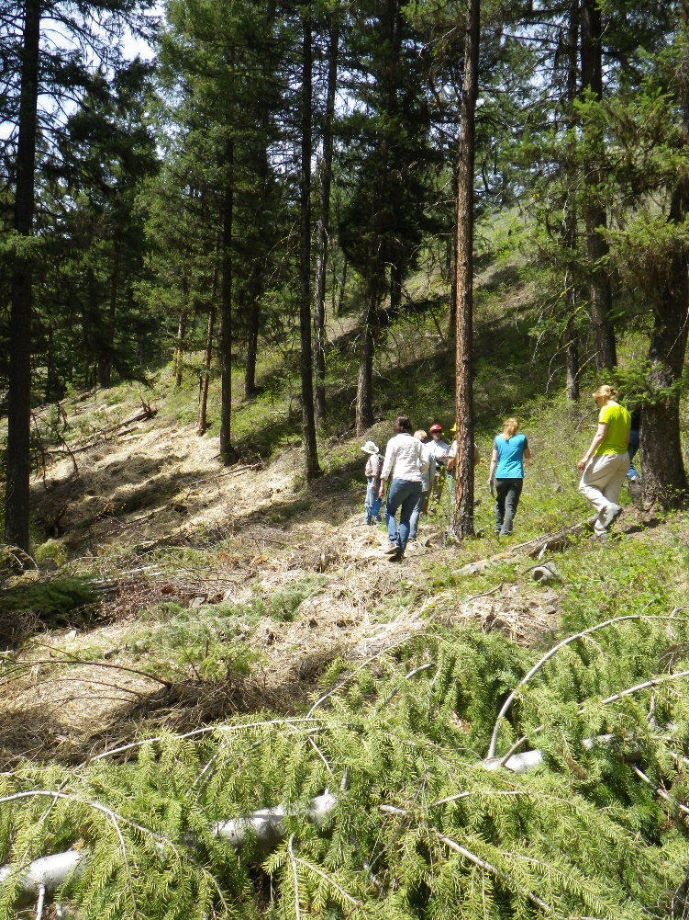
The group toured the first part of Lick Creek road decommissioning and walked along what use to be an old logging road. David Deschaine, forest hydrologist, led the discussion about the re-contoured road. The group discussed how fewer roads can result in benefits for wildlife and better hydrological functions. This kind of road de-commissioning is quite expensive.

Joint Chief’s funding will help finish the project along the slope and with slash piles. David mentioned he wanted to experiment with bio char, which is great for soil and water capacity. They will monitor the temperature of the soil in the burn piles where they use this technique, and the goal is to reduce soil scorching. The collaborative group offered to organize volunteers to help with these projects, potentially saving money and other resources.

Stop #2: Twin Creeks Campgrounds
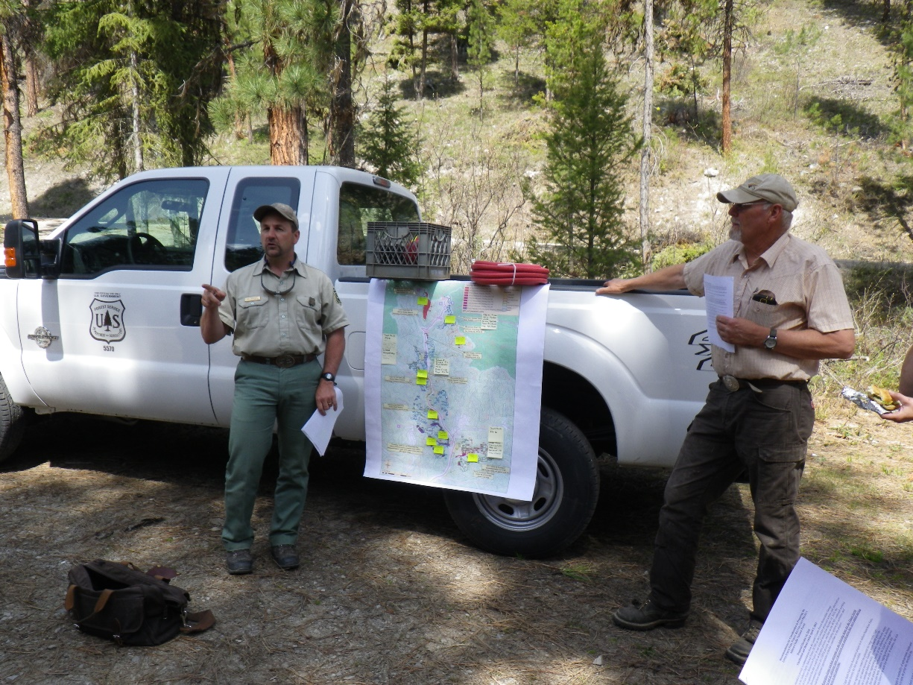
The group arrived at The Twin Creeks Campground to see the shaded fuel breaks and to discuss recent timber sales and fuels projects. A culvert was replaced in 2016 that is 2 miles up from the campground, and Ken urged each member to go check it out.

State Line Update:
-Stewardship Contract, which should be announced week of May 9th, 2016
-380 acres, Timber
-100 acres, Meadow Restoration (designed last year),Weeds and Treat encroaching conifers, 90% lodgepole pine
-22 acres, Aspen Stand (remove encroaching conifers), knock down stumps
Crone Gulch Update:
-Observe slash piling across Highway 93
-170 acres completed with Joint Chief’s funding
Lick Creek Update:
-442 acres completed in 2016
Moose Creek Estates Update:
-Actively thinning behind the property
Fuels Projects in UNF Update:
-450 acres of fuels projects
Hughes Creek Update:
-1-2 years left of burning
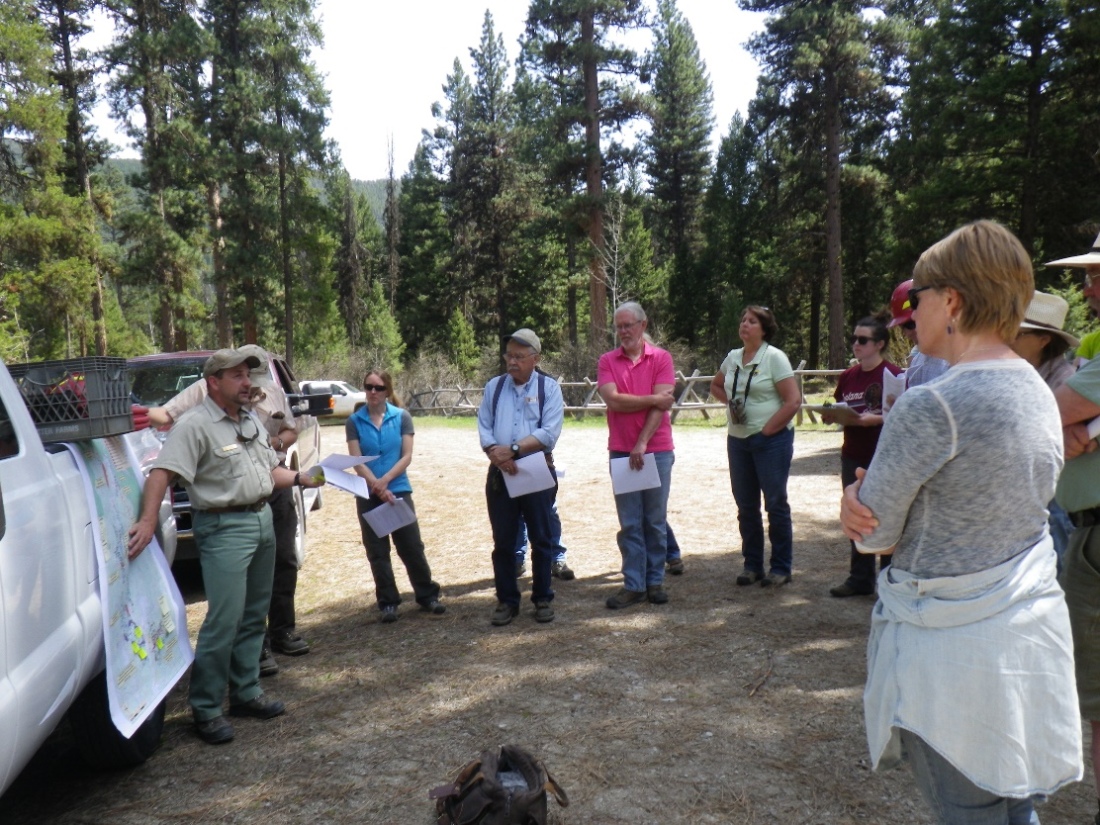
-The group brainstormed ideas on how to keep the community updated and informed about prescribed fires pre, during and post burns.

New Business:
- Tuesday, May 17th, 2-5 p.m., Public Lands Planning Meeting, Challis Community Event Center
- Monday, May 23rd, 2016 Regional Forester, Nora Rasure will be visiting Salmon.
- Lemhi County Wildland Urban Interface will host a Fire Mitigation Meeting Tuesday, June 7th at 6:00 p.m. at The Brooklyn Annex Room 105.

